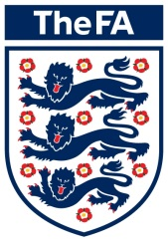
06 October 2014
FA National Youth Futsal Festival 2015

Dear Colleagues,

I am pleased to announce that the guidelines for this season’s FA National Youth Futsal Festival 2015 have now been finalised. I specifically wanted to provide you with further details around the co-ordination of the 2015 FA National Youth Futsal Festival events / leagues.

The underlying aim of the FA National Youth Futsal Festival is not necessarily to be elitist and to identify the very best youth Futsal clubs; more importantly the Festival’s primary role is to act as a catalyst to stimulate and support the ongoing youth development of Futsal across the country. Your work in co-ordinating the local and Regional Events plays a pivotal part in this development by ensuring that as many teams as possible have the opportunity to compete for a place at our showcase event.

Thus to build upon this success we will be providing teams / school’s the opportunity to play Futsal on a more regular basis.

Local qualifying leagues can be established in a variety of different ways according to local need and opportunities. For example, you may choose to work with local youth leagues and clubs to offer some form of mid-winter indoor Futsal league, or perhaps working with local schools (and where appropriate your ESFA representative) to establish an after school district competition, or it might be simply working with local partners to create your own league and advertise through a range of mediums to attract teams. There various ways to create a local qualifying league to help raise awareness of Futsal and how it can support young player development.

All Youth Futsal Festivals or leagues will mirror the age categories of the national festival (e.g. boys & girls: U10s, U12s, U14s & U16s), but it is at the discretion of the County FA, ESFA or league if you just wish to hold the festival for one age-group.

As has been the case for the last few years there will be no restrictions on schools or clubs entering the same event. From the regional stages onwards, schools and club teams will be competing against each other in every age category. Please note for clarity that no academy or COE players both male and female can play in the competition whether that is for a club or school. Please note that Academy or Centre of Excellence Teams are not allowed to compete at this stage

We are looking for the Festivals / leagues to be completed by the end of April 2014.

If you are interested in running either a league or festival then please complete one of the expression of interest forms included with this letter. The closing date for applications is on the 7th November 2014.

The Regional finals will be co-ordinated by the following County FA’s please make sure you make contact with your respective County to finalise numbers of allocated places.

East Regional | Essex FA | Brendan Walshe
East Midlands Regional | Leicestershire FA | Marion Hayton
North & Yorkshire Regional | West Riding FA | Joanne DeTut
North West Regional | Liverpool FA | Tony Smith
South East Regional | Surrey FA | John O’Malley
South West Regional | Devon FA | Chris French
West Midlands Regional | Birmingham FA | Will Perkins
London Regional | Middlesex FA | Leigh O’Conner

If you have any questions or queries at this stage then please get in touch and I am only too happy to help.

Yours faithfully,
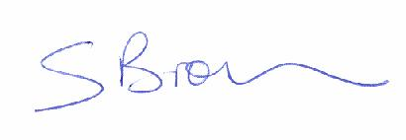
Stephen Brown
FA Small Sided Football Consultant

