Mandatory Stadium Entry Requirements For Wembley Stadium Ticket Holders
Mandatory stadium entry requirements are in place for all ticket holders with tickets for the group matches (13, 18 and 22 June) at Wembley Stadium. Procedures for the remaining EURO 2020 matches in London may change and will be confirmed shortly.

Wembley Stadium entry
You must demonstrate you are at a low-risk of transmitting COVID-19. All ticket holders aged 11 or older must show evidence of one of the following to be allowed entry to Wembley Stadium:
- For ticket holders based in the UK
  - Proof of a negative Lateral Flow Test (LFT), reported and demonstrated via a text message or email from NHS Test and Trace. The test needs to be taken within 48 hours of the time stadium gates open (meaning three hours before match kick-off).
  - Proof of a negative Lateral Flow Test (LFT) via the NHS App if you are 16 and over and registered with a GP in England. Your LFT result will show in the NHS App once you have reported it using the NHS self-report tool. our LFT result will show in the NHS App once you have reported it. You can access it via the Share my status tab (passcode euros)

  - Or proof of full vaccination - both doses received at least 14 days prior to the match (demonstrated via the NHS App or via the Scottish or Welsh vaccination record services).
Please note the “NHS App” is different to the “NHS COVID-19 App”.
- For ticket holders based elsewhere:
  - Proof of a negative Lateral Flow Test (LFT), reported and demonstrated via a text message or email from NHS Test and Trace. The test needs to be taken within 48 hours of the time stadium gates open (meaning three hours before match kick-off).Any other test results, e.g. a PCR test result from a private company, will not be accepted and entry will be denied.
Failure to provide one of these forms of evidence will mean you are unable to enter the stadium.

NHS Lateral Flow Test (LFT)
- The test needs to be taken within 48 hours of the time gates open (meaning three hours before kick-off).
- All tests will be self-administered.
- The results of the Lateral Flow Tests need to be uploaded using the NHS self-report tool, whether you are a UK resident or a ticket holder from abroad.
- You must show proof of your negative test result (text message or email) upon entry to the stadium. This can be on your device or a printout.
- You can also show proof of your negative test result via the NHS App if you are 16 and over and registered with a GP in England. Your LFT result will show in the NHS App once you have reported it using the NHS self-report tool. You can access it via the Share my status tab (passcode euros)
- The Lateral Flow Tests for stadium entry are free of charge.

Options available for ticket holders:
1. At Home testing (Recommended)
UK residents (England, Scotland, Wales and Northern Ireland) can order Lateral Flow Tests for home delivery online.
2. Asymptomatic Testing Site (ATS) testing
Alternatively, you can go to an ATS to take your test. Find a test site on this website. Apply filters under the heading “test site for people without symptoms”. You will need to book an appointment. If you’re an international ticket holder and unsure which ATS to pick, check out the list of recommended sites.
3. Lateral Flow Test - Collect
Another option is to visit a Test Collect Site or pharmacy to collect your Lateral Flow Tests for self-testing.
Remember if you’re an international ticket holder who is required to quarantine, you can only visit an ATS site, Test Collect Site or pharmacy once you’ve completed your quarantine period.
Example text message or email:

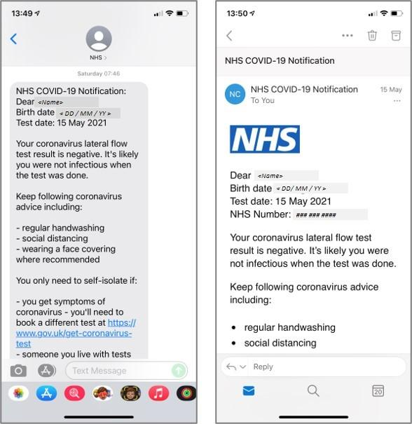

Vaccine Certification
If you live in England, you can see your vaccination status via the NHS App.
Please note the ‘NHS App’ is different to the ‘NHS COVID-19’ app.
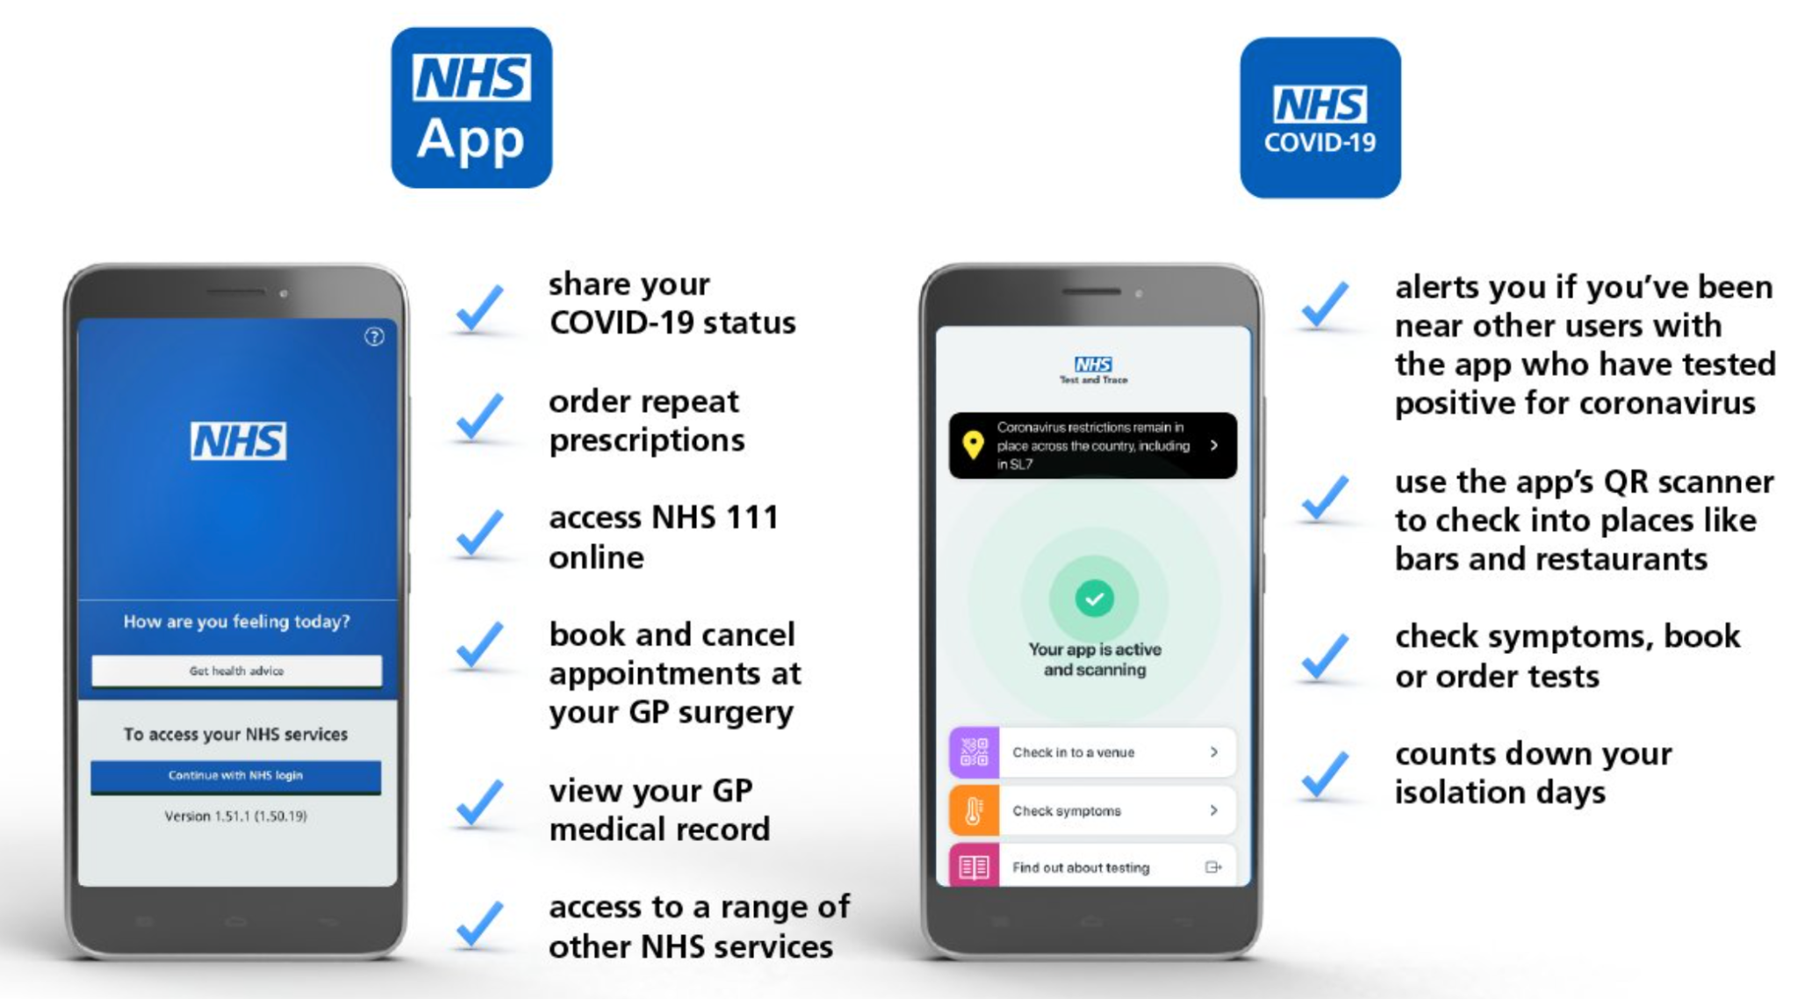

- If you have been vaccinated against COVID-19, you can show your certification on the NHS app when entering the stadium.
- Ticket holders are required to have had both vaccine doses at least 14 days prior to attending their match.
- From 10 June - select the “Share your COVID-19 status service” on the homepage, then select "Attending an event as part of a trial? Use the test service.” This is currently a test (beta) service and you will be required to enter the passcode ‘euros’ (not case sensitive) in the app.
- In order to use the NHS App you must be registered with a GP in England and over 16 years of age.
- Keep in mind you will need to download and register for the NHS App, prove your identity and check your vaccination status BEFORE travelling to Wembley Stadium. This process may take up to 7 days, so we recommend you do this as soon as possible before attending the match, however on average this is completed in a quicker time frame.
- You need to check if your vaccination data is correct in the NHS App. If you need help, you can check the official website for detailed instructions.
- A step by step guide on how to find your ‘COVID-19 event status’ within the app from 10 June is available.

Example screen:
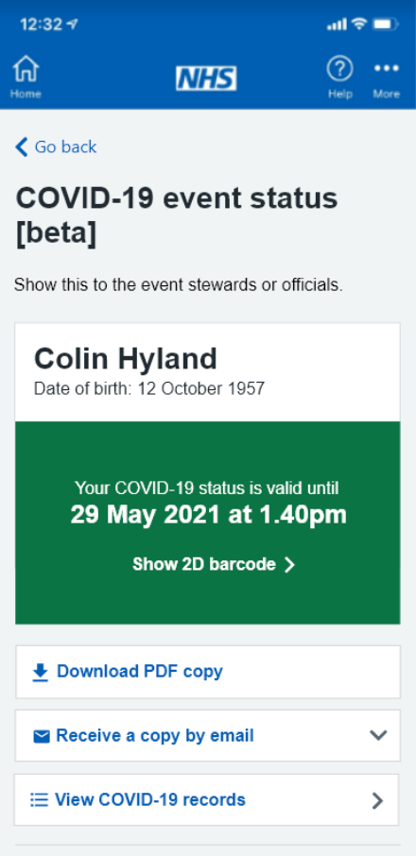

If you live in Scotland, you can obtain your vaccination status on this website.
If you live in Wales, you can request your vaccination status by following these instructions. It can take up to 10 working days for a certificate to arrive.
At this stage, there is no process for residents of Northern Ireland to evidence their vaccination status.

All ticket holders should expect queues at the entrances to the stadium.
You must arrive in the entry time slot indicated on your match ticket.
The UK Government is working with UEFA and The FA to explore all possible ways of allowing greater numbers of fans to return to stadia as safely and efficiently as possible. As such, these events require proof of a negative Lateral Flow Test, or proof of vaccine via the NHS App.

Safer Travel Guidance
See here for government advice of how to travel safely to the venue.
Please see here for EURO 2020 matchday travel information.
International Attendees
See here for travel guidance for international attendees.

A message from UK Government Event Participation
EURO 2020 matches being played at Wembley Stadium on June 13 and June 18 will be part of the UK Government’s ongoing Events Research Programme. As well as requiring attendees to meet the conditions above, ventilation and behavioural studies will also be conducted at these events. The UK government may ask UEFA to contact ticket holders after the event to complete a survey and volunteer to take part in an interview about their experience.
While steps are being taken to minimise risk of infection from COVID-19, attendance at this event is at your own risk. It is your responsibility to decide whether or not it is appropriate for you to attend this event. This decision should be based upon your own health status and susceptibility to infection, and that of members of your family, social bubble or, where applicable, your support bubble, together with an assessment of your own attitude to the potential risks.
Please refer to the UEFA Ticketing Terms and Conditions and the UEFA Ticketing FAQs on the conditions for transferring tickets.
For details on Data Privacy please see here

Best regards,
UEFA



