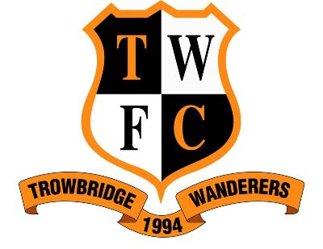
Trowbridge Wanderers FC

Trowbridge Wanderers Annual Tournament - Football Festival
Lambrok Playing Fields, Trowbridge. Wiltshire. BA14 9HA
FRIDAY 16TH JULY, SATURDAY 17TH & SUNDAY 18TH JULY 2021
On behalf of Trowbridge Wanderers FC, I would like to invite you to our Annual Tournament & Football Festival. After a very successful event in previous years, we are hoping that you can join us and make this year the best yet.
Teams u7’s & u8’s (both 5 a-side with 3 rolling subs) are to play “non-competitive” football and are therefore invited to participate in our Football Festival with each player receiving a memento of the day.
The tournament will consist of qualifying group games, quarter finals (where appropriate), semi-finals and finals, with trophies for the winners and runners up in each age group. Teams in age groups u9 – u13 inclusive to consist of 6 players and 2 rolling subs, where teams in age groups u15’s, u16’s and 17/18’s play 5 a side with 3 rolling subs (no academy teams please). All players must be under their respective age limit as at season 2020.
Along with a weekend packed full of football played in a safe and friendly environment, there will also be a full range of refreshments.
For those who have attended our Tournament before, you will note a change of venue this year. Lambrok Playing Fields have limited Car Parking so please bear this in mind when entering as we may need to restrict the use of cars to a minimum. There will be no parking on Lambrok Road.
No smoking is permitted on the premises or the sports field. No dogs are allowed on the premises or the sports field.
Covid restrictions will apply in line with government guidelines.
Please return the entry form by the 30thMay 2021, please note that entries are on a first come first served basis. Entry fee is £30 per team. Any queries please contact Julie Turner via email j.turner999@hotmail.co.uk or (07845) 482499.
Check our Facebook page for more information.
-----------------------------------------------------------------------------------------
Name of Club: ……………………………………………………………………………………. Affiliation No: ……………………….

Name of Contact …………………………………………………………Contact No: …………………………………………………...

Correspondence Address: …………………………………………………………………………………………………………………..

Contact e-mail (this is very important for communication) ………………………………………………………………………………..
DAY | AGE GROUP | No of  Teams | Team Names  (A,B,Utd etc) | MANAGER NAME | MANAGER CONTACT  (Email/Tel Number)
FRI | Under 15 Girls EVE
 | Under 16 Girls EVE
 | Under 17/18 EVE
SAT | Under 7 AM
 | Under 9 AM
 | Under 11 PM
 | Under 15 PM
SUN | Under 8 AM
 | Under 10 AM
 | Under 12 AM
 | Under 12 Girls PM
 | Under 13 Girls PM
Please make payment direct to our bank account nr 31455265 Sort Code 40-44-33
Please make sure you write club name and age groups entered on your notification to us. We will endeavour to send out confirmation 2 weeks prior to the tournament by Email Only. Please note no refund unless 21 days’ notice is given for cancellation.
THANK YOU FOR YOUR PARTICIPATION IN OUR TOURNAMENT AND WE LOOK FORWARD TO SEEING YOU ON THE DAY.

