WEST RIDING COUNTY FOOTBALL ASSOCIATION
FLEET LANE 3G USER GUIDE

Footwear
Anybody entering beyond the perimeter fence MUST wear appropriate footwear. This includes managers, coaches and anyone who wishes to be in the dugout/technical area.

Acceptable Footwear – Circular Studs Only
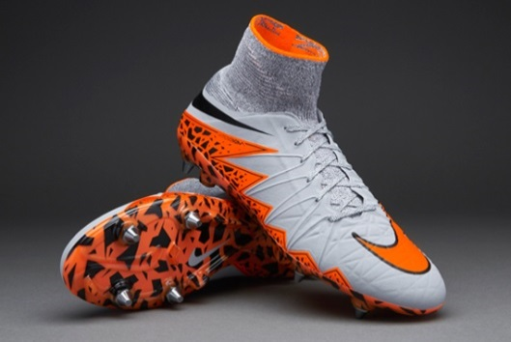
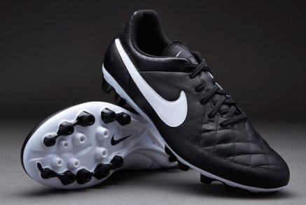
Metal Studded Boots
Artificial Ground (AG) Boots

Unacceptable Footwear – Flat-Soled or Bladed Footwear
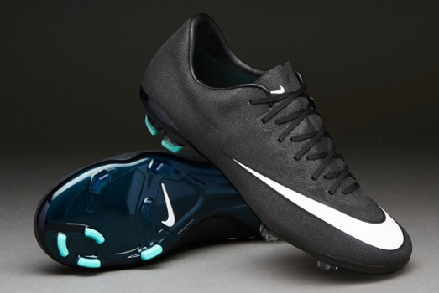
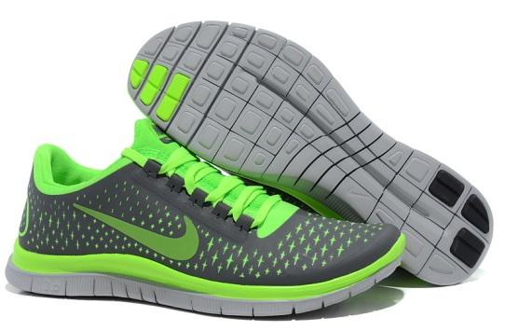
Indoor & Astro Turf Trainers
Bladed Boots
Generic Sports Trainers
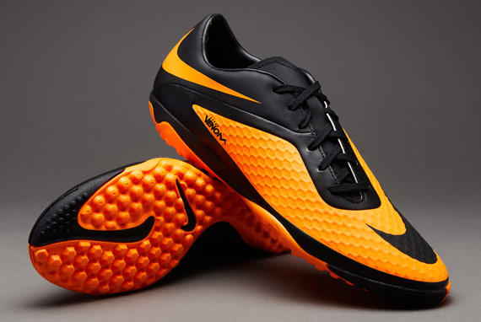

The use of incorrect footwear will significantly reduce the lifespan of the Fleet Lane 3G surface and is against the terms of the pitch warranty.
For this reason:
Any player without the correct footwear will not be allowed to participate
Any coach/manager without the correct footwear will not be allowed inside the perimeter fence

