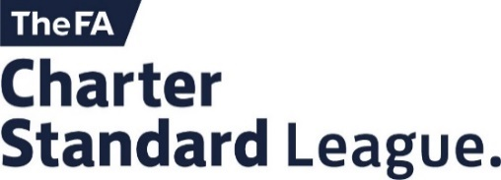

Referee Appointments Officer Vacancy

The Huddersfield Junior Football League is seeking to appoint a volunteer to fill the role Referee Appointments Officer at the league’s Annual General Meeting in June 2021.

This is an exciting role to be part of the committee of the league which is recognised as one of the largest and foremost junior leagues in Yorkshire. The Appointments Officer would be expected to make weekly appointments across all divisions ( 90 clubs and 850 teams).

Please find below key tasks that the officer will be required to undertake;

Referee Appointments Secretary Job Description

Key Tasks
- Appointments of Registered Referees to fixtures whenever possible.
- Ensure Referees hold a current DBS and have completed the online safeguarding course
- Communicating with referees and clubs as necessary, building relationships.
- Provide a report at monthly committee meetings and other times as necessary.
- Provide progression opportunities for match officials.
- Recruitment and development of referees.
- Working with County FA, District FA and other relevant football organisations as required concerning refereeing matters, in particular the County FA Referee Development Officer (coverage figures, promotional candidates, continuous poor marks etc)

Key Skills
- Ensure appointments are made with consideration to the requirements of referees and league affiliated clubs.
- Computer literate to include use of the league’s Full-Time website, the FA’s Whole Game System (WGS)
- Good organisation, communication and time management skills.
- Excellent interpersonal skills.

Key Relationships
- Referees
- General Secretary
- Other league officers
- Club secretaries
- County FA – Football Services and Football Development
- District FA’s

An annual grant towards expenses will be paid for the role with an attendance allowance also payable for any meetings that the candidate is required to attend on behalf of the role.
To apply for the role, please send your application letter outlining why you would make a good candidate for the role of Referees Appointments Secretary to League General Secretary Ursula Spencer secretaryhjfl@gmail.com<mailto:secretaryhjfl@gmail.com>

