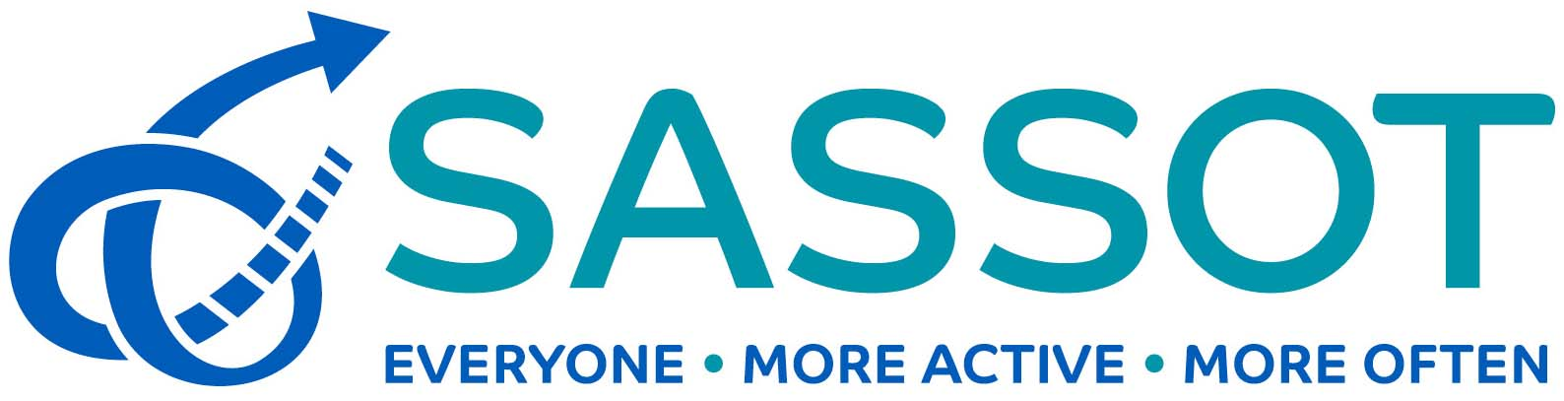
Recruitment Pack
Together Active Trustees

February 2020

Contents
Contents | 1
Welcome Letter | 2
How to Apply | 3
About Us | 4
The Board of Trustees | 6
Role Profile and Person Specification | 8
Principle Terms and Conditions | 13
Key Dates and Supplementary Information | 14
Appendix One – Equality Monitoring Information | 15

Welcome Letter
Dear Applicant,
Thank you for your interest in becoming a trustee of Together Active at what is a very exciting time for us. We have created this pack to give you some insight into who we are and what the role of a Trustee involves.
Together Active is a newly-formed Charitable Incorporated Organisation and was officially registered with the Charity Commission in January 2020. However, the new organisation is the evolution of an unincorporated organisation which has been established for nearly 20 years; SASSOT (Sport Across Staffordshire and Stoke-on-Trent).
SASSOT is one of a network of 43 Active Partnerships, all funded by Sport England to reduce inactivity levels within their own geographic areas. Throughout the time SASSOT has been in existence, we have been hosted by Stafford Borough Council. However, in the summer of 2019, the SASSOT Board took the decision to become a registered charity and to gain independence from our host, and Together Active was born.
Together Active will become operational on 1st April 2020, and at that point business will transfer from SASSOT to the new charity. We will bring with us our successful track record and the relationships and reputation we have built both locally and nationally, but we believe this transition will give us longer-term financial sustainability and also allow us to operate with more agility, creating new partnerships and increasing our impact.
We are therefore seeking new Trustees to help steer us through this exiting period of transformation, so that Together Active can embrace the challenges posed by the changing physical activity and sport landscape both locally and nationally. We hope that you will read this pack, get a flavour of who we are and what we do, and feel inspired to want to join us.
Please do contact me if you wish to have an informal discussion about the role and organisation or if you have any other questions to help you decide whether to apply. You can contact us on 07825 415153 (Malcolm Armstrong) or 07814 131074 (Jude Taylor).

Yours faithfully,
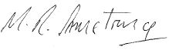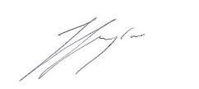
Malcolm Armstrong  Chair  Together Active (and SASSOT) | Jude Taylor  Director  Together Active (and SASSOT)

How to Apply

On the following pages, you will find details of the role and the selection process to help you to complete and tailor your application. To apply you should submit:
- An up-to-date CV which shows your full career history and provides two referees – we recommend that this is no longer than three pages
- A covering letter explaining how you found out about the role, why you are interested in this role, and telling us why you are a good candidate for this post. You must make sure that your CV/covering letter gives us enough information to demonstrate that you have the requisite experience, competencies and personal qualities as set out in the person specification. We recommend that this is no longer than three pages;
- A completed copy of our Equality Monitoring Sheet (Appendix 1). This will be separated from your application prior to shortlisting and will be used only for anonymised monitoring purposes
- Please indicate in your covering letter if you cannot attend the interview date.
Please note that applications can only be considered if all the documentation is complete. Please send your application by email to Hazell Thorogood: hthorogood@staffordbc.gov.uk.
Applications must be received by Friday 28th February 2020 at 5pm.
You will receive an acknowledgement within two working days of receipt and we suggest that if after that time you have not heard from us, you telephone the office (01785 619349) to ensure that it has arrived.

About Us
Together Active / SASSOT is a partnership of agencies working together to create active places and healthy lives through physical activity and sport.
We are part of an England-wide network of 43 Active Partnerships (APs). Through our nationwide coverage and our local knowledge APs are uniquely positioned to support the development of physical activity and sport. Increased participation in sport and physical activity can have a positive benefit on a wide range of agendas, such as physical wellbeing, mental wellbeing, individual development, social and community development and economic development.
We are funded by national and local partners, including Sport England, our Local Authorities and Universities. Our long-term strategy can be found on the SASSOT website (https://www.sportacrossstaffordshire.co.uk), but the following logic model illustrates our approach:
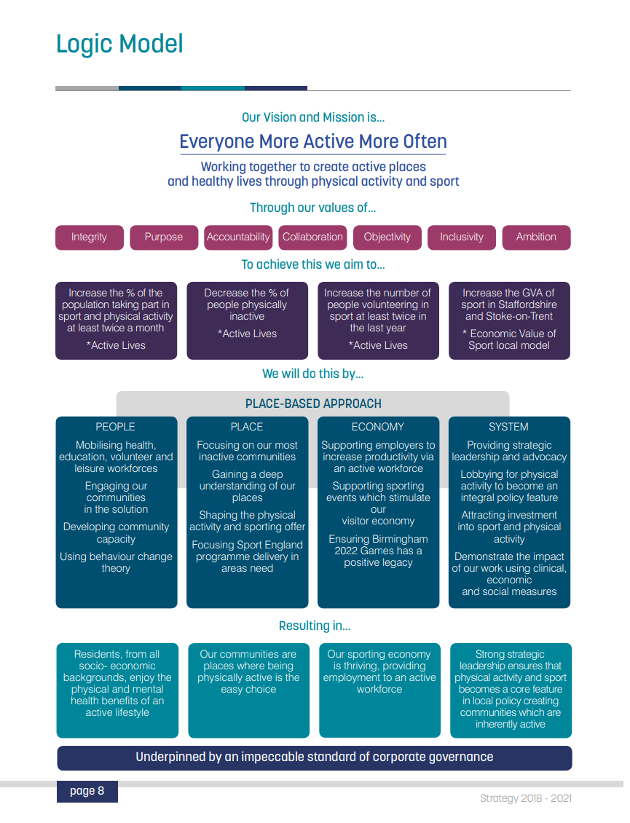
We believe the above approach will enable us to deliver effectively across the four roles which Sport England has tasked all APs to fulfil via our Primary Role funding:
- A strong granular understanding of the place and people
- An ability to broker and facilitate a much wider range of relationships
- Where necessary supporting projects and relationships on Sport England’s behalf
- Supporting local authorities by consent

The Board of Trustees
The Board is collectively responsible for providing leadership, inspiration and vision for Together Active, and for setting our strategic direction based on intelligence and insight. Trustees should be staunch advocates for the benefits of physical activity and sport, and for the role Together Active can play in addressing inactivity and in reducing inequalities in participation.

The purpose of the Board is to:

Provide leadership | To provide inspiration, vision and clear direction to Together Active
Provide strategic direction | To be responsible for agreeing the strategic direction of Together Active based on intelligence and insight
Be the ultimate decision-making body of the organisation | To exercise all of the powers of the organisation, ensuring that key decisions are made in a timely manner based on sufficient information and consideration
Ensure effective governance | To ensure the Board complies with Tier Three of A Code for Sports Governance
Scrutinise the effectiveness of the organisation | To retain an overview of the operation of the organisation, scrutinising effectively as required.
Uphold and protect the Values | To ensure behaviours comply with, and decisions are made in line with the values of Together Active
Act collectively in the best interests of Together Active | To declare interests where appropriate and work together as a Board in the best interests of Together Active.
Provide advocacy and attract additional resources | Trustees should be staunch advocates for Together Active and where appropriate and/or feasible should assist in developing a resource base for the partnership.
Ensure equality | To ensure the Board and Organisation are committed to working proactively to ensure equality. To ensure the Board has appropriately diverse membership.

Trustees
Malcolm Armstrong (Independent) – Chair
Strategy; Leadership; Governance; Sports & Exercise Science
Kimiyo Rickett - Senior Independent Director
Inclusion; Finance; Strategy
Tim Clegg, Chief Executive, Stafford Borough Council
Local Government; Strategy
Councillor Mark Deaville, Cabinet Member for Commercial, Staffordshire County Council
Political Insight
Alistair Fisher, Strategic Manager, Primary Prevention, Public Health City of Stoke-on Trent
Primary Prevention and Public Health
Toyin Higgs (Independent)
Safeguarding
Professor Derek Peters (Independent)
Physical Activity; Evaluation & Research
Rebecca Roberts (Independent)
Marketing; Communications
Jonathan Topham, Senior Commissioning Manager, Public Health Staffordshire
Public Health; Commissioning
Professor Pauline Walsh (Independent)
Higher Education; Medicine & Health
All of the above are also currently serving as members of SASSOT’s Board

Trustee Role Profile
Job purpose:
- To ensure the Board provides leadership and sets the strategic direction of Together Active
- To approve Together Active’s strategy, long-term financial plans and annual budget, and to monitor delivery against these
- To take decisions collectively and act solely in the best interests of Together Active.
- To ensure that Together Active complies with its Constitution, the law and good practice and that Together Active applies its resources solely for the purposes set out in its Constitution.
- To ensure that Together Active ’s controls, monitoring and reporting systems are robust, and to periodically review and address major risks
- To uphold and protect the values, integrity and reputation of Together Active.
- To be a visible role model for the Partnership, and to advocate and champion Together Active ’s work
- To advocate the role of physical activity and sport for its own sake and for how it contributes to wider cross-cutting agendas
- To contribute towards making the Board a high performing team.
- To contribute towards ensuring Together Active’s long term success.
- To support as appropriate the Chair, other trustees, senior management and other staff, sharing expertise and experience
- To engage with Together Active’s current and potential partners and to represent Together Active and its Board at events.

Duties:
Duty of Compliance | Trustees are expected to comply with Together Active’s constitution, policies and strategy
Duty of Care | Trustees are expected to act reasonably and prudently in all matters relating to Together Active and its long-term interest.
Duty to promote openness and debate | Trustees are expected to enable an environment that encourages transparency and where debate is encouraged. When those opinions may differ, they will be respected.
Duty to protect the organisation | Trustees have a duty to protect all the resources belonging to Together Active by ensuring effective management systems are in place e.g. financial controls, risk register etc.  Trustees have a duty to protect the organisation’s reputation and intellectual property.
Duty to act in the best interests of the public | As Together Active is financed through public money Trustees have a responsibility to act in the best interests of the public as a whole.  They have a responsibility to avoid conflicts of interest especially when they involve financial transactions.
Duty to abide by Together Active’s Code of Conduct | Trustees will ensure that they abide by Together Active’s Code of Conduct for Trustees to ensure that the highest personal standards are observed at all times.
Personal Interests | No Trustee shall participate in discussions, or vote in response of a matter in which they have a material interest.
Personal Liability | Although any legal proceedings initiated by a third party are likely to be brought against the Organisation, in exceptional cases civil, or in certain cases, criminal, proceedings may be brought against a Chair or other individual Trustee. For example, a Trustee may be personally liable if he or she makes a fraudulent or negligent statement, which results in loss to a third party. Trustees who misuse information gained by virtue of their position may be liable for breach of confidence under common law or may commit a criminal offence under insider dealing legislation.  However, the Government has indicated that individual Trustees who have acted honestly, reasonably, in good faith and without negligence will not have to meet, out of their own personal resources, any personal civil liability, which is incurred in execution or purported execution of their Board functions. Together Active indemnifies its Trustees against legal proceedings brought against them personally in execution of their Board duties, provided they have acted in accordance with this paragraph.
Person Specification
Core competencies:
- Leadership – Has a successful track record of leadership and strategic management, having operated effectively at a senior level in the public, voluntary private or community sector. The ability to inspire confidence.
- Communication – Able to listen and make reasoned contributions to debate and a willingness to speak their mind.
- Strategic thinking - Understands the organisation’s overall strategy, able to assess implications before making decisions. Strategic vision, thinking, planning and oversight.
- Judgement - Proven track record of providing clear, independent, balanced advice and guidance with the ability to challenge constructively.
- Influence - Demonstrates effective skills in persuasion and negotiation to influence others.
- Team working - Experience of working in collaboration with others, working towards common goals and shared objectives. An ability to build effective relationships and work well as a member of a team.

Abilities, skills and knowledge:

- Experience of board or committee membership.
- Knowledge of good governance and an understanding and acceptance of the legal duties, responsibilities and liabilities of a Together Active Trustee.
- Knowledge and understanding of the sport and physical activity landscape and the issues currently influencing it
- Ability to actively monitor and manage the performance of the organisation, encouraging and supporting others to achieve the highest standards of governance, scrutiny, legal and financial responsibilities.
- Able to assess and manage risk and promote risk awareness without being risk averse.
- Ability to apply creative and imaginative solutions, with good judgement and a commitment to results.
- Ability to participate fully and effectively as a member of the Board, take decisions for the good of Together Active and deliver collective responsibility.
- Demonstrate a strong and clear commitment to equality and diversity.
- Ability to inspire others and build trust and respect from colleagues and stakeholders.
- IT literate and comfortable with handling, analysing and prioritising data.
- Demonstrate proficiency in financial management, strategy and planning.

Personal attributes:
- Commitment to Together Active and its effective governance.
- Integrity and credibility.
- Willingness to devote the necessary time and effort to the role.
- Effective self-management skills.

Board Member Code of Conduct:
Our values underpin everything we do as a Board and as individuals. We believe that by using these values to guide our decisions and actions, we will be best placed to achieve our vision of Everyone More Active More Often.

As a Board member for Together Active I will respect and uphold these values:

Integrity | This is our foundation; we will work openly, honestly and sincerely, showing respect and sharing our passion for what we do
Inclusion | Actively accessible to all, whilst putting the individual at the heart of what we do
Collaboration | Drawing on our strengths and those of others, brokering, enabling and influencing for positive results
Ambition | Committed to excellence and continually improving our services through innovation and creativity
Objectivity | Making informed decisions for the benefit of the local population, based on robust evidence
Purpose | Having clearly articulated goals underpinned by appropriate insight and action
Accountability | Owning decisions and delivering on promises individually and collectively

GENERAL
- I will act within the Constitution of Together Active and the law, and abide by the policies and procedures of the organisation. This includes having a knowledge of the contents of the Constitution and relevant policies and procedures.
- I will support the vision and mission of Together Active, championing them, using any skills or knowledge I have to further them and seeking expert advice where appropriate.
- I will be an active Trustee, making my skills, experience and knowledge available to Together Active and seeking to do what additional work I can outside of Board meetings, including sitting on sub-committees.
- I will respect organisational, Board and individual confidentiality, while never using confidentiality as an excuse not to disclose matters that should be transparent and open.
- I will develop and maintain a sound and up-to-date knowledge of Together Active and its environment. This will include an understanding of how Together Active operates, the social, political and economic environment in which it operates and the nature and extent of its work.
- I will use Together Active’s resources responsibly, and when claiming expenses will do so in line with Together Active procedures.
- I will seek to be accountable for my actions as a Trustee of Together Active, and will submit myself to whatever scrutiny is appropriate.
- I accept my responsibility to ensure that Together Active is well run and will raise issues and questions in an appropriate and sensitive way to ensure that this is the case.

MANAGING INTERESTS
- I will not gain materially or financially from my involvement with Together Active unless specifically authorised to do so.
- I will act in the best interests of Together Active as a whole, and not as a representative of any group – considering what is best for Together Active and its present and future beneficiaries and avoiding bringing Together Active into disrepute.
- Unless authorised, I will not put myself in a position where my personal interests conflict with my duty to act in the interests of the organisation. Where there is a conflict of interest I will ensure that this is managed effectively in line with Together Active policy.
- I understand that a failure to declare a conflict of interest may be considered to be a breach of this code.

MEETINGS
- I will attend all appropriate meetings and other appointments at Together Active or give apologies. I understand that I am expected to attend 75% of formal Board meetings during a calendar year.
- If I cannot regularly attend meetings I will consider whether there are other ways I can engage with Together Active.
- I will prepare fully for all meetings and work for the organisation. This will include reading papers, querying anything I do not understand, thinking through issues before meetings and completing any tasks assigned to me in the agreed time.
- I will actively engage in discussion, debate and voting in meetings; contributing in a considered and constructive way, listening carefully, challenging sensitively and avoiding conflict.
- I will participate in collective decision making, accept a majority decision of the Board and will not act individually unless specifically authorised to do so.

GOVERNANCE
- I will actively contribute towards improving the governance of the Board, participating in an induction and training and sharing ideas for improvement with the Board.
- I will help to identify good candidates for becoming a Trustee at Together Active and, with my fellow Trustees, will appoint new Trustees in accordance with agreed selection criteria.

RELATIONS WITH OTHERS
- I will endeavour to work considerately and respectfully with all those I come into contact with at Together Active. I will respect diversity, different roles and boundaries, and avoid giving offence.
- I recognise that the roles of Trustees and staff of Together Active are different, and I will seek to understand and respect the difference between these roles.
- I will seek to support and encourage all those I come into contact with at Together Active. In particular I recognise my responsibility to support the Chair and senior staff members.
- I will not make public comments about the organisation unless authorised to do so. Any public comments I make about Together Active will be considered and in line with organisational policy, whether I make them as an individual or as a Trustee.

LEAVING THE BOARD
- I understand that substantial breach of any part of this code may result in procedures being put in motion that may result in my being asked to resign from the Board.
- Should this happen I will be given the opportunity to be heard. In the event that I am asked to resign from the Board I will accept the majority decision of the Board in this matter and resign at the earliest opportunity.
- If I wish to cease being a Trustee of Together Active at any time, I will inform the Chair in advance in writing, stating my reasons for leaving.

Principal Terms and Conditions
Position:
Trustee of Together Active
Remuneration package:
These are non-salaried positions. Travel and other reasonable out-of-pocket expenses will be reimbursed for attendance at official meetings and events on behalf of Together Active.
Location:
Meetings may be held throughout Staffordshire and Stoke-on-Trent.
Terms of office:
Three years initially. Maximum of three, three-year terms
Time commitment – attendance and preparation for:
- An induction training event;
- A minimum of 4 and a maximum of 8 meetings of the Board annually;
- Where appointed a member, meetings of any sub groups or time-limited action groups;
- Occasional Together Active events;
- Participation in Board learning and Board appraisals;
- Occasional Partner events, representing Together Active.
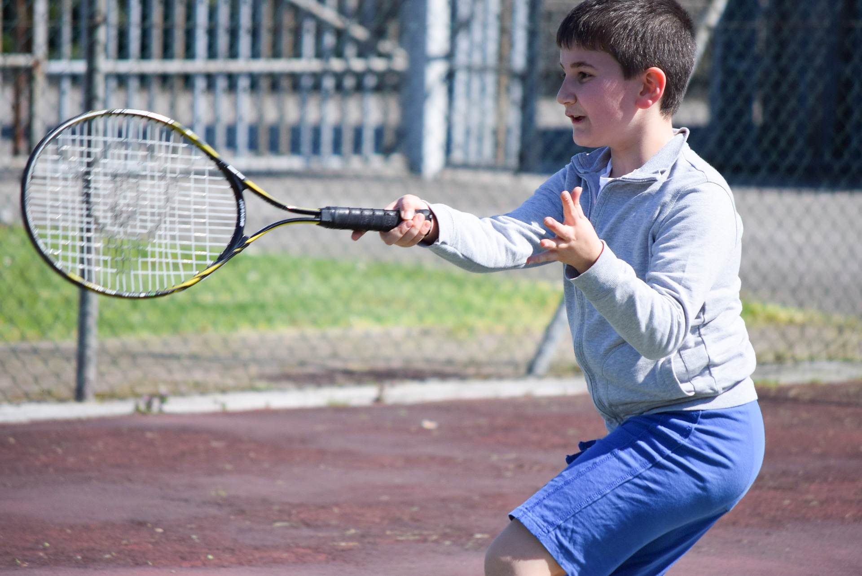

Key Dates and Supplementary Information
Closing date:
Friday 28th February 2020 at 5pm
All candidates will be informed of the outcomes of the shortlisting process by 5th March.
Please email applications to Hazell Thorogood – hthorogood@staffordbc.gov.uk
Interviews:
Tuesday 10th March
Shortlisted candidates will be invited to an interview with the Together Active selection panel.

Supplementary information:
The link for our Annual Report and our Services document is:
https://sportacrossstaffordshire.co.uk/about-us/what-we-do-2/

Our Strategy can be found here:
https://sportacrossstaffordshire.co.uk/wp-content/uploads/2018/04/Strategy-Final.pdf

To find out more about us please visit the SASSOT website: http://www.sportacrossstaffordshire.co.uk

Appendix 1
Equality Monitoring Form

Together Active wants to meet the aims and commitments set out in its equality policy. This includes not discriminating under the Equality Act 2010, and building an accurate picture of the make-up of the workforce in encouraging equality and diversity.

The organisation needs your help and co-operation to enable it to do this, but filling in this form is voluntary.

Please return the completed form to Hazell Thorogood (hthorogood@staffordbc.gov.uk) along with your other documentation. Alternatively, please return the completed form separately to the above email address, marking the email ‘Strictly Confidential’
Gender Male ☐ Female ☐ Intersex ☐ Non-binary ☐ Prefer not to say ☐
If you prefer to use your own term, please specify here:
Are you married or in a civil partnership? Yes ☐ No ☐ Prefer not to say ☐
Age 16-24 ☐ 25-29 ☐ 30-34 ☐ 35-39 ☐ 40-44 ☐ 45-49 ☐ 50-54 ☐ 55-59 ☐ 60-64 ☐ 65+ ☐ Prefer not to say ☐
What is your ethnicity?
Ethnic origin is not about nationality, place of birth or citizenship. It is about the group to which you perceive you belong. Please tick the appropriate box

White
English ☐ Welsh ☐ Scottish ☐ Northern Irish ☐ Irish ☐
British ☐ Gypsy or Irish Traveller ☐ Prefer not to say ☐
Any other white background, please write in:

Mixed/multiple ethnic groups
White and Black Caribbean ☐ White and Black African ☐ White and Asian ☐ Prefer not to say ☐ Any other mixed background, please write in:

Asian/Asian British
Indian ☐ Pakistani ☐ Bangladeshi ☐ Chinese ☐ Prefer not to say ☐
Any other Asian background, please write in:

Black/ African/ Caribbean/ Black British
African ☐ Caribbean ☐ Prefer not to say ☐
Any other Black/African/Caribbean background, please write in:

Other ethnic group
Arab ☐ Prefer not to say ☐ Any other ethnic group, please write in:

Do you consider yourself to have a disability or long-term health condition?
Yes ☐ No ☐ Prefer not to say ☐

What is your sexual orientation?
Heterosexual ☐ Gay ☐ Lesbian ☐ Bisexual ☐
Prefer not to say ☐ If you prefer to use your own term, please specify here:

What is your religion or belief?
No religion or belief ☐ Buddhist ☐ Christian ☐ Hindu ☐ Jewish ☐
Muslim ☐ Sikh ☐ Prefer not to say ☐ If other religion or belief, please write in:

