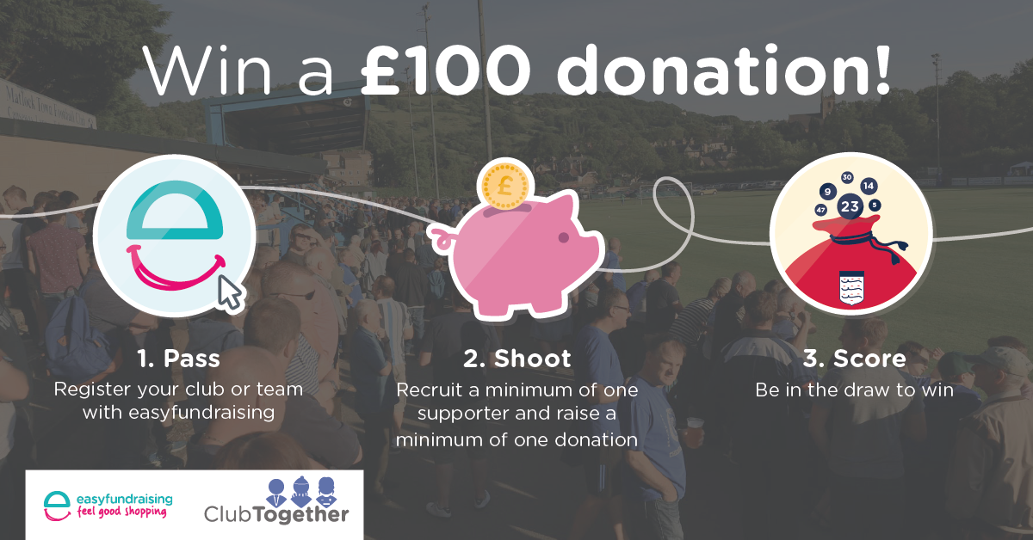

To be in with the chance to win £100 register your football club or team with easyfundraising, recruit your first supporter and raise your first donation before midnight on Sunday 10th June 2018.

If your football club or team has already registered with easyfundraising, simply recruit a supporter and collect a donation between 14/05/2018 and 10/06/2018 to be entered into the draw.

Terms & Conditions
- No purchase necessary.
- The competition is open to all affiliated football clubs & teams.
- The competition will run from 14/05/2018 to 10/06/2018.
- Last time for entry will be 23.59, 10/06/2018.
- New football clubs and teams who register as an easyfundraising cause, recruit a supporter and raise a donation between 14/05/2018 and 10/06/2018. will be entered in to the prize draw.
- Football clubs and teams who have already registered with easyfundraising prior to 14/05/2018 must recruit a supporter and collect a donation through the easyfundraising site between 14/05/2018 and 10/06/2018 in order to enter the draw
- For football clubs and teams to be eligible, they must be registered with easyfundraising as a cause by 23.59, 10/06/2018. Football clubs and teams not registered with easyfundraising as a cause by this time will not be entered.
- The draw will take place on 13/06/2018 and the first randomly selected will win a £100 to support grassroot football.
- The administrator of the winning football club or team will be notified by email within 2 working days of the draw taking place. Please ensure your account details are correct.
- In the event that the winner does not reply to their winning notice within 30 days then the prize will be redrawn and awarded to an alternative winning cause.
- No cash alternative will be offered
- The winner agrees to participate in press and publicity events, and for their name to be featured on the easyfundraising website, easyfundraising Facebook page and the easyfundraising twitter page.
- The Judges' decision is final and no correspondence will be entered into.
- By entering the competition, football clubs and teams agree to be bound by all competition and site rules.

