Somerset Schools

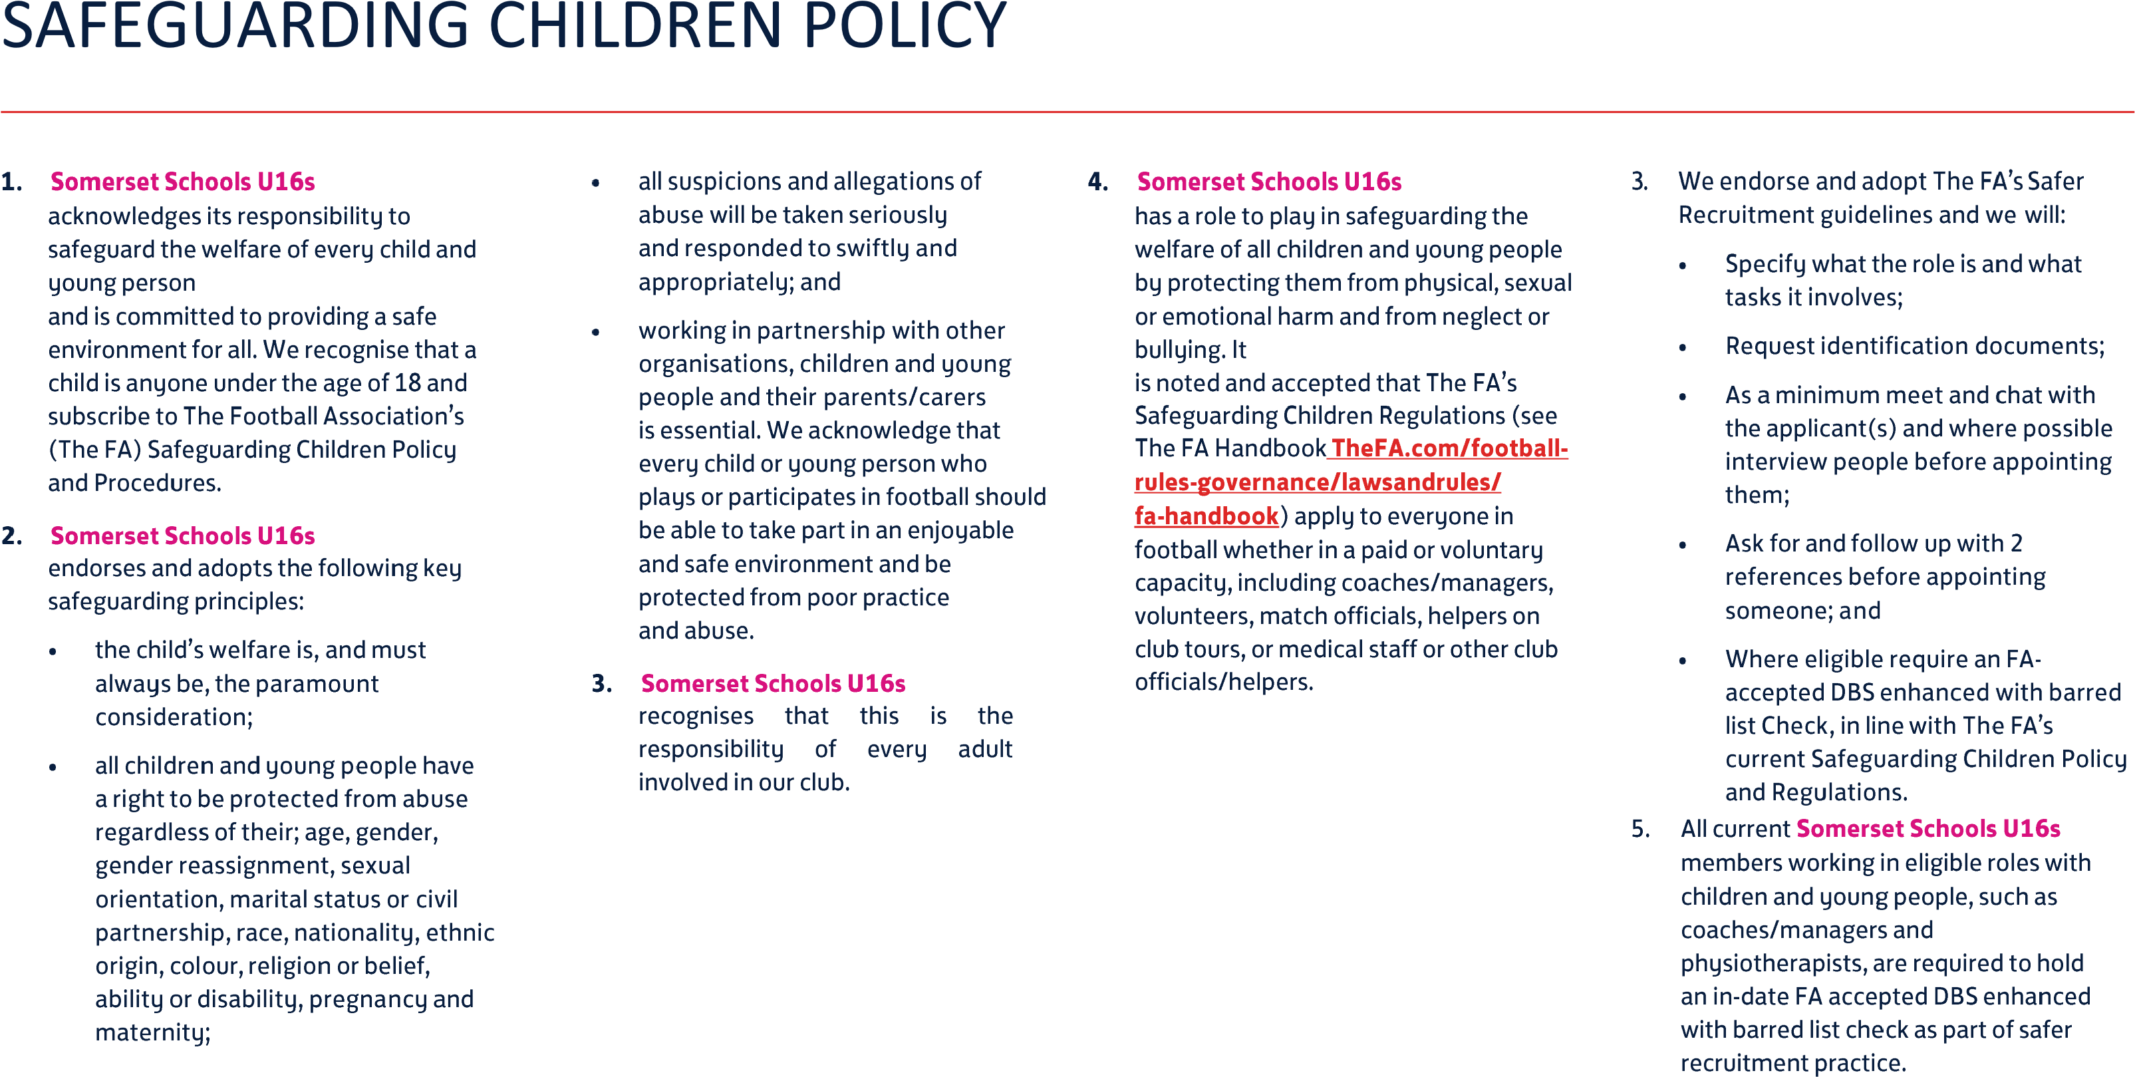

**Somerset Schools**

**Somerset Schools**

**Somerset Schools**

**Somerset Schools**

**Somerset Schools**

**Somerset Schools**

**Somerset Schools**



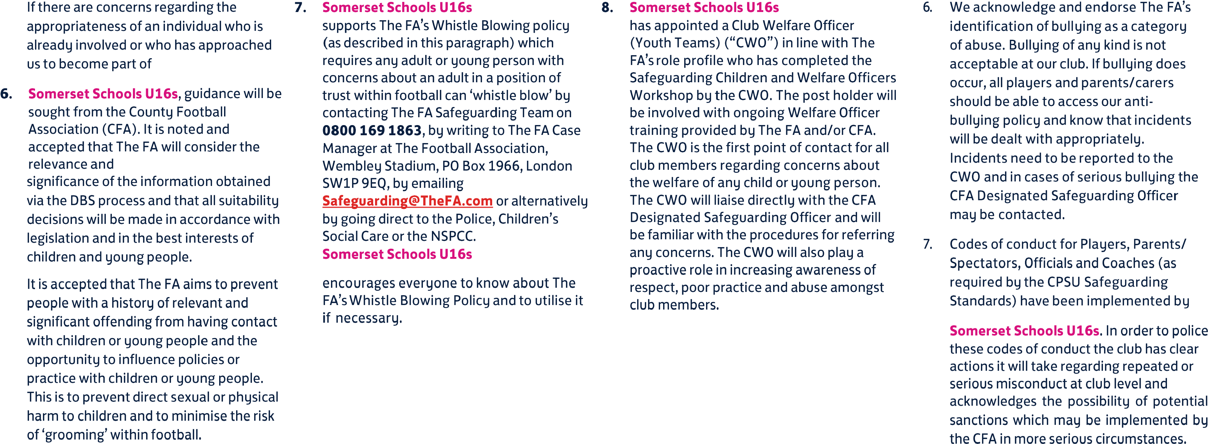

**Somerset Schools**

**Somerset Schools**

**.**

**Somerset Schools**



**Somerset schools Welfare Officer**

Richard Pryor

September 2023

September 2023

September 2023

September 2023

**Assistant Welfare Officer**

Mo Hopkins

Jess Humphrey

**Somerset Schools**

