How to create a Programme
This guide will explain how to set up a programme.

1. To create a Wildcats/Comets programme, you will first need to head to My programmes Module within the admin area.
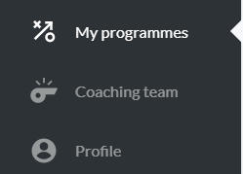

2. Click into the junior Wildcats/Comets category.

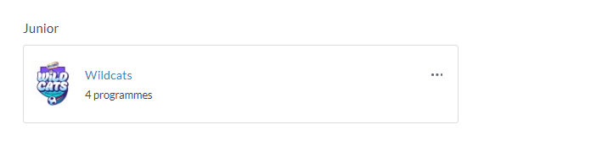

3. Next either select 'Add new programme' in the top right hand corner or 'Create a new programme', both will take you to the same screen.
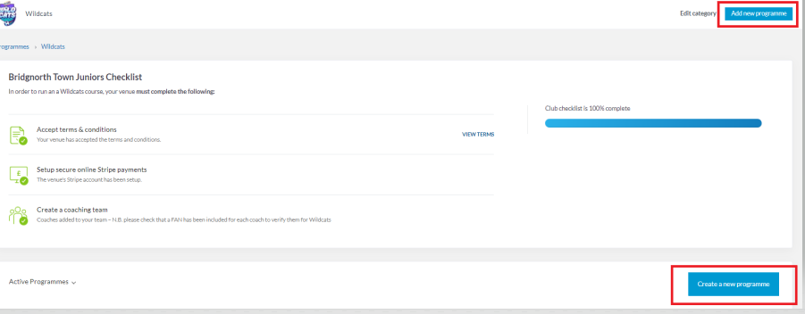

4. Add the programme details, such as 'Status'(click on the question mark icon next to the boxes to find out more information), Code, Additional Information and Additional confirmation..
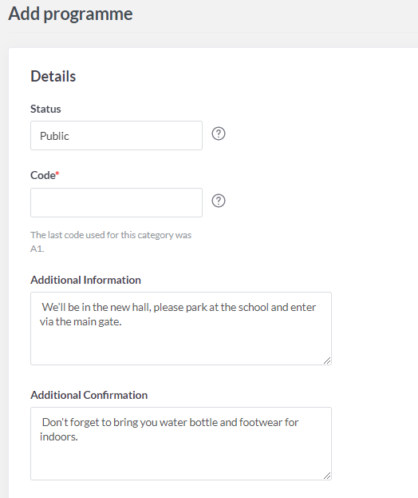
5. Next decide if you want reminder emails to be sent out (click on the grey tab to turn the toggle to blue, this will make it active). Select a start date and number of weeks you want the program to run for (by default this is set to 10 but you can amend this, click in the box and a drop down will appear, please note 10 is the max). The contact details are pulled through from the category, you can edit these details or edit the category if you want these pre-set to other details going forward.
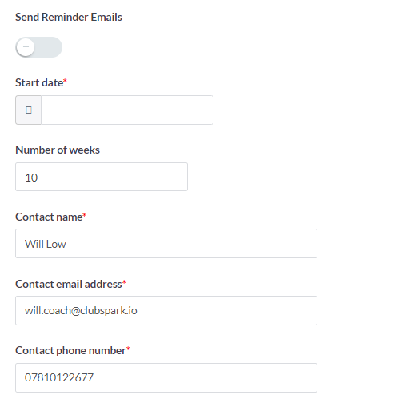

6. Lastly fill out the session default details. You should be able to find your venue from the list, if not please email support and we can assist with this. Set a minimum and maximum age these are set to 5-11 but again can be changed to suit your program. Add a lead coach and any assistance coaches that will be helping with the sessions. Please note coaches will need to have been added to your coaching team and have their FAN included to verify them for a Wildcats/Comets program. Select a time and duration, as well as the surface type. Then add in capacity and cost of the session.

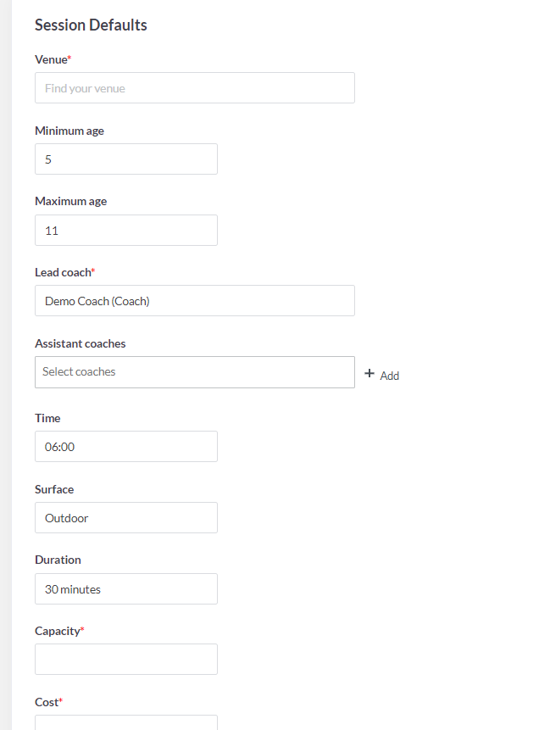

7. Select 'Save programme'


Your programs will then appear on the programming page under 'Active Programs'
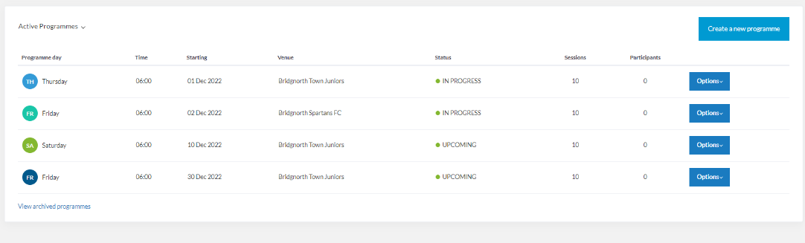
Click on the drop down to view 'Completed' and 'Cancelled' programs.
