Providers – First time visit

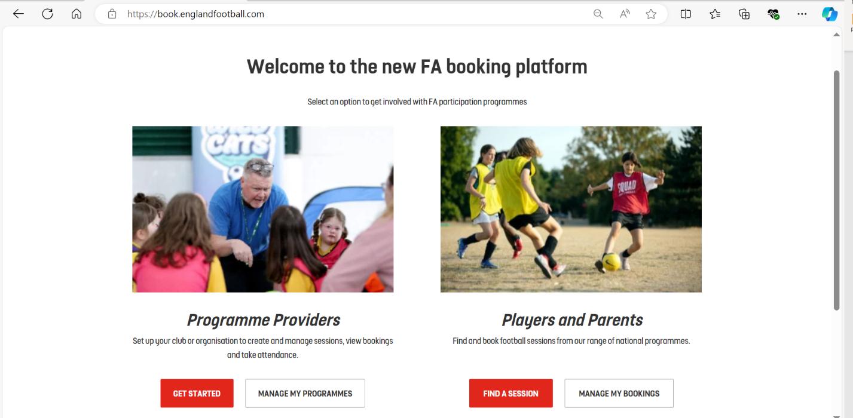
- Head to http://book.englandfootball.com.

- Select ‘Get started’.

2a. A log in page will appear if you’ve not already signed in or create an account
2b. If you’ve already logged in (and its your first time) it will ask you if you are an affiliated club. Please select the correct option. You will only be asked this question the first time you set up your organisation on Book football.
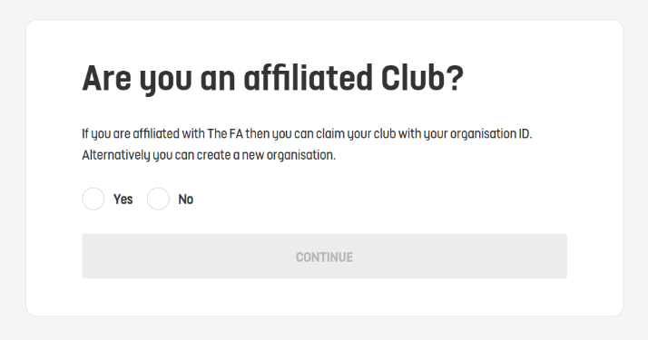

- Claim a club (Affiliated Clubs)
If you’ve selected ‘Yes’ you will then be asked to enter your organisation ID. This is so it can connect your account to the club you claim to belong to. Please note that only one person can claim a club. If your club delivers more than one programme you will be able to add accounts to give them access.

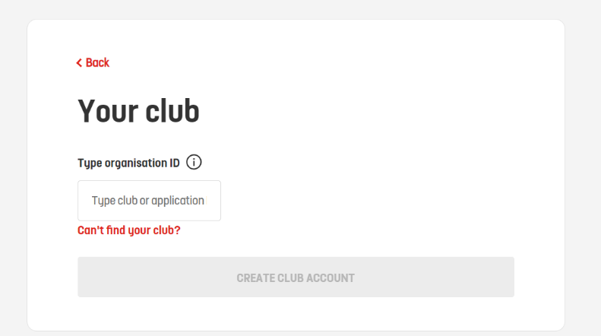

- Claim a club (Non-Affiliated Organisation)
If you’ve selected ‘No’ you will then be asked to complete the form which requires key information to set up your organisations account in book football
