To add an Administrator on Book Football, you will need to have Administrator access. You may need to check with the lead (Super) Administrator who set up your club's Book Football venue account if you do not have the correct access.

To add an Administrator:
- Click the 'Administrator' tab on the LEFT side of the screen:
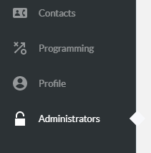
- Click the BLUE 'Add administrator' button:
- You'll then need to choose whether this person is a 'New contact' (i.e. they're not listed within your contacts module) OR an 'Existing contact' (can be found in your contacts module), if they're a NEW CONTACT, fill in the below form:
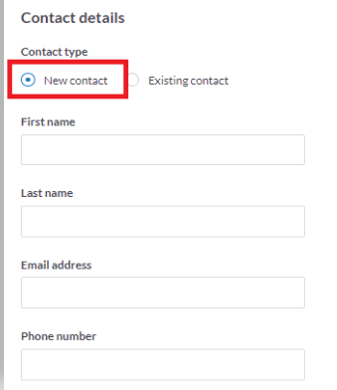
- For EXISTING contacts, you can search by name and select the applicable person in the dropdown menu.
- Choose the admin role (tick box) you wish to apply:
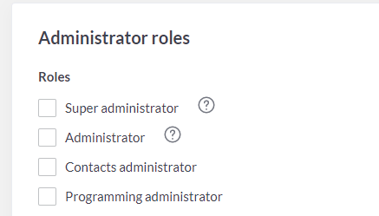

Administrator role name | How it works
Super administrator | Has access to coaching, contacts, profile and administrator modules. They can also remove admin access from others.
Administrator | Can access programming, contacts, profile and administrator modules but CANNOT remove admin access from others.
Contacts administrator | Has access to only the contacts module. They will NOT see the programming, profile or administrator module.
Programming administrator | Programming admins have access to the programming module and contacts module. They will NOT be able to access the administrator module.

6. Click 'Save' at the bottom of the page.

To 'edit' administrator rights:

- Click 'Administrators' module on left side of the screen
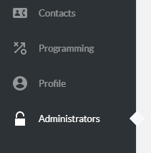
- Select the person you wish to 'edit' rights for.
- Select 'Options' and then 'Edit contact'
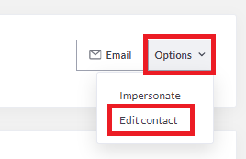
- Scroll down to the 'Administrator Roles' section and untick any options they shouldn't have and add the correct one.
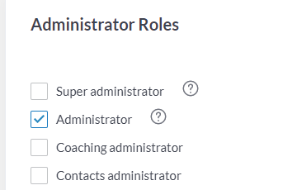

- Click 'Save contact' at the bottom of the page.

To remove administrators / admin rights:
NOTE: Only super administrators can REMOVE admin rights from an individual / contact.

1. Click 'Administrators' on the left-hand side of the screen.
2. Select the person you wish to remove.
3. Choose the 'Options' button and then 'Edit contact'
4. Untick all the admin role / notifications they have and select 'Save contact'.

