- Click 'Coaching Team' on the left and Select 'Add coach' (top right)
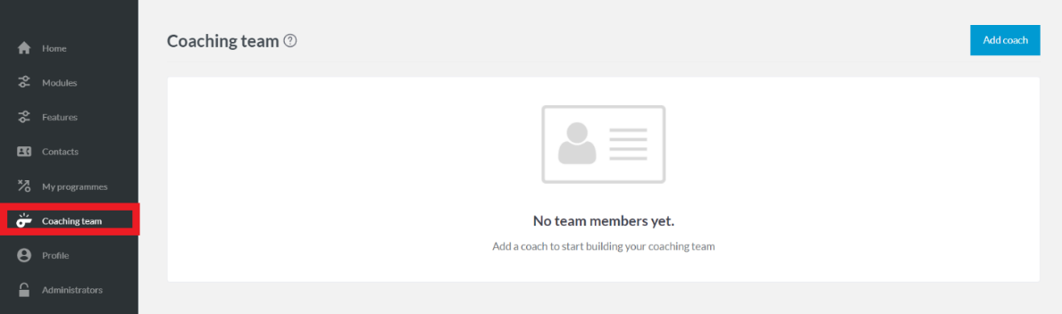
- Choose whether this is an 'Existing contact' (i.e. they're in your contacts module) or a 'New contact.
NOTE: For illustration purposes, we're showing the screen as if you were adding a new contact. Selecting 'Existing contact' will provide a search bar to type the person's name and add a dropdown.
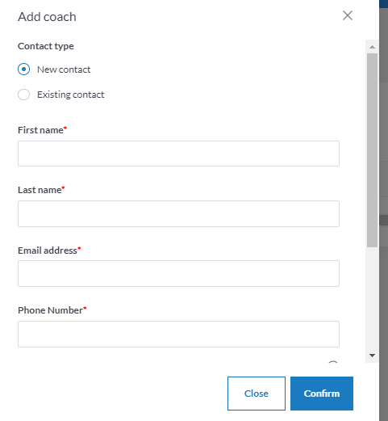
- Once you're happy with your selection / information added, choose the role for example 'Lead coach and Coach/Volunteer' as shown below. You must also add in the FAN to link the coach with their records.
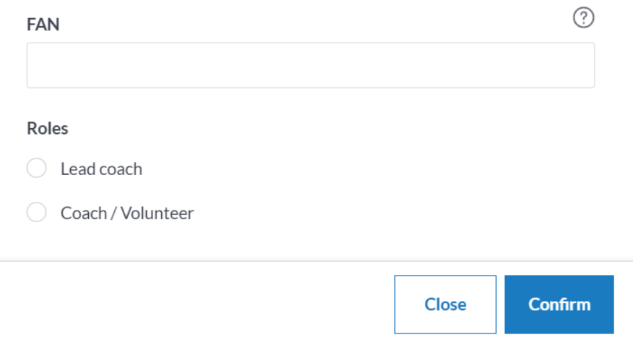
- Click 'Confirm' to save the coach to the coaching team and to use them for future programmes.
- They will be listed into the coaching team as shown below: 