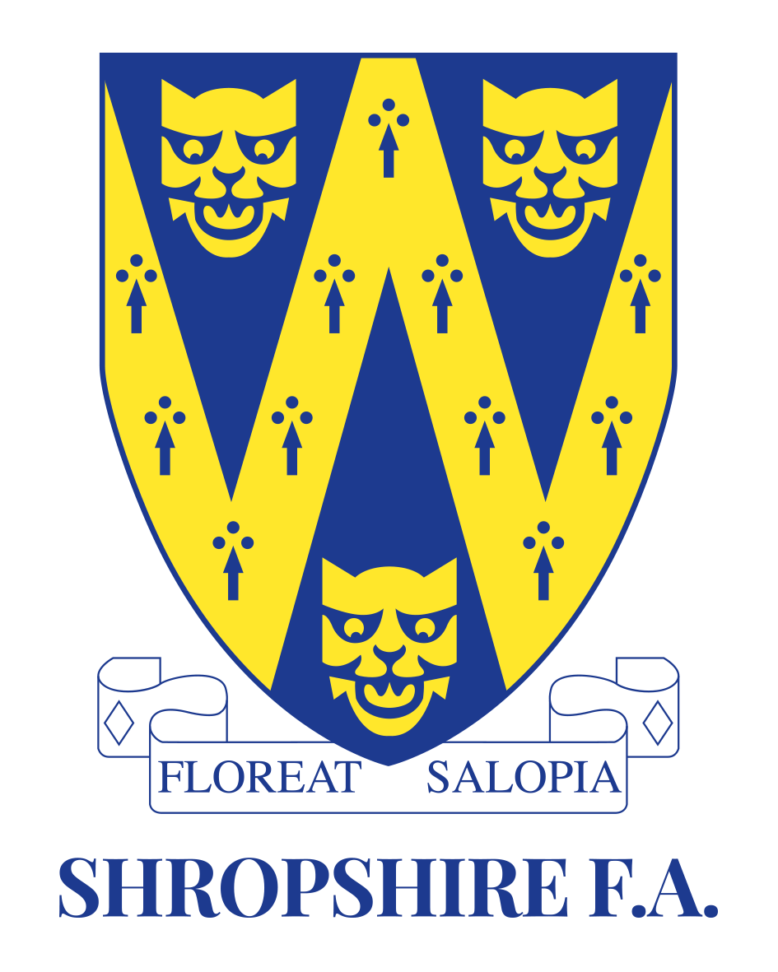

Shropshire FA
Football Festival
2018/19 Season

Shropshire FA festivals are available for affiliated boys and girls teams eligible for the under 8’s age group during the 2018/19 season. This involves players from school years 2 & 3 currently, and born between the following dates;
1st September 2010 – 31st August 2012
Games will be played in a 5-a-side format and following normal mini-soccer rules, with the emphasis on player development and a positive first experience of playing football.
Team Name
Manager
Contact Number
Email Address
Signed
Date
Festival Date
Saturday 18th May 2019 (PM) Girls
Venue
Shifnal Town FC, The Acoustafoam Stadium, Coppice Green Lane, Shifnal, TF11 8PD

Russell Meadow Playing Fields

Club

Please return completed registration forms to Darren.Beech@shropshirefa.com
Closing date for team entries is Friday 10th May 2019

