Sheffield & Hallamshire County FA Ltd.
Appointment of an Independent Trustee
Chair – Inclusion Advisory Group

Application Pack
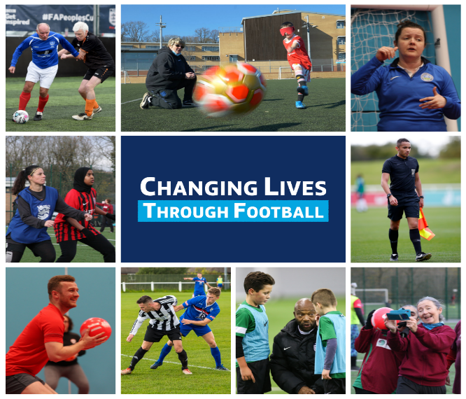
Dear Applicant,
Sheffield and Hallamshire County FA Inclusion Advisory Group (IAG) provides strategic advice and guidance on equality matters to the County FA and provides oversight of the delivery of the County FA operations plan. IAG members to consist of passionate individuals from a variety of backgrounds, experiences and perspectives to help guide and drive our work for everyone.
We are currently looking to recruit an Independent Trustee who, in addition to being a full member of the Board of Trustees (Director), will Chair and lead the IAG to support our organisation's continued progress with inclusion, diversity and equality. The successful person will have significant knowledge and experience of operating at a strategic level in either the Public or Private Sector and equally bring a breadth and depth of knowledge and experience in equality matters.
The Independent Trustee will need to be able to think strategically and have the capacity to guide the implementation of inclusion provisions across grass roots football. They will need to be an advocate of the role of football within inclusion and anti-discrimination with a proven ability to work collaboratively and challenge constructively.
This is an exciting, but challenging opportunity with the incentive of shaping our County FA’s inclusion work and positively impacting the landscape of football at every level within the County.
The pack includes the following:
  - The role advertisement
  - IAG Terms of Reference (the appointed Chair will have the opportunity to further develop these)
  - The Role Profile
  - The Application Form
This pack provides all the necessary information that you require to submit an application. Should you have any questions about the role, or require clarity on the recruitment pack, you can contact:
The Chair, Brian Coddington (brian.coddington@sheffieldfa.com) or
The CEO, Simon Frost (simon.frost@sheffieldfa.com) who will be happy to assist / discuss.

1. Independent Trustee
(Chair Inclusion Advisory Group)

This post is unremunerated
We are looking for a dynamic, self-motivated and proactive individual who wants to make a positive contribution to the strategic direction and governance of grassroots football in the Sheffield and Hallamshire area.
The person will use their experience to lead IAG members in order to identify strategic priorities and to promote inclusion and diversity throughout the organisation and across local football.
The post holder will be supported by the executive team, primarily the Inclusion and Diversity Officer, but their focus should remain on identifying and recommending strategic priorities at Board level and the signing off of annual operational plans. Detailed tactically delivery and implementation will be managed via the executive team.
The Inclusion Advisory Group will report directly to the Board, through the Independent Trustee on all matters relating to strategic progress in inclusion, equality and diversity.
There will be a minimum of four IAG meetings each season (although this could change according to need) and communication between meetings to support the County FA in delivering the National Game Strategy and its contract with The FA. There will also be a requirement to attend County FA Board meetings and National County FA Inclusion Day.
The Inclusion Advisory Group (IAG) will share their experiences and knowledge in order to help advise the Association and to embed inclusion across the County FA.

What can we offer?
- An exciting opportunity to be part of a forward thinking, progressive business.
- An opportunity to shape strategic thinking and priorities.
- An opportunity to work with key stakeholders within the grassroots game.
- Expenses in accordance with F.A policies.

How to apply:
Applications will be accepted upon the completion of the application form contained in this recruitment pack. It is essential that applicants clearly demonstrate their ability to meet the requirements of the role, explaining how their experience and skills will assist them with developing and delivering strategic priorities.

Sheffield & Hallamshire County FA is committed to creating a Board of diverse skills, experiences, and backgrounds who can add value to the game and our activities in the Sheffield & Hallamshire County FA region. We are committed to equality of opportunity and positively encourages applications from suitably qualified and eligible candidates regardless of sex, ethnicity, disability, age, sexual orientation, gender identity, religion, and belief.

To help measure our impact on inclusion and diversity we would appreciate it if you could complete The County FA’s Diversity Monitoring form along with your application. We will use your data to measure whether our vacancies and adverts are reaching people from all sections of the local community. This data will then be collected and collated anonymously.

Please take a couple of minutes to complete the anonymous online form here.

The interview process:
The date for applications to close will be at 5pm on 10th February 2023.
Applications will be shortlisted, suitable candidates will be invited for an interview.
The interviews are intended to take place week commencing 20th February 2023 and will be held at the County FA Headquarters. We can be flexible with interview times where required.
A formal induction process will take place once an appointment has been made.
This process will be adapted for anyone who has a disability or any other accessibility requirements

While previous experience in sport is not a requirement, an alignment with our vision and mission is essential. The existing Board of Trustee have outlined a preference for those individuals applying for the role, to ideally be residing within the boundary area of Sheffield & Hallamshire County FA.

2. Inclusion Advisory Group Terms of Reference

Purpose
The Inclusion Advisory Group will help shape an inclusion strategy and offer support and advice to the County FA on all issues of diversity and inclusion in order to embed inclusion across the Association.

Membership
The membership will go through an application process. Members should where possible represent the diversity of County FA and cover the range of protected characteristics, but as if not more important is diversity of experience, knowledge and thought. All members will be volunteers and will be paid travel expenses in line with F.A. policies. The IAG Chair will sit on the County FA Board

Role
The role of the Inclusion Advisory Group is to:
- Contribute to the development of strategic planning and advise on County Plan priorities to help maximise the Association’s impact on under- represented communities. e.g. diverse ethnic communities, women and girls, people with impairments, LGBT, faith communities and people of all ages.
- Foster good relationships with the local community and key local decision makers, so that football can be used to create positive sporting opportunities, bring diverse people together and increase participation
- Review the impact of the County FA’s work in relation to equality through the County plans
- Support the progress of the County FA towards achieving the next level of the Equality Standard.
- To support the executive team with specialist knowledge and guidance when required.
- To help use the power of football to help progress broader social and health agendas.

In supporting the role as defined above, the Inclusion Advisory Group may:
- Analyse data to provide intelligence and support recommendations for the County FA.
- Consult on and support the county planning process, including the setting of business objectives and targets which align to the overall strategy.
- Assess and advise on equality impacts arising out of County plans.
- Provide support to County FA’s community engagement, consultation, development programme and disciplinary procedures.
- Act as Ambassadors as appropriate for the County FA.
- Bring a diverse and inclusive perspective, mindset and culture to County FA.
- Identify key and current equality issues and support the identification and delivery of solutions.
- Advocate the benefits of addressing equality issues.
- Contribute to consultation sessions with the wider community in relation to annual County plans and general football inclusion issues.
- Promote inclusion and diversity in football. Identify key issues and trends that may promote the growth of the game through inclusion and diversity interventions.
- Meet four times a year (as a minimum, although this could change according to demand circumstances) in an appropriate format for the members of the group.

3. Independent Trustee - Chair Inclusion Advisory Group

Role Title: | Independent Trustee - Chair Inclusion Advisory Group
Role Purpose
- As a Trustee lead and support an effective, constructive and cohesive Inclusion Advisory Group
- To assist the IAG Members and all County FA staff to plan, lead and develop a strategic vision for inclusion in football within Sheffield and Hallamshire County Football Association.
- To report and feedback on the delivery of Inclusion to County FA Board and Council
Principal Accountabilities/Responsibilities
Governance
- To represent the IAG on County FA matters
- To attend any national or regional FA inclusion events (where possible and relevant)
- To attend County FA Meetings as and when required and when reasonable
Agendas, Papers/packs and Presentations
- To support the recruitment of and inspire the very best and talented IAG team possible
- To ensure the performance of the IAG is measured and accountable where possible
- To assist in the preparation of the Agenda for IAG meetings
- To work closely with the County FA CEO, Chair, fellow Trustees and all County FA staff where relevant to ensure resources are effectively prioritised for inclusion and that inclusion is embedded across all County FA work and staff
- To ensure that IAG action points are documented and actioned.
Strategy & Vision
- To be a key person Is shaping a County FA strategy for Inclusion.
- To support work around maintaining the current and/or progressing to the next level of the Equality Standard for Sport, including the creation of a robust Equality Action Plan to sit alongside, compliment and be part of County FAs wider operations plan.
- To liaise with the IAG Working Group to ensure IAG work remains strategically focussed and supports the attainment of FA KPIs and the County FA broader strategic aims.

Knowledge/Experience/Technical Skills
Essential  - Have a working knowledge of the key legislation around inclusion and diversity  - Promote inclusion and diversity as part of a group  - Identify key issues and trends that may help to promote the game through inclusion and diversity interventions  - Ability to meet and work outside of normal working hours  - Successfully network with key staff and contacts within County FA and the areas in which County FA operates  - Be able to plan, drive and Chair meetings  - Ability to communicate effectively and confidently, both in written form and verbally  - Positive attitude to the requirements of the role  - Capacity to handle confidential information sensitively  - Work as part of a team  - Ability to work in a professional manner as a representative of the County FA | Desirable  - A degree of experience of the sports/football industry  - Have existing positive contacts within the sports/football industry and the wider community  - Have existing contacts within local community groups  - Have knowledge of existing equality groups in the local area  - Ability to review and analyse data to assist in making informed decisions  - Ability to work strategically to engage under represented communities  - Experience of strategy planning/consultation  - Good presentation skills

4. Application Form

Personal Details

Surname: |  | Forename:
Address:
Postcode:
Home Telephone No: |  | Daytime No:
Mobile No:
Email Address:

Please tell us how you meet the IAG Chair role profile as shown above.

Please tell us your reasons for wanting to be on this Inclusion Advisory Group.

Please give details of any other skills (professional/life skills), interests or experience you have that may be beneficial to you undertaking this role with County FA.

Please complete and return this form via email to simon.frost@sheffieldfa.com
Closing date for applications: 10th February 2023
Applicants will be invited to interviews w/c 20th February 2023

Thank you for taking the time to apply for the voluntary Board positions at Sheffield & Hallamshire County Football Association.

