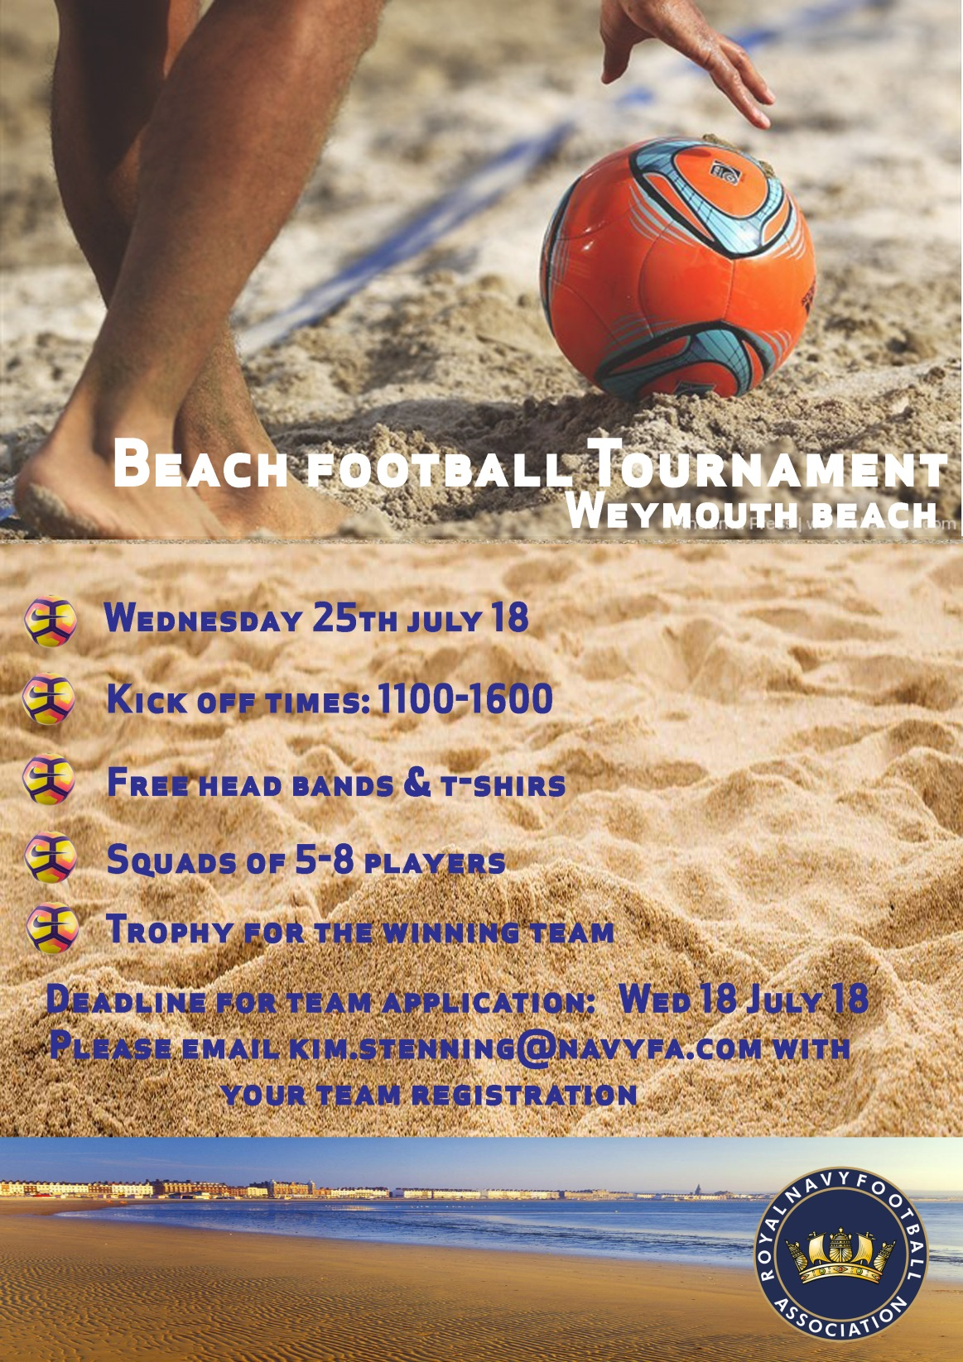 | Beach Soccer Tournament  WEYMOUTH  Team Entry Form  TEAM NAME:  TEAM ORGANISER NAME:  DATE OF BIRTH:  ADDRESS:  POSTCODE:  PHONE:  EMAIL:  By submitting this entry form, I confirm that have read, understood and agree to adhere to the competition rules on behalf of the above named team.  Signed:  Date:  Please return this entry form by Wed 18th July 18 email to  Kim.Stenning@NavyFA.com  Entries must be received by.

