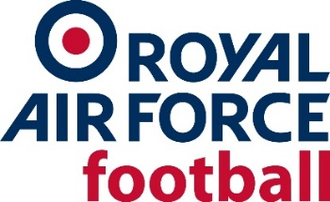
Royal Air Force Football Association - INDEPENDENT NON-EXECUTIVE DIRECTOR(S)
The Royal Air Force FA aims to deliver the RAF Football Association Strategy and Vision and meet the (FA endorsed) strategic objectives cited within the 2021-2024 Business Reset Strategy. Key to this is the objective to, ‘Re-generate, evolve and expand participation at all levels, providing opportunities for all’. To support this aim, we are seeking to appoint 3 Independent Non-Executive Directors to join the Board of Trustees.
The RAFFA Governance Structure
The Board of Trustees direct the business of the Association, determining the vision and strategy, the plans, policies and financial management required to achieve the Association's aims. Sitting below the Board is the Executive Committee which implements the strategic plan and drives the business.
The Challenge
Our mission is to inspire people from all communities to engage with football at all levels and in all its formats. We are seeking individuals who share our vision for high business standards and value the work that we do to develop football for young people and adults in a safe, enjoyable and inclusive environment.
Role Requirements/Commitments
In order to support the full breadth of the activities of the Board, the Association is ideally looking for individuals with backgrounds, experience and skill sets in any of the following areas:
- Board Experience:
  - Sport
  - HR/Finance/Marketing/Digital
- Charitable sector
The Association would particularly encourage applications from under-represented groups including women, young people, ethnic minorities and people with disabilities.
This voluntary role involves a minimal time commitment with regular scheduled Board meetings (currently held online during normal working hours); some additional email or telephone contact may be necessary as well as occasional meetings with the Chairman, CEO or Board members to provide guidance on the running of the Association. Reasonable expenses will be remunerated as required.
How to apply
A more detailed role profile is included with this advert. If you are interested in this exciting opportunity to join the governing body for football in the Royal Air Force, please send a CV along with a covering note outlining your suitability and reasons for wanting the post to secretary@royalairforcefa.com. Closing date for applications is 14 March 2022 with interviews planned for late March/early April and appointment soon after.
The Royal Air Force FA is committed to equality of opportunity and welcome applications from all sections of the community.

https://www.thefa.com/-/media/cfa/royalairforcefa/files/stratagies/raf---2021-24-business-reset-strategy_v7.ashx?la=en

