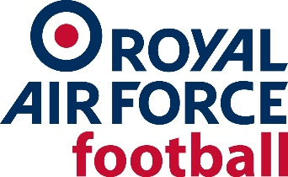

JOB TITLE: RAF FA Ladies Representative Team Manager
ORGANISATION: RAF Football Association, RAF Brize Norton.

ROLE
1. Manage the RAF Ladies Representative Team.
POST DESCRIPTION
2. Provide management and leadership to ladies' representative football in order to set the conditions to achieve success.
3. Responsible for ensuring that the values and standards are of the highest order and contribute to the development of a ‘one club’ ethos.
4. The post holder works to the Director of Representative Teams (Wg Cdr John Hetherington) and directly under Chief of Staff RAF Representative Football (Sqn Ldr Scott Hyndman).
POST REQUIREMENTS
5. The post holder should be an individual on the coaching pathway and ideally has experience within female football. The appointment requires outstanding interpersonal and leadership skills and the ability to communicate effectively both up and down the organisation. The post holder should understand the complexities of wider Service football and be able to act as an ambassador for RAF football.
SPECIFIC RESPONSIBILITIES
6. The post holder is responsible for the following tasks:

- Managing the Ladies Representative Team.

- Co-ordinate Coaching Staff and Coaching camps.

- Working with the General Manager to set the highest standards for players and staff at all times.

c. Ensure that all Staff/Players have a clear understating of a well-developed playing philosophy.
- Work with units and the RAF FA regarding player development and identification.
- Represent the RAF FA at RAF football events throughout the season; including, but not limited to: the RAF Cup Final and Festival of Football.

- Ensure team admin is completed professionally in conjunction with the General Manager.

- Meeting safeguarding requirements as required.

CORE COMPETENCIES
7. The following core competencies are required:
Competence 1 – Coaching – A minimum level 2 working towards UEFA B at appointment
Competence 2 – Management and Leadership.
Competence 3 – Communicating and Influencing.
Competence 4 – Planning and attention to detail.

The RAF FA aims to ensure that no role applicant suffers discrimination because of any of the protected characteristics as outlined in the Equality Policy. Our recruitment procedures are reviewed regularly to ensure that individuals are treated based on their relevant merits and abilities. Role selection criteria are regularly reviewed to ensure that they are relevant to the job and are not disproportionate.

Applications accompanied by a Football CV are to be submitted to the Secretary of the RAF Football Association, Mr Vince Williams (vince.williams@royalairforcefa.com) Closing date 25th March 2022.

