Role Profile
Job title | RAF Football Association - Chief Executive Officer
Reports to: | Chairman | Jobs Reporting into the Job Holder: |  | All Members of RAF FA Executive Committee  (Organisational Chart Attached)
- Job Purpose
To deliver the RAF Football Association Strategy and Vision and meet the (FA endorsed) strategic objectives cited within the 2021-2024 Business Reset Strategy. Key to which is the objective to, ‘Re-generate, evolve and expand participation at all levels, providing opportunities for all’.

- Principal Accountabilities/Responsibilities
Supported by all members of the Board and RAF FA Executive Committee, you have the following responsibilities: •

- Ensure the safe delivery of Stn, pan-service and regional tournaments from Grassroots football through to Senior Representative Level.
- Delivery of suitably qualified officials, coaches and medical staff to support all levels of football.
- Constant engagement with the RAF FA HQ Permanent Staff to maintain the appropriate blend within the Association between the HQ and the volunteer cadre.
- Chair the RAF FA Executive Committee Board; commitment is 6-8 meetings per year.
- Sit as a Trustee on the RAF FA Board of Trustees; commitment is 3-4 meetings per year.
- Liaison with the RAF FA Inter-Stn League Chairmen.
- Delivery of Elite Football within the RAF.
- Operational Leadership and Guidance for the 5 x Representative Teams.
- Liaison with the RAF FA Veterans Community.
- Support the RAF FA Chairman in the delivery of football.
- Provide guidance and oversight in support of the Chair, who acts as the Responsible Person for the RAF FA and owns the Association Safety Management Plan.
- Sit on the RAF FA Board of Trustees as a nominated Trustee.
- Lead the delivery of the RAF Cup and RAF FA Festival of Football.
- Oversee programmes/projects to deliver the targets to retain and grow participation for male, women and BAME players across all football formats.
- Contribute to raising the profile and the perception of the RAF FA in leading and developing grass roots football.
- Identify, manage and develop relationships with key partners (including sponsors) to meet the objectives and targets of the RAF FA.
- Undertake and support the compliance of Safeguarding 365.
- Responsibility for safeguarding policy to protect vulnerable people engaged with the Association.
- To support the England Football Accreditation Programme.
- Support the delivery of the Association’s 3-year business strategy, annual operational plan and FA KPIs
- Promote an inclusive working environment.

- Knowledge/Experience/Technical Skills/Behaviours
- Knowledge/Experience/Technical Skills/Behaviours
Essential: |  |  | Desirable:
· Developing goal setting/strategic delivery plans  · Monitoring and evaluation  · Project management skills/experience  · Budget management skills/experience  · Managing Teams |  |  | · Knowledge of the structure and organisations within RAF FA  · Demonstration of equality in action  · Practical experience of Sports / Football Development  · Demonstrate a working understanding and application of inclusion, equality and anti - discrimination, safeguarding and best practice  · Ability to work with partner organisations to deliver Football Development objectives  · OF5/OF6
b) Key skills – as defined in County Football Association Competency Model |  |  | Key Information
· Problem Solving  · Teamwork  · Communicating  · Delivery  · Customer Excellence  · Developing Self and Others  · Leadership |  |  | - Essential that the selected individual is currently serving and of sufficient experience to run and manage the largest Sports Association in the RAF: OF5 rank or above is recommended.  - Time commitment demands weekly engagement, with higher periods of activity through the Feb-Apr timeframe.  - Some form of indication of a time commitment, especially as we are looking likely to be looking internally at a serving officer
Further Information
- Will the job-holder have direct access to young persons under the age of 18, within the context of the job or any subsequent related activities or responsibilities? NO

Completed by Name/Role Signature Date
Signature
Date

This job description is only a summary of the role as it currently exists and is not meant to be exhaustive. The responsibilities/accountabilities and skills/knowledge/experience/behaviours might differ from those outlined and other duties, as assigned, might be part of the job.
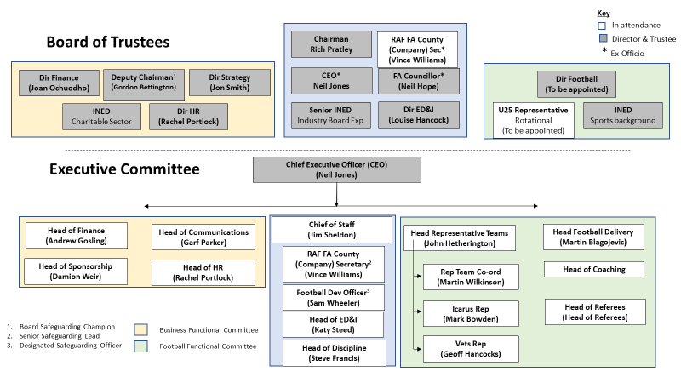

https://www.thefa.com/-/media/cfa/royalairforcefa/files/stratagies/raf---2021-24-business-reset-strategy_v7.ashx?la=en

