Role Profile
Job title | RAF Football Association – Independent Non-Executive Director
Reports to: | Chairman | Jobs Reporting into the Job Holder: |  | N/A
- Role Purpose
To provide independent expert guidance and support to the RAFFA as it aims to deliver the RAF Football Association Strategy and Vision and meet the (FA endorsed) strategic objectives cited within the 2021-2024 Business Reset Strategy. Key to which is the objective to, ‘Re-generate, evolve and expand participation at all levels, providing opportunities for all’.
- Principal Accountabilities/Responsibilities
Supported by all members of the Board and RAF FA Executive Committee, you have the following responsibilities: •

- Sit as an independent advisor to the RAF FA Board of Trustees; commitment is 3-4 meetings per year plus ad hoc meetings/calls as required.
- Support the RAF FA Chairman in the delivery of football.
- Provide guidance and oversight in support of the Chair, who acts as the Responsible Person for the RAF FA and owns the Association Safety Management Plan.
- Contribute to raising the profile and the perception of the RAF FA in leading and developing grass roots football.
- Identify and help develop relationships with key partners (including sponsors) to meet the objectives and targets of the RAF FA.
- Help support the delivery of the Association’s 3-year business strategy, annual operational plan and FA KPIs.
- Promote an inclusive working environment.

- Knowledge/Experience/Technical Skills/Behaviours
- Knowledge/Experience/Technical Skills/Behaviours
Essential: |  |  | Desirable:
· Developing goal setting/strategic delivery plans  · Monitoring and evaluation  · Project management skills/experience  · Budget management skills/experience |  |  | · Experience within the following key areas:  - Board Experience:  - Sport  - HR/Finance/Marketing/Digital  - Charitable sector
b) Key skills – as defined in County Football Association Competency Model |  |  | Key Information
· Problem Solving  · Teamwork  · Communicating  · Delivery  · Customer Excellence  · Developing Self and Others  · Leadership |  |  | - Time commitment requires attendance at Board mtgs (either virtually or in person) and additional calls, mtgs with Chairman and/or Board of Trustee members to advise as required.  - Travel expenses will be re-imbursed in line with HMRC guidelines.  - Appointment will be for 3 x 3 years by mutual agreement.
Further Information
- Will the job-holder have direct access to young persons under the age of 18, within the context of the job or any subsequent related activities or responsibilities? NO

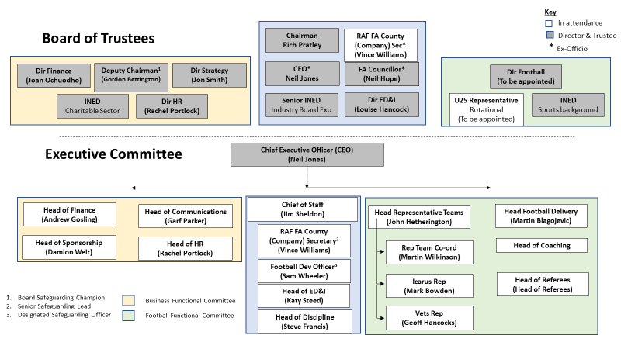

https://www.thefa.com/-/media/cfa/royalairforcefa/files/stratagies/raf---2021-24-business-reset-strategy_v7.ashx?la=en

