UK ARMED FORCES FOOTBALL

Formed in 1922 as the Combined Services Football Association to provide a platform to promote the image and improve the standard of football for those serving in the Royal Navy, British Army and the Royal Air Force.
The best players from all 3 Services have the opportunity to play together at a higher level which at the same time provides the means to support Defence Engagement Activities, where the opportunity and resource exists to do so.
The Men’s team main competition is the annual Kentish Cup (details below) whilst over the years the team has toured world-wide including to China and New Zealand. In more recent times a prestigious annual fixture against the Irish Defence Force has and continues to be played.
In 1999 the Combined Services Women’s team was formed and have played various friendly fixtures against the likes of Liverpool Ladies and Lincoln City Ladies. In 2016 the Presidents Cup was formalised, this being an annual fixture competed for between the Women’s Teams of the UK Armed Forces and Royal Netherlands Combined Services.
In 2016 the Combined Services Football Association became known as UK Armed Forces Football and works above the 3 Single Service Football Associations.
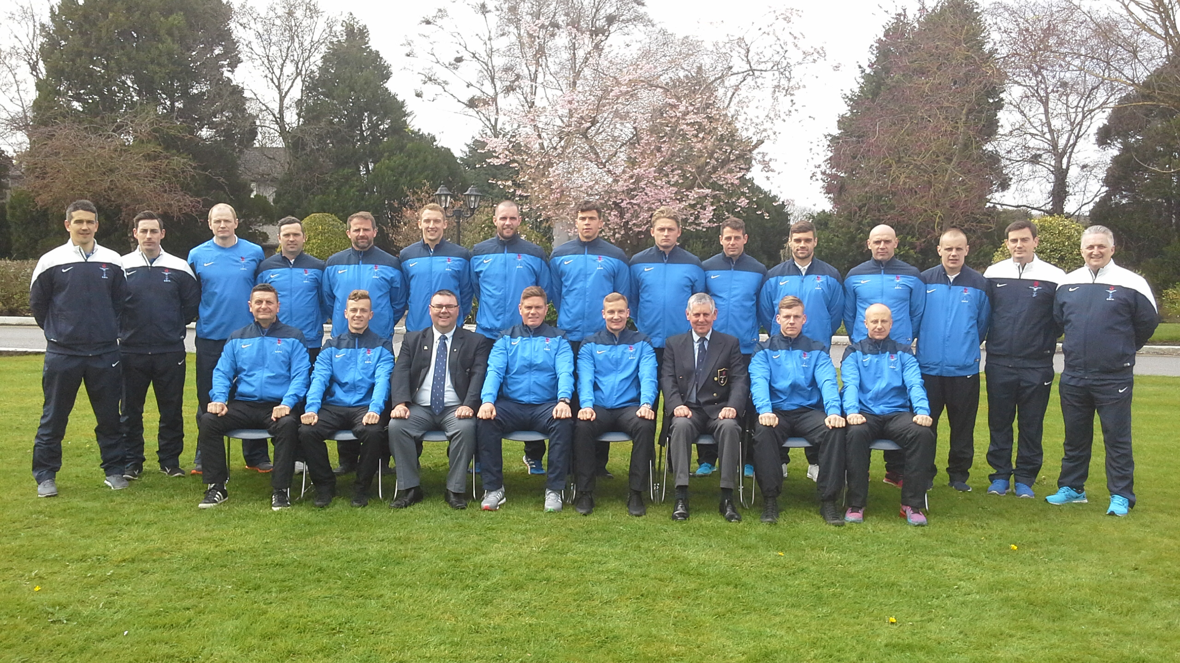

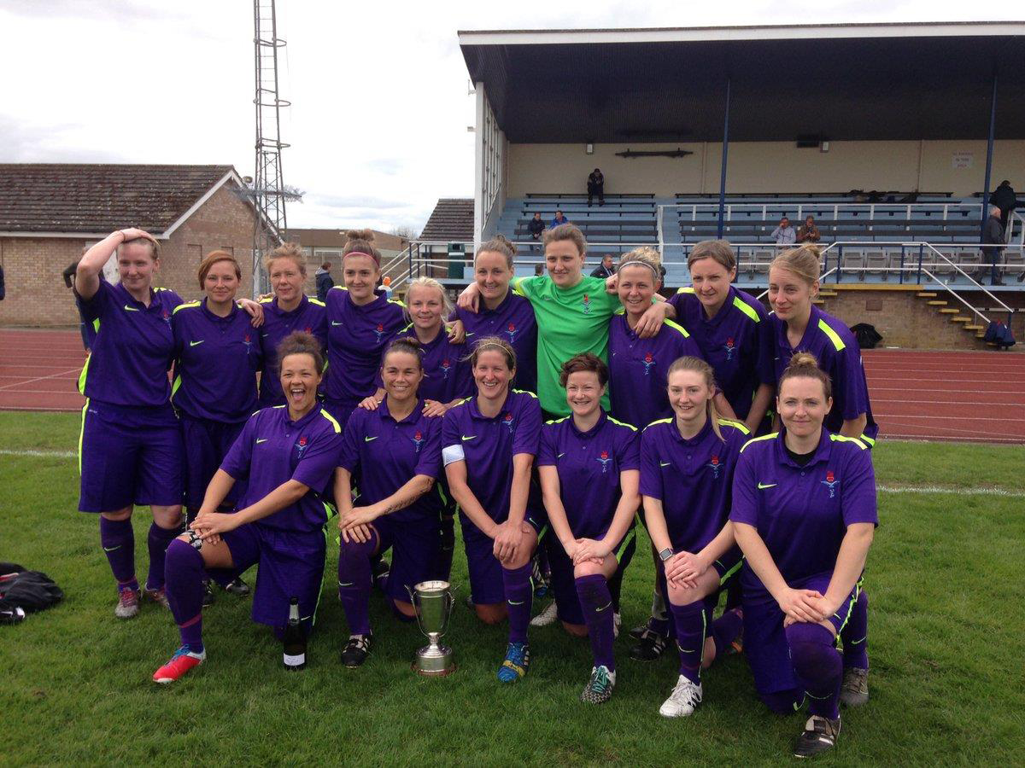
KENTISH CUP

The Kentish Cup is named after Brigadier General R J Kentish CMG DSO and was first played for in 1921 with the purpose of fostering relations between Armed Forces. The tournament was first played for between The British Army, French and Belgian Forces. The British Army handed the competition to the Combined Services Football Association in 1980 as conscription was still introduced in The Belgian and Dutch Armed Forces and the level of players available to those countries included international (professional) players.

The triangular tournament was cancelled during the Second World War and when France withdrew in 1986 the Netherlands took over. France came back into the competition in 2005 when Belgium withdrew.

The competition is recognised by UEFA and FIFA as the oldest Cup competition in Europe.

WINNERS KENTISH CHALLENGE CUP
1921 – 2017

Year | Winner | Year | Winner | Year | Winner
1921 | UK | 1959 | France | 1989 | UK
1922 | UK | 1960 | France | 1990 | Belgium
1923 | Undecided | 1961 | France | 1991 | Belgium
1924 | Belgium | 1962 | UK | 1992 | Belgium
1925 | Belgium | 1963 | France | 1993 | Belgium
1926 | Belgium | 1964 | UK | 1994 | Netherlands
1927 | UK | 1965 | France | 1995 | Netherlands
1928 | UK | 1966 | France | 1996 | UK
1929 | France | 1967 | Belgium | 1997 | Netherlands
1930 | Belgium | 1968 | Belgium | 1998 | UK
1931 | UK | 1969 | UK | 1999 | Belgium
1932 | Belgium | 1970 | UK | 2000 | Netherlands
1933 | Belgium | 1971 | France | 2001 | Netherlands
1934 | France | 1972 | France | 2002 | Netherlands
1935 | UK | 1973 | Belgium | 2003 | UK
1936 | France | 1974 | Belgium | 2004 | UK
1937 | France | 1975 | Belgium | 2005 | UK
1938 | France | 1976 | Belgium | 2006 | Netherlands
1939 | Belgium | 1977 | Belgium | 2007 | France
1940-1946 | No competition | 1978 | Belgium | 2008 | France
1947 | Undecided | 1979 | Belgium | 2009 | France
1948 | UK | 1980 | Belgium | 2010 | UK
1949 | France | 1981 | France | 2011 | France
1950 | France | 1982 | France | 2012 | France
1951 | Belgium | 1983 | France | 2013 | Netherlands
1952 | UK | 1984 | UK | 2014 | UK
1953 | UK | 1985 | France | 2015 | No competition
1954 | France | 1986 | Belgium | 2016 | UK
1955 | Belgium | 1985 | France | 2017 | UK
1956 | France | 1986 | Belgium
1957 | Belgium | 1987 | Belgium
1958 | France | 1988 | Netherlands

Number of Championship Wins as at 2017 (97 years in existence)
Country Wins
Belgium 27 Undecided in 1923 & 1947
UK 24 No competition 1940-1946 and 2015
France 27
Netherlands 9 Total 97

