TAKING FOOTBALL TO AFRICA AND BEYOND CHARITABLE APPEAL

REPORT ON NEPAL VISIT – 14 DEC TO 29 DEC 2017

On behalf of the Taking Football to Africa and Beyond Charitable Appeal a team of 12 people travelled to Nepal on 14th December 2017 to complete a range of deliveries across the country in association with the Gurkha Welfare Scheme (Trust).

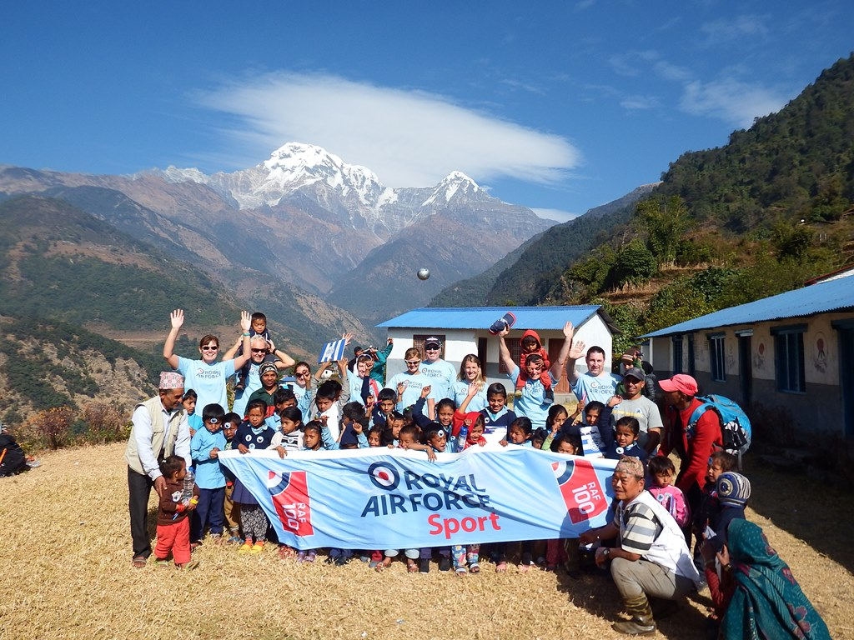

Travelling Party:

Wg Cdr Neil Hope MBE – Appeal Organiser – SO1DAAM – RAF Shawbury
Wg Cdr Chris Skaife – Defence College – Shrivenham (ex OC PMS RAF Shawbury)
Sqn Ldr Gary James – Station Flight Safety Officer – RAF Shawbury
Sqn Ldr (Retd) Sue Crooks – ex CATCS Instructor RAF Shawbury
Flt Lt (Retd) Tony Kinchley – Appeal Team – Cobham Instructor SAOC RAF Shawbury
Flt Lt Suzi Mitchell – PSO to AOC 2 Gp - HQ Air Command, RAF High Wycombe (soon to be Sqn Ldr – SATCO RAF Linton On Ouse)
Flt Lt Izzi Tierney – Instructor SAOC RAF Shawbury
Flt Lt Nic McNamee – Physio RAF Leeming (ex RAF Shawbury)
Flt Lt (Retd) Gary Rogan – ex DHFS Instructor RAF Shawbury
FS Louise Simpson – Appeal Team – Instructor SOAC RAF Shawbury (soon to be Warrant Officer staying at Shawbury)
Mrs Sandra Nevins – Cobham RAF Shawbury
Mr Alan Fish – Coolwater Direct/Tiger Moth Experience – RAF FA Sponsor

Travel:

Most of the team met at Birmingham Airport and flew together on Qatar Air via Doha. Gary Rogan met the team in Doha having flown from his home in Spain. Suzi Mitchell travelled separately to the team via Istanbul and Alan Fish via Bangkok. The team met up in Kathmandu at their first hotel, the Kathmandu Grand Hotel in Thamel following a one hour transit from the airport thorough very congested dusty polluted roads with little organisation. The hotel was comfortable with a warm welcome from the owners. Following arrival Neil Hope and Tony Kinchley met with Capt (Retd) Purna Limbu, the Senior Area Welfare Officer for the Bagmati Region for the Gurkha Welfare Scheme and also with the owners of Himalayan Ecstasy, the Trek company for the Annapurna Trek.

Kathmandu:

16 Dec – The team were met at the hotel by Capt (Retd) Purna Limbu for a full day of deliveries in the Kathmandu area. The Gurkha Welfare team had earlier organized the boxes sent over the previous 18 months, to Nepal by the Appeal. A total of 14 boxes of kit had been delivered in preparation for the visit and the team carried an additional 6 kitbags of items with them.

On meeting the team we were astounded to realise that Purna and Gary Rogan had previously crossed paths, whilst not actually realising it. On 1 June 1982 Gary, as a Sgt Crewman on the famous Chinook BN, had transported Purna, as a young Rifleman in 7th Gurkha Rifles from San Carlos Bay to Goose Green in the Falklands War.

The first delivery of the day was at the Hindu Higher Secondary School, Kageswari Manahara. At the school the team were met by the Headmaster and some teachers and students. Following some brief introductions the team handed out items of kit and then joined the boys for a football match, whilst the girls played a separate game. The schools were very accommodating and provided the team with jam sandwiches and hot tea. The team also took time to explain why they were there as well as explaining that the visit corresponded with the beginning of the RAF’s 100th Anniversary.

The next delivery was at the Siphal Orphanage. The orphanage also has a small home for children with disabilities. The team handed out items including football shirts and pens and pencils and spent time chatting and playing with the children as well as visiting the bed bound children and adults with disabilities.

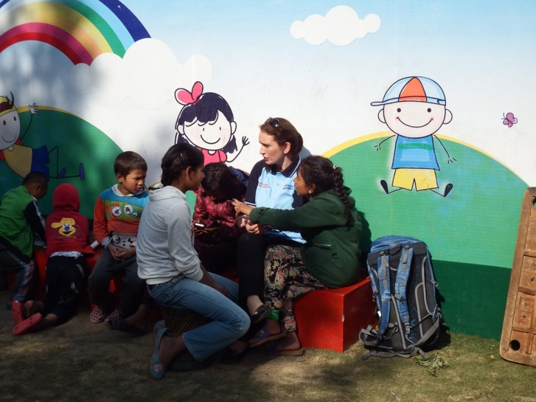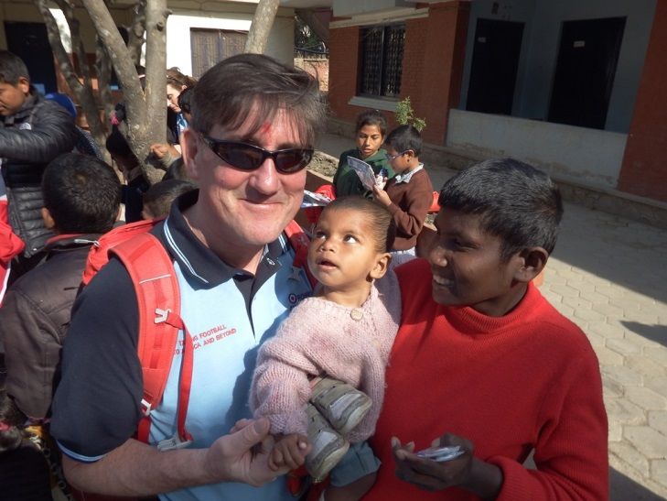

The final delivery in the Kathmandu area was at the Lalitpur orphanage. Again, the team were warmly welcomed and handed out kit to the children, which again included children with disabilities. Furthermore some members of the team had an impromptu football match with the children.

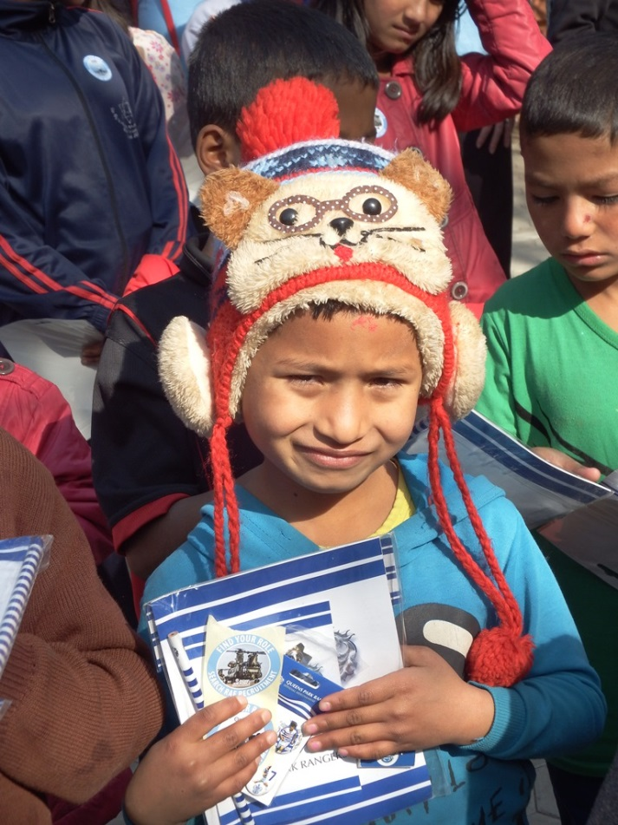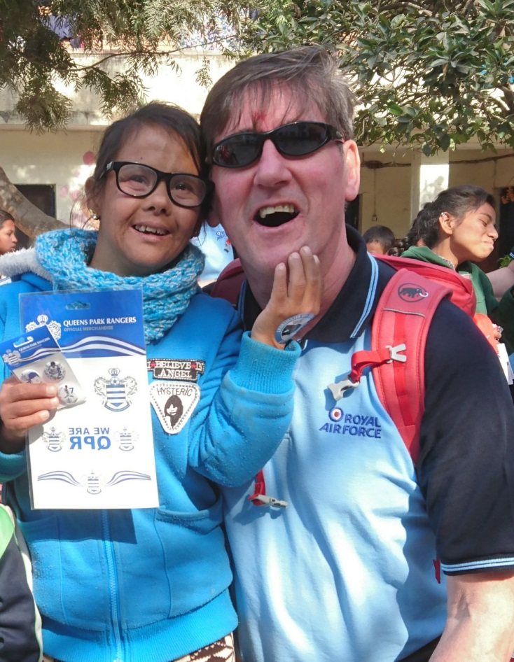
Following a period of downtime the team prepared to move on the next leg of the visit to Pokhara.

17 Dec – The team split into 2 groups for the short flights to Pokhara. Team one had a seamless transfer to the airport for their flight with Yeti Airlines. The 2nd group were not as lucky and took well over an hour to get through the busy Kathmandu traffic arriving in time to run through the domestic terminal to make their flight on Simrik Airlines. The flights, however, went well allowing the team a 25 minute fabulous view of the Himalayas followed by a 90 degree turn on short finals for the hair-raising landings at Pokhara. On landing and disembarking the team got an excellent view of the incredible Mt Machapuchare, known as the ‘Fish Tail’. The Fish Tail sits behind Pokhara and is 22793ft high with many of the 25000ft plus peaks of the Annapurna Range sitting beyond it. Pokhara is very different to Kathmandu with the main tourist area sitting on the edge of the beautiful Lake Fewa. In comparison to Kathmandu it is a much cleaner town. The team arrived and settled into their hotel, the Hotel Splendid View.

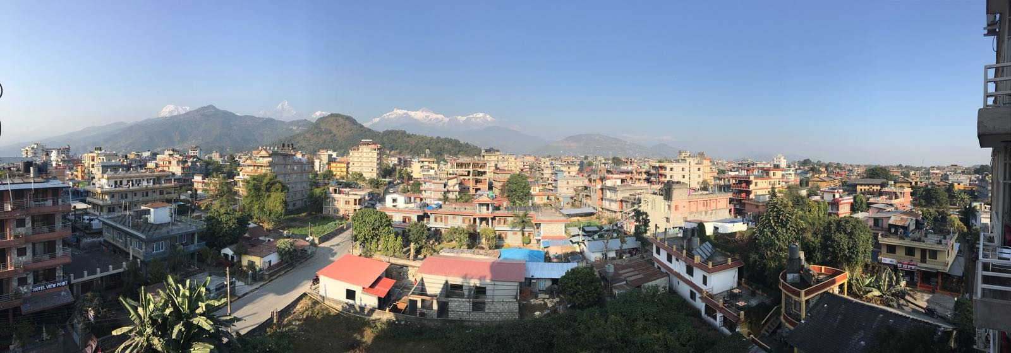

18 Dec – The team travelled through Pokhara to the Headquarters of the Gurkha Welfare Scheme. The Scheme is a UK charity working with the Ghurkhas. In the UK the Scheme is known as the Trust. The HQ is also the place that attracts up to 10000 Nepalese each year, all hoping to qualify for one of the 200 or so places in the British Gurkha Regiments. They also recruit for the Singapore Police and the Indian Gurkha Regiments.

At the HQ the team were met by Capt (Retd) Pimbahadur Gurung. Pim had already been of great assistance to the Appeal as he is the contact in Nepal and also the man that had re-sorted all of the kit ready for distribution. Pim will also ensure that items not delivered during the teams visit would be properly distributed across Nepal through the Trust. The team also met with Lt Col John White, the head of the Earthquake Response Teams. John gave the team a full brief on the ongoing efforts in relieve of villages and Gurkha families affected by the massive Earthquakes in 2015. The brief was incredibly interesting and showed how extensive the efforts had to be following the extensive damage the Earthquakes caused. The team then had coffee in the Officers’ Mess before setting off to complete the day’s deliveries.

First delivery of the day was at Shree Mahendra Secondary School at Lahachock in Machapuchare Rural Municipality in the foothills above Pokhara. The journey to school was up a very steep mountain road which was only accessible by 4 wheel drive land rovers from the Ghurkhas. The school was home to 315 children, who were currently sitting exams. The team were met by the Headmaster, Mr Govinda Prasad Adhikari, a previous pupil, who briefed on the school. The team then had a tour of the school and met many of the children before handing out items of the kit.

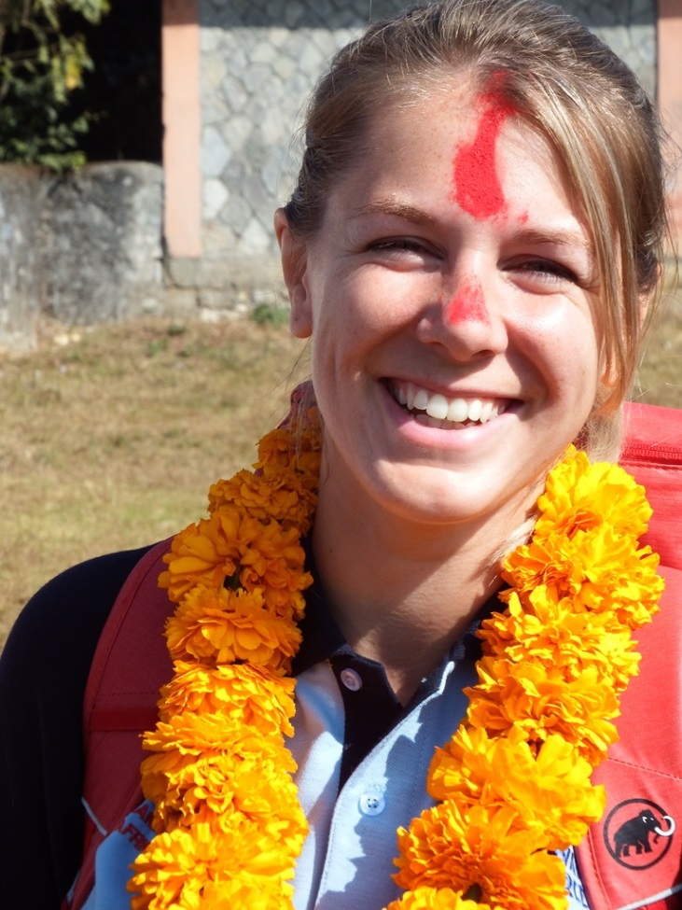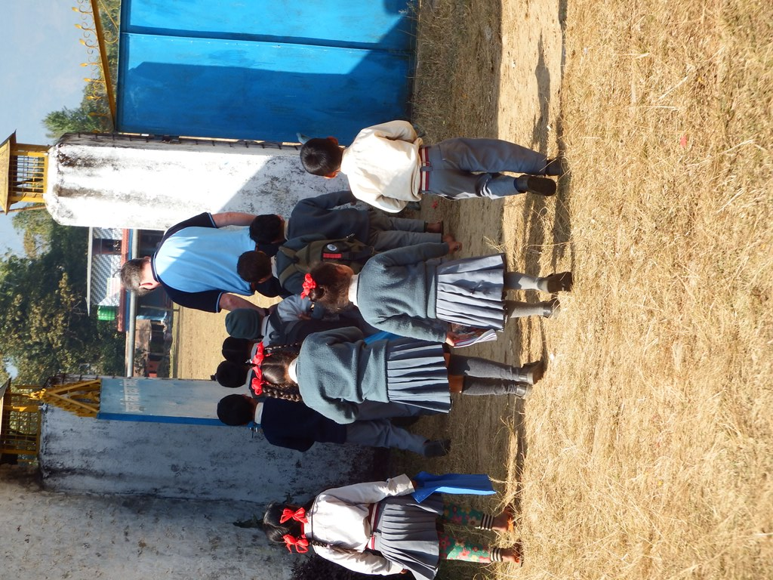

Next the team travelled back into the centre of Pokhara to visit the Shree Bindhyabasini Secondary School. The team were briefed by the headmaster, Basanta Raj Pandy and took tea before meeting some of the schools 500 children and handing out football kit. It was interesting to note that the plaque at the entrance stated that the school was opened in 2021! This is due to it currently being 2074 in the Nepalese calendar.

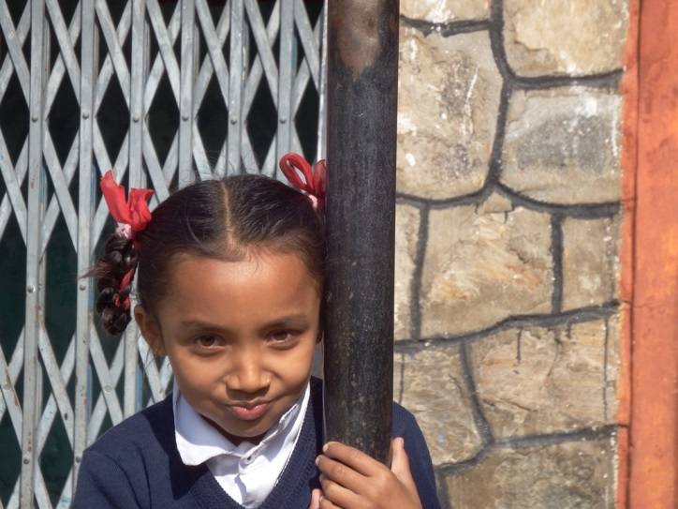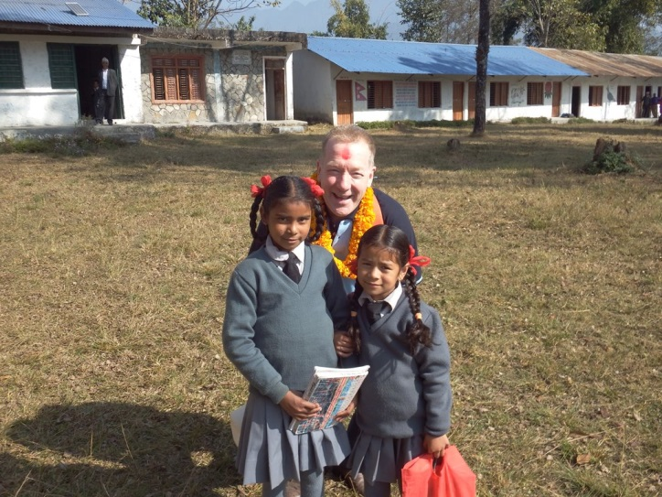

The final school of the day was the Shree Amar Singh Secondary School. This was a huge school with over 3000 pupils and 200 teachers!

Final call of the day was to the Gurkha Welfare Scheme Residential home, AWC Kaski. Kaski is the region in which Pokhara sits and the home provides Residential live in care and accommodation for ex Ghurkhas and their spouses as well as widows. The centre also has a Medical centre providing for residents as well as Ghurkhas and families. The team were shown around by Pim and spent time chatting with residents.

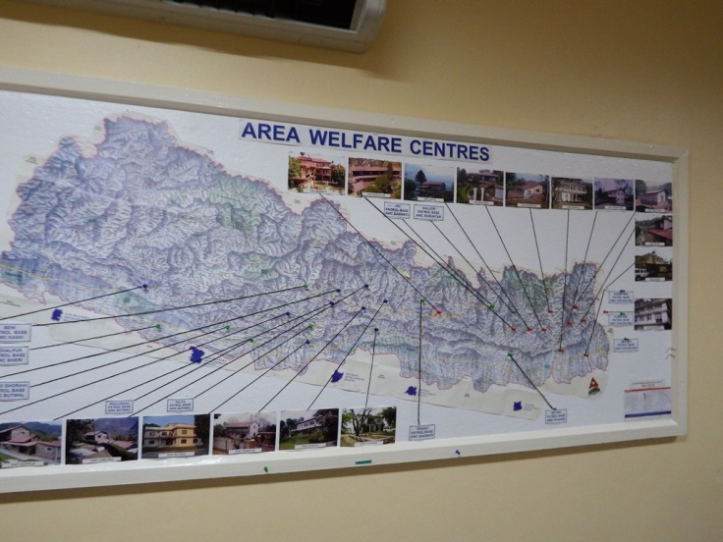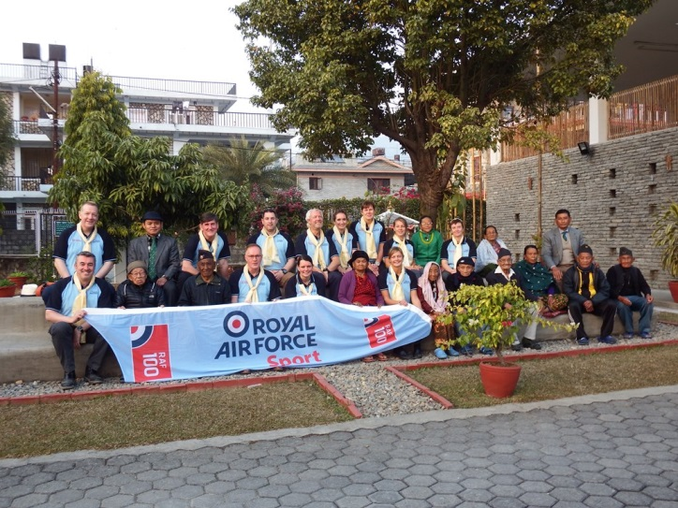

19 Dec – An early start saw the team head out for the beginning of the Trek in the foothills of the magnificent Annapurna Range. The journey took around 2 hours with a slight delay due to the
attempted recovery of a lorry which had driven off the side of the road and down a 300ft ravine! Eventually, the team disembarked, at Nayapul, met with their Sherpa guides and collected sleeping bags before starting the days trek to the night stop at Tikhedhungga. The beginning was eventful as just 6ft into the Trek, Neil Hope, slipped and fell off the side of the trail, falling several hundred feet…….ok….3 feet into a gully. A good start!! Unfortunately, Alan Fish was not feeling well and it was obvious, after just a couple of hours of continuous climbing, that he was not going to be able to continue the Trek. He was assisted back to the start and returned to the hotel in Pokhara. Unfortunately, Alan was not well enough to continue and subsequently returned to the UK in time for Christmas. En route the team visited the first school of the trek when they delivered kit at the Shree Birethanti Secondary Human School to meet the principal, Prem Bahadur Thapa and some of the 212 children to present some kits. The first night was spent in the Chandra Guest House at the village of Tikhedhungga with fantastic views of the hills and mountains. The rooms were adequate with some getting hot showers although the night time temperatures were extremely cold.

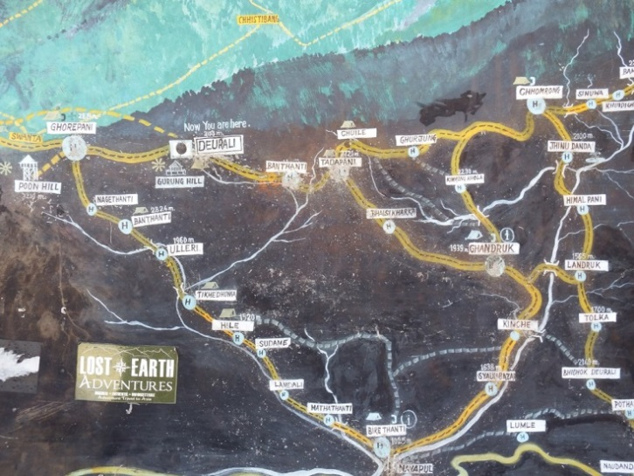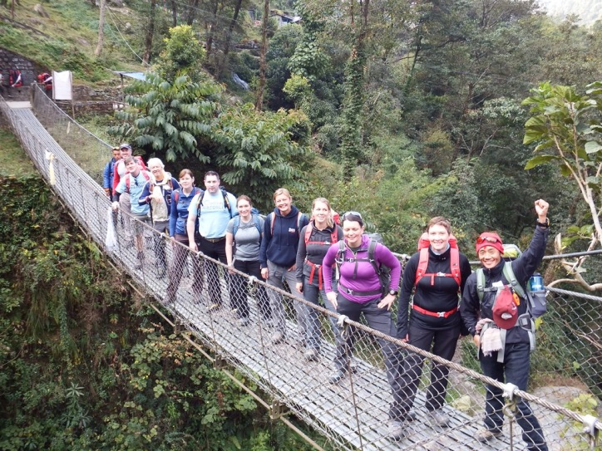

20 Dec – The day began with a short climb up to the Shree Bhagawati Secondary School with a fantastic view of the mountains and the children busy preparing for end of term examinations. The school has 105 children from 5 to 15 years of age. The second day of trekking was billed as the hardest day as we climbed all day to the night stop in the upper part of the village of Ghorepani. The Trail is made up of steps of differing heights using local stone and is extremely hard on the legs. That said the team managed admirably. The third school visited was in the village of Ulleri. The Shree Ulleri Lower Secondary School was a superb visit with great interaction from the children and is was right on the trekking trail, which passed through its playground. The school has just 60 children from 3 to 14 years of age. The Tea House for the night stop was at the bottom of the climb to Poon Hill considered to be one of the best places to view sunset and sunrise in the Annapurna.

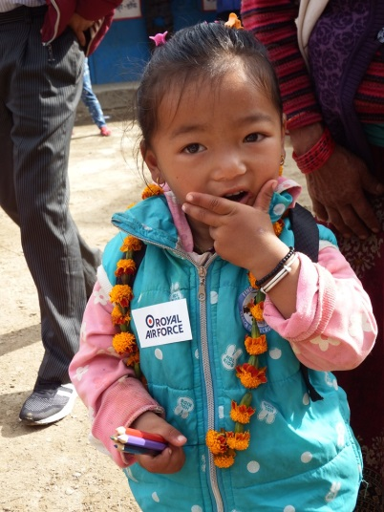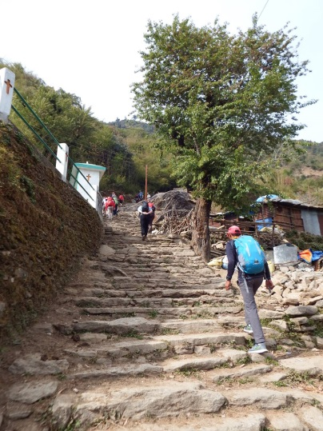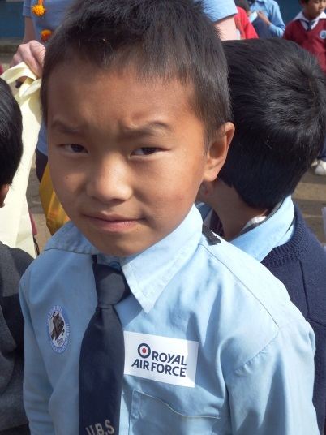

21 Dec – Some of the team rose early to climb the steep trail to the top of Poon Hill to take in the Sun rise. The team then began a shorter day of trekking to the next night stop at Tadapani. The trek was superb with fabulous views and scenery although the first half was a steep climb to the highest point of the main trek at approximately 10300ft. Again they had a fabulous Tea House accommodation in rooms with 2 sharing with fabulous views of the Annapurna and the ‘FishTail’. The initial part of the trek was very steep but well worth the magnificent views.

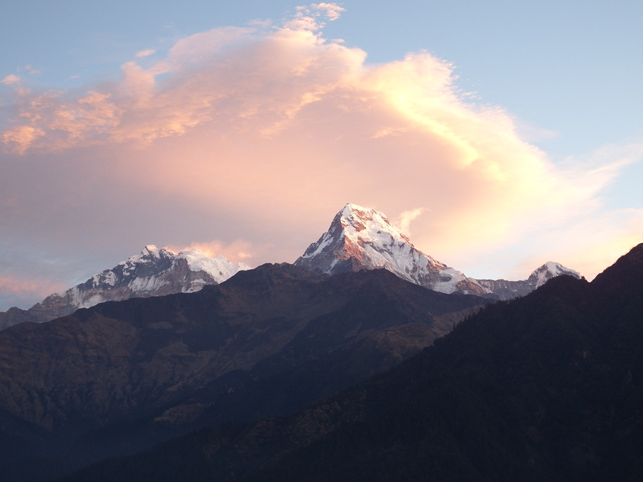

22 Dec - The village for the next night stop was Ghandruk. The team settled into their Tea House before visiting the Shree Meshram Baraha Secondary School. The school was fantastic with lots of very enthusiastic children and some great staff. The team took time to visit each classroom and hand out gifts of kit and stationery under the guidance of the Head Teacher, Ragneshwor Subel.

23 Dec - From the night stop the team could actually see most of the following days trek across the valley. Unfortunately, this meant a long steep descent to the river followed by a long difficult and very steep climb to the next village at Landruk. The team were obviously getting used to the efforts and managed well. They then visited the Shree Landruk Primary School and spent time chatting and playing with the children whilst handing out kit. The school has only 47 children from 5 to 10 years of age. Lunch was then taken before the team continued on their Trek to the next stop at Tolka. In Tolka, another school, and the final delivery of the visit, was completed at the Shree Himalaya Secondary School. Unfortunately, due to the timing, there were only a few children available but the team met with the Headmaster and a few scholars before handing out kit. The final Tea House of the Trek was ideal with fabulous views. The team also seemed to adopt a new trekking partner, a dog, who they named Alan.

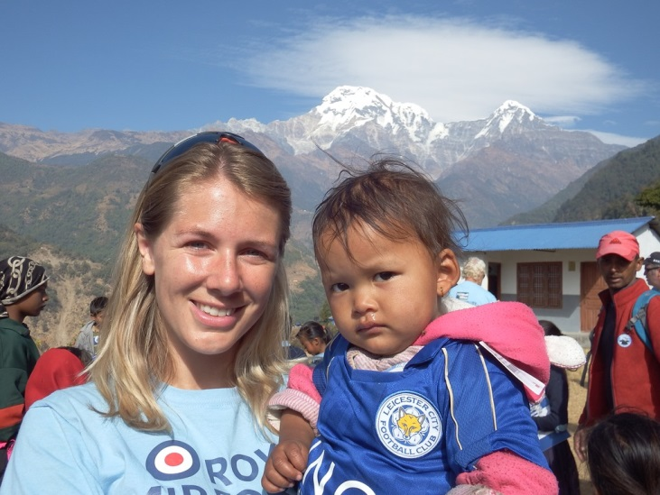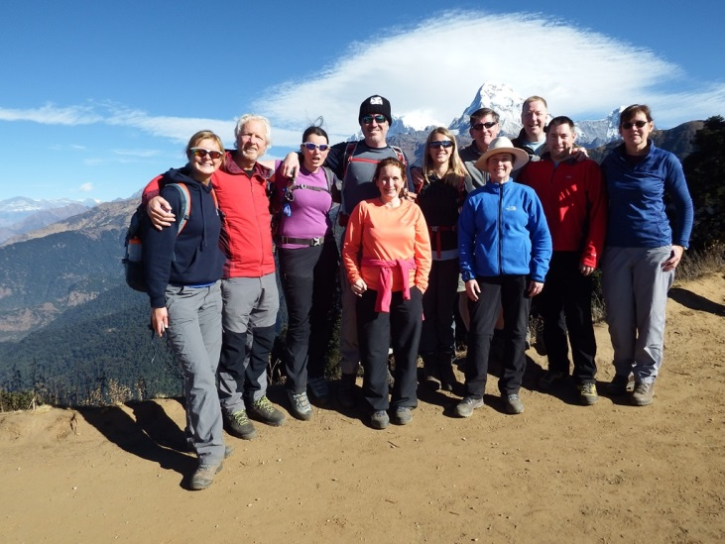

24 Dec – The finish to the Trek was a 3 hour walk to the vehicles for the journey back to Pokhara. The Trek included a difficult final descent into Dhampus. The team also managed to lose Sandra Nevins, who had dropped behind and even managed to slip the Sherpa’s bringing up the rear. Fortunately she was quickly found!!! The team arrived back in Pokhara to get cleaned up before a few Christmas Eve drinks.

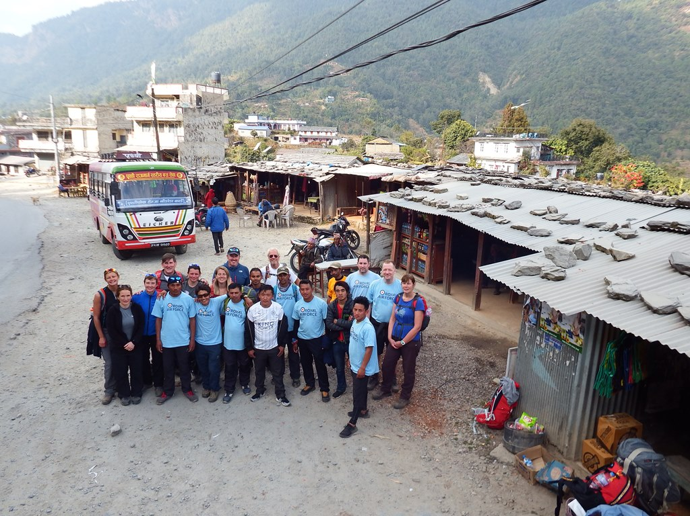

25 Dec – To mark Christmas Day the team decided on a morning with a difference and headed to Babu Paragliding for a brief on the mornings activities. The full team, bar Suzi Mitchell, then headed up Mt Sarangkot to the take-off point before being paired up with their pilots. All 10 then took to the air at 5500ft for the 15-20 minute flight above Pokhara with the Fish Tail in the background. It was an exhilarating way to spend Christmas Day morning before landing by Lake Fewa some 4000ft below. The afternoon saw the team take a Christmas Dinner at the Glacier Hotel before spending the night at a local bar in Pokhara.

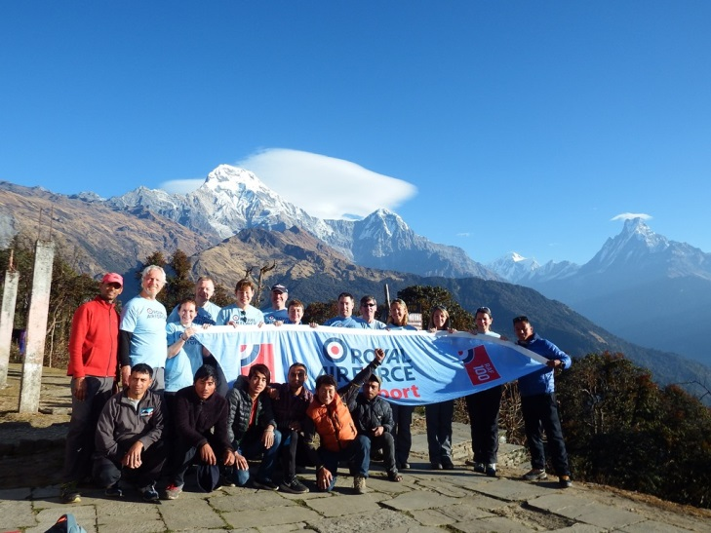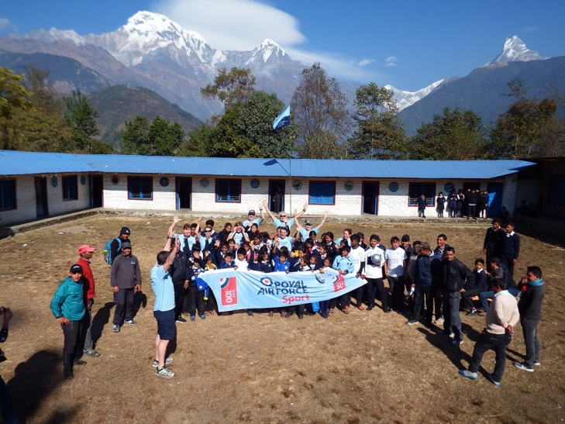

26 Dec – Boxing Day was a chill out day for the whole team in Pokhara. Some did a bit of shopping whilst others had a walk. Some visited the Buddha statue whilst Tony Kinchley and Lou Simpson took a boat over the lake to climb the steep steps to the Monastery. Gary James, Gary Rogan and Sue Crooks took a taxi to visit the Gurkha Museum. The team met up later for food and to watch football beamed from the UK.

27 Dec – The team packed up and said a final goodbye to the wonderful Pokhara before heading to the airport and the flights back into Kathmandu. They then re-grouped at the Hotel Grand in Thamel. It was time for last minute shopping in the Trekkers shops before a meal.

28 Dec – After a lie in (bar Suzi Mitchell, who had already departed to Australia and Gary Rogan for an earlier flight via Doha to Spain) the team checked out of the hotel before taking a taxi to the Swayambhunath (Monkey) Temple. The Temple sits on a hill above Kathmandu with commanding views of the city. It is home to hundreds of monkeys who are protected as they are believed to be a spiritual part of the temple. On returning to the hotel the team completed final packing before heading back to Kathmandu Airport for the journeys home.

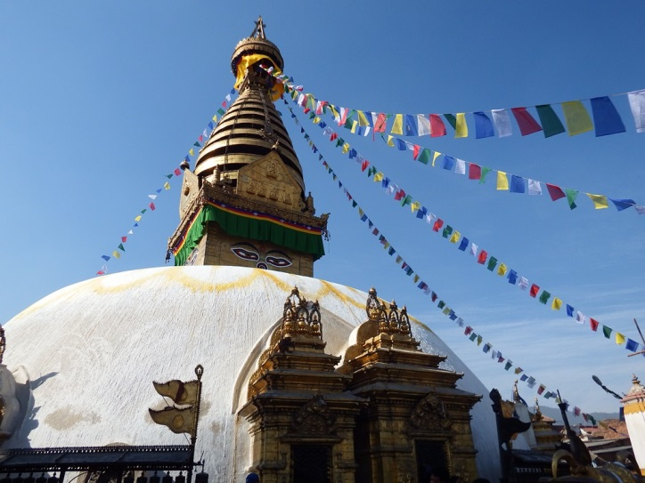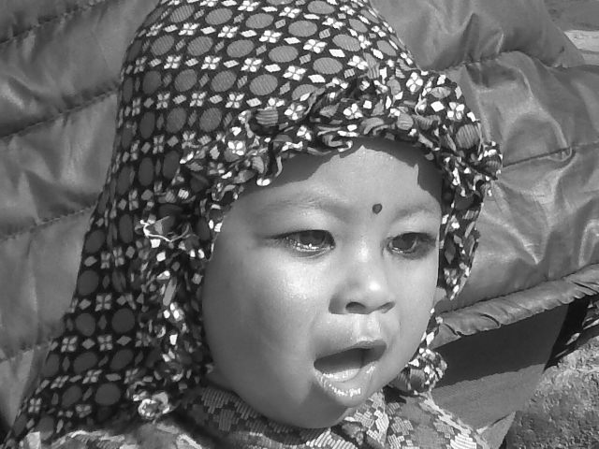

Conclusion – The trip was a fabulous success and achieved many things in very different ways for the travellers. From the Appeals point of view it was not as successful as the Kenya visits, mainly due to the Nepalese having very different cultural needs and not being so football orientated as in Africa. That said, we still achieved our aim of delivering ‘Aid through Football.’ The whole trip was only made possible through the fantastic assistance of the Gurkha Welfare Scheme, to whom we are all incredibly thankful. We have set up some fantastic links which we will now continue to grow by continuing to send items to the GWS for distribution.

Items delivered were donated by: Wolverhampton Wanderers, Shrewsbury Town, Tesco’s, Leicester City, Cottingham Rangers (East Riding FA), Fenstanton Youth (Huntingdon FA), England, FA, SGP, Bristol Rovers Academy, QPR, Eckington Boys (Sheffield & Hallamshire CFA), Halfords, Southern league, Caythorpe & Fulbeck (thro Sue Crooks), Everton, Mo Marley, Nova International, Sir Dave Richards, Manchester United, Fulham, Wem Town (Shropshire FA), Sue Crooks, Porter FC (Sheffield & Hallamshire CFA), Shrewsbury School, Forres Sevens, Dinnington Town and Charlotte Hope.

Items remaining in Nepal to be distributed on behalf of the Appeal by the GWS were donated by: Sandra Nevins, Moira Holt, Energize Shropshire, Millwall, Rawmarsh St Josephs, Manton Athletic, Rotherham Rangers, Greenhill JFC, Sheffield FC (All Sheffield & Hallamshire CFA).

