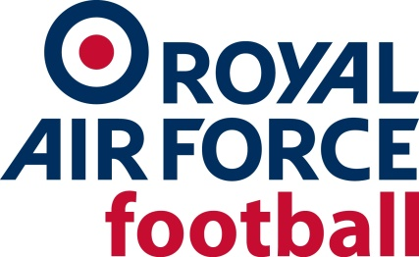
Managing Breaches of the Safeguarding Code of Conduct

Poor
Practice
Head of Safeguarding contacts individual concerned and requests a statement
Head of Safeguarding contacts other possible observers / witnesses for accounts
Head of Safeguarding and Head of Discipline determine sanction, if any, or actions to be taken by individual

Evidence and information recorded and stored appropriately. Incident logged on Poor Practice Spreadsheet

Please note that if a report involves a safeguarding allegation or a child protection concern, this will be dealt with in liaison with the Police, LADO’s, FA Case Management and the DSO’s to determine appropriate action.
Incident logged on Poor Practice Spreadsheet
Individual / club and league notified that the individual / club suspended until compliant
Safeguarding Support Officer emails the individual / club concerned with threat of santion
Non-Compliance

