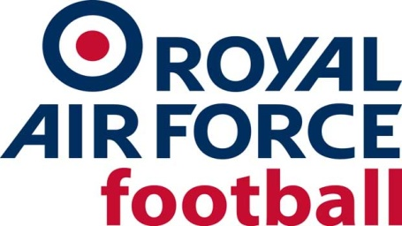

RAF WRT Team

2022-23 Fixtures & Results

Date: Wed 24 Aug 22
Competition: Friendly
Opponents: Wolves Women Academy
Venue: Away, Wolves Women Academy
Result: L 2-0
Date: Wed 28 Sept 22
Competition: Friendly
Opponents: Khalsa Women
Venue: Home, RAF Cosford
Result: L 1-2
Date: Wed 19 Oct 22
Competition: Friendly
Opponents: Stourbridge Women Reserves
Venue: Home, RAF Cosford
Result: W 6-0
Date: Wed 30 Nov 22
Competition: Friendly
Opponents: West Brom Women
Venue: Home, RAF Cosford
Result: W 4-0
Date: Wed 18 Jan 23
Competition: Friendly
Opponents: England Colleges
Venue: Home, RAF Cosford
Result: Called Off, frozen pitch
Date: Wed 15 Feb 23
Competition: Friendly
Opponents: Leek Town Women
Venue: Away, Leek Town FC
Result: W 0-5
Date: Tue 14 Mar 23
Competition: Inter-Services
Opponents: Royal Navy Women
Venue: Away, Victory Stadium, HMS Temeraire
Result: W 0-3
Date: Wed 29 Mar 23
Competition: Inter-Services
Opponents: Army Women
Venue: Home, Leek Town FC
Result: W 4-1

