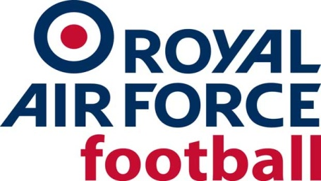

RAF Senior Rep Team

2021-22 Fixtures & Results

Date: Tues 13 July 21
Competition: Friendly
Opponents: Clanfield (85)
Venue: Away, Clanfield FC
Result: L 7-0
Date: Wed 14 July 21
Competition: Friendly
Opponents: Fairford Town
Venue: Away, Fairford Town FC
Result: W 0-3
Date: Tue 17 Aug 21
Competition: Friendly
Opponents: Aldershot Town XI
Venue: Neutral, Clanfield FC
Result: CANCELLED
Date: Wed 18 Aug 21
Competition: Friendly
Opponents: Mansfield Town XI
Venue: Neutral, Clanfield FC
Result: CANCELLED
Date: Tues 14 Sept 21
Competition: Friendly
Opponents: Hungerford Town
Venue: Neutral, Fairford Town FC
Result: L 6-0
Date: Tue 12 Oct 21
Competition: Friendly
Opponents: Oxford City XI
Venue: Away, Oxford City FC
Result: L 5-0

Date: Wed 17 Nov 21
Competition: Friendly
Opponents: North Leigh
Venue: Away, North Leigh FC
Result: W 1-6
Date: Thurs 16 Dec 21
Competition: Friendly
Opponents: Aldershot Town U21s
Venue: Neutral, Fairford Town FC
Result: W 3-0
Date: Wed 19 Jan 22
Competition: Friendly
Opponents: Oxford University
Venue: Away, Iffley Road Sports Centre
Result: W 1-2
Date: Tue 1 Mar 22
Competition: Friendly
Opponents: Norwich CBS FC
Venue: Away, The Nest, Norwich
Result: W 1-7
Date: Thurs 3 March 22
Competition: Friendly
Opponents: Wroxham FC XI
Venue: Away, Wroxham FC, Trafford Park
Result: W 2-3
Date: Wed 16 Mar 22
Competition: Inter-Services
Opponents: Royal Navy
Venue: Home, Shrewsbury Town FC
Result: W 2-0
Date: Wed 23 Mar 22
Competition: Inter-Services
Opponents: Army
Venue: Away, Aldershot Town FC
Result: W 1-4

