**RAF U23s Coaching Staff 23/24**

**Manager - Danny Bartley**

The ‘Gaffer’ is leading the team into his second IS in 2023. Danny has a plethora of playing experience. An Ex-professional at West Ham United, winning the Southeast Counties League and U19 Premier League, before joining the RAF in 2000. He has represented the SRT and UKAF for 10 years, winning the IS 4 times and the Kentish Cup twice. He hopes to pass on his own experiences and playing style to the RAFFA U23’s. Currently coaching at Broadfields FC in the Combined Counties League Prem.

**Coach – Adam Lills**

Currently serving his second posting with the Tactical Supply Wing. MOD Stafford. Before joining the RAF, he completed a YTS and 1 year pro contract at Stockport County, also having played for other sides such as Caernarfon & Altrincham. He has represented the RAF at U23 & Senior level and in his second stint as a coach with the U23s, hopefully brining the X Factor to the setup.

**Coach – Scott Styles**

Having been a part of the U23s for several years he made the transition into coaching. Has managed at RAF Coningsby and is current Manager of the Trade team Sparks. The U23s is a perfect opportunity to develop his coaching style whilst he is looking to complete his next coaching badges. A quiet member of the backroom staff who keeps his opinions to himself!!!

**GK Coach - Ian Pallace (Crystal)**

Based overseas in Italy, Crystal has previous experience with the U23s by winning the competition with the backroom staff in 2020. As a youngster he played for his favourite hometown club Sunderland and represented his county. Ian is the most experienced military man amongst us having completed over 11 postings. A highly competent GK coach.

**GK Coach - Andy ‘Barthez’ Laurie**

Andy or Barthez, as he’s better known throughout the RAF, is in his fourth season with the U23s/MDS squad as an “experienced” member of the goalkeeping coaching staff. Barthez re-joined the RAF four years ago and thrives on the opportunity to pass on his knowledge and experience on and off the field. Having played at a very high standard for many years, he has also been the GK coach and player for the RAF over 35’s team. Barthez has recently undertaken the role of kit manager as well as his coaching role. Totally outshining the previous kit manager who just didn’t seem be interested.

**Strength and Conditioning Coach - Adam King**

A real passion for trying to develop young athletes through strength, conditioning and human performance training the role gives the opportunity to work with athletes that have a real thirst for development which is fantastic. One of the greatest things about being on the coaching team, is having the opportunity to work alongside one of my best mates … the Strength and Conditioning apprentice, Kahmeel Spence

**Strength and Conditioning Coach - Kahmeel Spence**

Spence is posted at AFCO Stoke in the role of Career Engagement. In his youth days he played in the Welsh premiership and at Hereford United before joining the Royal Air Force. He has represented the RAF at both U23s and senior level, along with other RAF units, winning the RAF Cup with Coningsby.

**Head Therapist - Gus Payne**

After completing 23 years in the RAF Regiment, he sought employment as a medical trainer / assessor in the Ambulance service. Since leaving he has continued to be very successful within the football medical world, working pitch side medical at Wembley stadium, Tottenham Hotspur and Fulham. Currently the Head Therapist for the RAF FA MDS, RAF FA Veterans & Southern Premier League side Hayes & Yeading United, he was also involved with the Anguillan National team last season. 50 years involved in football at all levels both military & civilian. Gus brings a wealth of medical and football knowledge to the group and is an integral member of the backroom team.

**Team Management Support Staff**

**General Manager – Dale Craven**

Dale’s second stint with the MDS as the general manager. Tasked with reigning in Danny when he has expensive ideas and battling to get players released weekly. Average footballer supporting a very average Manchester United. Improved the standard of the staff crossbar challenge team.

**General Secretary - Paul Carter**

Fourth season involved with the RAF MDS squad, ‘PC’ works behind the scenes ensuring all admin is complete for players, officials, and coaching staff benefit. 25 years of Service football, with 300+ games as player, captain & manager of his beloved RAF Northolt. A massive advocate of Grassroots football in the RAF, having organised the RAF Challenge Cup for many seasons. Former Strike Command & RAF U25 player, many years ago!!

**Kitman - Rudy Aherne**

A logistics supplier on 1ELS at RAF Wittering, Rudy is entering his fourth season with the MDS as the Kitman has outlasted his twin brother who made the sideways move to National League Wealdstone!!!. He describes himself as an avid football fan and a season ticket holder for Leicester City FC. He hopes to contribute to the RAF winning this year’s competition by given that extra % that is required. Rudy is currently OOA, so hoping for a guest appearance from brother Brett!!

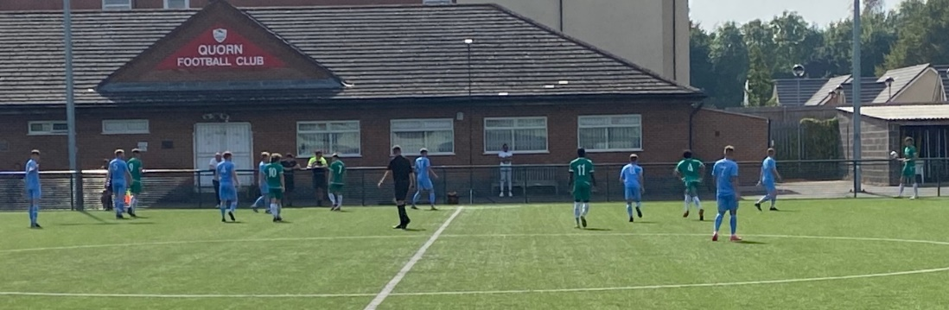

**RAF U23s Player Profiles 23/24**

**Harry Brown** - Harry is Based at RAF Coningsby a Survival Equipment technician by Trade. This is his first Inter Services as a right back. Big supporter of the mighty Wolves.

**Logan Buick** - Striker/winger in his 3rd Inter Services campaign, working with RAF Regiment at Brize Norton, from Scotland and supports Celtic. He scored against the Army 2 years ago in a 2-2 draw.

**James Butcher** - Based at RAF Coningsby, Butch is an aircraft mechanical engineer who supports Liverpool. He plays central midfielder or left back.

**Raul Christer** - Based at RAF Waddington as an aircraft technician this is Raul’s first U23 Inter Services. Before joining the RAF he played in Lincoln City’s academy.

**Luke Cranswick** – Based at RAF Leeming, working as a Communications Infrastructure Technician. This is Luke’s first Inter Services and is a midfielder or winger. A keen Huddersfield Town fan.

**Luigi Donini** - Goalkeeper based at RAF Leeming working within HR Ops, first Inter Services Campaign with the 23’s, with many more years at this level.

**Roko Draunidalo** - Based at RAF Northolt as Regiment Gunner. Plays in the midfield and is his first season with the U23’s.

**Mackenzie Gulliver** - Gully is an RAF Regiment Gunner. He is based out of Brize Norton currently posted at II SQN. Loves a tackle and can usually hear him before seeing him!

**Jak Harrison** - Mid/Def, based at RAF Leeming, recently joining the U23s Squad, also a Boxer for the RAF.

**Dean Higham** - Based at RAF Waddington as a Firefighter. Second Inter Services with the under 23s, a talented ball player, has played at many different levels and bounced around academies before joining up.

**Jacob Hutchinson** - Hutch’s second Inter Service with the squad. Currently based at RAF Brize Norton as a Logistics Mover. Can play in most positions on pitch, would love to see his goal celebration again.

**Frankie Jones** - Based at RAF Northolt as a Regiment Gunner, his first season with the U23s and massive supporter of Bolton Wanderers.

**Adam Lamb** – The skipper and a real leader, Adam is a centre half who doesn’t enjoy the ball on the floor. He is currently based at RAF Benson and this is his Second Inter Services.

**Brynley Morris** - His second year with the U23s, based at RAF Coningsby, a tenacious midfielder who loves a tackle, supports Liverpool.

**Ryan Mulligan** - Based at RAF Coningsby a centre half involved in his first IS. Cool under pressure, the John Stones of the squad.

**Thomas Naisbett** - Thomas is a Firefighter based at RAF Coningsby. This is his first season with the Under 23s, a Sunderland fan who goes to games whenever he is home.

**Tom O'Hanlon** - Tom is based at RAF Digby working within People Ops. This is Tom’s second season with the squad. He is a Liverpool fan and huge Darwin Nunez enthusiast. Tom is scoring for fun this season, unlike Nunez!!

**Lewis Parry** - Stationed at RAF Brize Norton, Lewis is in his first season with the U23s. A Regiment Gunner and a Gunnersaurus fan boy. Before joining the RAF he played for Wrexham AFC, a close friend of Ryan Reynolds.

**Luke Preen** - Stationed at RAF Benson as an Aircraft Technician. Currently playing for Wallingford fc and massive NUFC fan. Third Inter Service competition. A regular with the Seniors over the last 2 seasons.

**Ben Price** - First year with the U23s having recently joined the squad, he is stationed at RAF Leeming working on 90SU.

**Armani Riley** - Stationed at RAF Odiham, Armani is a centre midfielder who is in his third and final season with the U23s. He is an aviation technician who works on chinooks and is currently playing Saturday football for Cove F.C. A regular with the senior squad this year, the real fans favourite.

**Taylor Ryder** – Taylor 1st season with the squad, an attacking player currently based at RAF Cosford and a big fan of the mighty Boro.

**Jake Staunton** - Jake is based at RAF Marham and works within the Fuels section. This is his first Inter Service playing as a left winger. He is a supporter of Manchester United.

**Josh Storey-Randell** - Based at RAF Coningsby and joined the squad for the last game of the previous U23s Inter services. Currently play for Newark Town in the United counties league and play preferably on either wing. A regular with the seniors this season, coming off the bench in the SRT’s successful campaign last year.

**Dom Turner** – GK based at RAF Odiham, a Survival Equipment Technician, this is his Second season for the Under 23’s, before joining the RAF he played for Newquay AFC.

**Joe Waters** - Defensive midfielder with an exceptional passing range. An Avionics Technician with 99 Sqn, RAF Brize Norton. A regular with the senior squad this season.

**Alfie Wood** - A defender stationed at RAF Waddington as a Firefighter, first inter services, big supporter of Rotherham.

