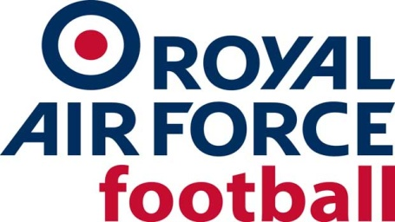

RAF MDS Team

2022-23 Fixtures and Results

Date: Tue 12 July 22
Competition: Trials match/Friendly
Opponents: TG4 - Sparks Trade Team
Venue: Home, Rayners Lane FC
Result: W 5-1

Date: Wed 7 Sept 22
Competition: Friendly
Opponents: Oxford City Academy
Venue: Away, Oxford City FC
Result: L 2-1

Date: Wed 5 Oct 22
Competition: Friendly
Opponents: Warboys Town
Venue: Away, Warboys Town FC, Huntingdonshire
Result: W 2-3

Date: Wed 9 Nov 22
Competition: Friendly
Opponents: Huntingdon Town
Venue: Away, Huntingdon Town, Jubilee Park
Result: W 0-6

Date: Wed 7 Dec 2022
Competition: Friendly
Opponents: Wealdstone Academy
Venue: Home, Rayners Lane FC
Result: W 10-0

Date: Wed 8 Feb 23
Competition: Inter-Services
Opponents: Royal Navy U23s
Venue: Home, Rayners Lane FC
Result: D 0-0

Date: Wed 15 Feb 23
Competition: Inter-Services
Opponents: Army U23s
Venue: Away, Aldershot Military Stadium
Result: L 3-0

Date: Tue 6 June 23
Competition: Presidents Cup
Opponents: Royal Netherlands Air Force
Venue: Away, The Netherlands
Result: L 3-0

