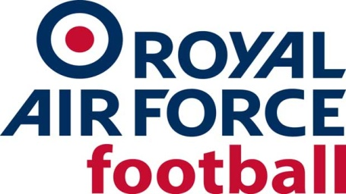

RAF MDS Team

2020-21 Fixtures & Results

Date: Mon 5 Oct 20
Competition: Friendly
Opponents: Icarus
Venue: Neutral, Oxford City FC
Result: W 3-1
Date: Wed 17 Feb 21
Competition: Inter-Services
Opponents: Royal Navy
Venue: Away, HMS Temeraire
Result: CANCELLED
Date: Wed 24 Feb 21
Competition: Inter-Services
Opponents: Army
Venue: Home, Oxford City FC
Result: CANCELLED

