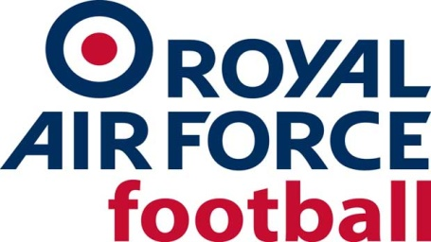

RAF LRT Team

2021-22 Fixtures & Results
Date: Wed 18 Aug 21
Competition: Friendly
Opponents: Wem Town Ladies
Venue: Away, Wem Town FC
Result: CANCELLED
Date: Thur 19 Aug 21
Competition: Friendly
Opponents: England Colleges Women
Venue: Aylestone Park
Result: L 7-1
Date: Wed 15 Sept 21
Competition: Friendly
Opponents: Sporting Khalsa Ladies
Venue: Home, RAF Cosford
Result: W 2-1
Date: Tue 12 Oct 21
Competition: Friendly
Opponents: Stourbridge Ladies
Venue: RAF Cosford
Result: W 5-3
Date: Thurs 14 Oct 21
Competition: Friendly
Opponents: Boldmere St Michaels Women
Venue: RAF Cosford
Result: W 3-1
Date: Wed 15 Dec 21
Competition: Friendly
Opponents: Wem Town Ladies
Venue: Away, Wem Town FC
Result: D 3-3
Date: Wed 19 Jan 22
Competition: Friendly
Opponents: Wolverhampton Wanderers Women XI
Venue: Home, RAF Cosford
Result: L 0-1
Date: Thurs 3 Mar 22
Competition: Friendly
Opponents: Norwich City Women
Venue: Away, The Nest, Norwich
Result: W 1-3
Date: Thurs 17 Mar 22
Competition: Inter-Services
Opponents: Royal Navy
Venue: Home, RAF Cosford
Result: W 2-0
Date: Wed 23 Mar 22
Competition: Inter-Services
Opponents: Army
Venue: Away, Aldershot Military Stadium
Result: W 0-2

