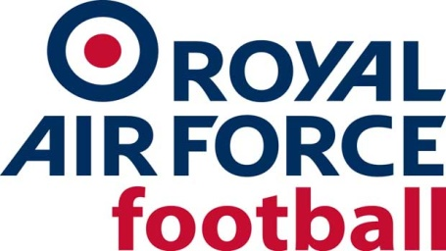
RAF CUP (The Keith Christie Trophy) Season 2022-23
PRELIM ROUND - WED 12 OCT 22
North
RAF Cranwell 1-4 RAF Waddington
RAF Valley 1-7 RAF Boulmer (Wed 16 Nov 22 at Bangor City FC)
RAF Digby receive a bye
PRELIM ROUND - WED 19 OCT 22
South
RAF Honington v RAF High Wycombe (RAF High Wycombe removed from competition)
RAF Wyton 2-4 RAF Odiham
RAF Halton 0-7 RAF Benson
RAF Brize Norton v RAF Swanwick (RAF Swanwick removed from competition)
1ST ROUND - WED 23 NOV 22
RAF Digby 6-2 RAF Shawbury
RAF Northolt 2-1 RAF Akrotiri
RAF Boulmer 2-0 RAF Waddington (Wed 30 Nov 22)
RAF Odiham 1-0 RAF Wittering (at North Wanborough FC)
RAF Lossiemouth 5-2 RAF Marham (Tue 24 Jan 23)
RAF Brize Norton 7-0 RAF Honington
RAF Benson 3-2 RAF Leeming
RAF Coningsby 3-4 RAF Cosford
QUARTER FINALS - WED 1 FEB 23
RAF Brize Norton 2-3 RAF Benson
RAF Digby 3-3 RAF Odiham, AET (RAF Digby win 9-8 on penalties)
RAF Lossiemouth 2-4 RAF Boulmer
RAF Cosford 2-0 RAF Northolt, AET
SEMI-FINALS - WED 5 APRIL 23
CUP
RAF Cosford 4-3 RAF Benson (at Racing Club Warwick FC)
RAF Digby 1-4 RAF Boulmer (at Beadle AFC)
PLATE
RAF Odiham* 2-0 RAF High Wycombe (at RAF Henlow)
RAF Wyton 6-0 RAF Halton (at RAF Henlow)
* (RAF Cranwell withdrew from competition and were replaced by RAF Odiham via a draw)
FINALS - THURS 11 MAY 23 (AT OXFORD CITY FC)
CUP
RAF Cosford 0-1 RAF Boulmer
PLATE
RAF Odiham 3-0 RAF Wyton

