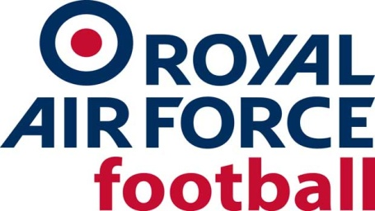
RAF CUP (The Keith Christie Trophy) Season 2021-22
Preliminary Round, Wed 13 Oct 21
North
RAF Lossiemouth v RAF Wyton (RAF Wyton conceded)
RAF Henlow 2-4 RAF Leeming (Wed 6 Oct 21)
RAF Digby 2-3 RAF Cranwell
RAF Valley 0-4 RAF Waddington (Wed 3 Nov 21 played at Bangor University)
South
RAF Wittering 5-0 RAF High Wycombe
RAF Cosford v RAF Halton (RAF Halton conceded)
RAF Benson v MoD St Athan (MoD St Athan conceded)
RAF Swanwick 2-9 RAF Shawbury (Wed 27 Oct 21)
1st Round, Wed 24 Nov 21
North
RAF Cranwell 0-6 RAF Lossiemouth
RAF Boulmer 1-1 RAF Marham AET (RAF Marham won 4-5 on pens)
RAF Honington 1-4 RAF Coningsby
RAF Leeming 2-1 RAF Waddington
South
RAF Odiham 0-3 RAF Northolt
RAF Cosford 4-3 RAF Akrotiri
RAF Benson 1-4 RAF Wittering (Wed 19 Jan 22)
RAF Shawbury 3-2 RAF Brize Norton
Quarter Finals
Cup (Wed 26 Jan 22)
RAF Lossiemouth 1-2 RAF Cosford
RAF Leeming 0-1 RAF Marham (AET)
RAF Coningsby 5-3 RAF Wittering
RAF Northolt 4-5 RAF Shawbury (AET) (Wed 9 Feb 22) Plate (Wed 9 Feb 22)
Plate (Wed 9 Feb 22)
RAF Valley 5-1 RAF Wyton
RAF Cranwell 0-9 RAF Digby
RAF Henlow 8-3 RAF Swanwick (Weds 2 Mar 22)
RAF High Wycombe 1-0 RAF Halton
Semi Finals (neutral venues)
Cup (Wed 6 April 22)
RAF Shawbury 2-5 RAF Cosford (at The New Saints FC, Owestry)
RAF Marham 2-0 RAF Coningsby (at March Town FC, March)
Plate
RAF Henlow 2-4 RAF Digby (at March Town FC, March)
RAF High Wycombe 4-0 RAF Valley (at RAF Cosford, Thurs 7 April 22)
Finals (Thurs 12 May 22 at Oxford City FC)
Cup
RAF Cosford 3-0 RAF Marham
Plate
RAF Digby 3-2 RAF High Wycombe

