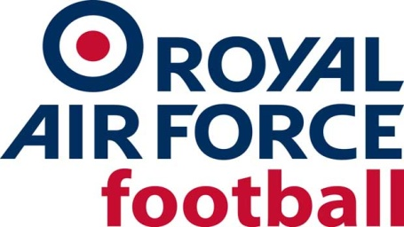
RAF CUP (The Keith Christie Trophy) Season 2019-20
First Round (25 Sept 2019)
Byes – RAF Brize Norton & RAF Coningsby (2018/19 Finalists), RAF Northolt, MOD St Athan, RAFC Cranwell.

North Region:
RAF Digby 2-4 RAF Lossiemouth
RAF Valley 0-12 RAF Shawbury
RAF Boulmer v TSW Stafford (TSW Stafford unable to field team, removed from competition)
RAF Waddington 4-2 RAF Cosford
RAF Leeming 6-0 RAF Scampton

South Region:
RAF Wyton 4-0 Swanwick Mil
RAF High Wycombe 1-6 RAF Marham
Northwood v JFC Chicksands/Henlow (Northwood unable to field team, removed from competition)
RAF Benson 0-10 RAF Odiham
RAF Wittering 0-2 RAF Akrotiri
RAF Halton 1-4 RAF Honington

Cup 2nd Round (6 Nov 2019)
MOD St Athan 2-4 RAF Shawbury (played at Barry Town FC)
JFC Chicksands/Henlow 0-4 RAF Coningsby
RAF Odiham 1-0 RAF Honington
RAF Marham 4-3 RAF Waddington
RAF Wyton 1-3 RAF Northolt
RAF Lossiemouth 0-1 RAF Brize Norton
RAF Cranwell 1-7 RAF Boulmer
RAF Akrotiri 5-1 RAF Leeming

Plate 1st Round (6 Nov 2019)
Byes - RAF Digby, RAF Cosford, RAF Benson, Swanwick Mil, RAF Wittering, RAF Scampton
RAF High Wycombe 1-2 RAF Halton
TSW Stafford v RAF Valley (TSW Stafford removed from competition)

Cup Quarter Final Round (22 Jan 2020)
RAF Akrotiri 3-1 RAF Northolt (Mon 10 Feb 20)
RAF Boulmer 0-3 RAF Coningsby
RAF Shawbury 1-4 RAF Odiham
RAF Marham 1-0 RAF Brize Norton (Wed 8 Jan 20)

Plate Quarter Final Round (22 Jan 2020)
Swanwick Mil 6-1 RAF Valley
RAF Halton 2-7 RAF Digby
RAF Wittering 5-0 RAF Scampton
RAF Benson 2-8 RAF Cosford

Cup Semi Finals
RAF Akrotiri v RAF Odiham (RAF Akrotiri withdrew due to Covid-19 travel restrictions)
RAF Coningsby 4-5 RAF Marham (2 Sept 20, match highlights can be viewed here)

Plate Semi Finals
RAF Cosford 6-3 RAF Wittering (30 Sept 20)
RAF Digby 4-0 Swanwick Mil (1 Oct 20)

Cup Final
RAF Marham 1-2 RAF Odiham (17 Dec 20 at Oxford City FC)

Plate Final (15 Oct 20 at Oxford City FC)
RAF Cosford 5-1 RAF Digby

