RAF Football Association - E-Bulletin
RAF SRT vs RN Men played at Montgomery Waters Meadow

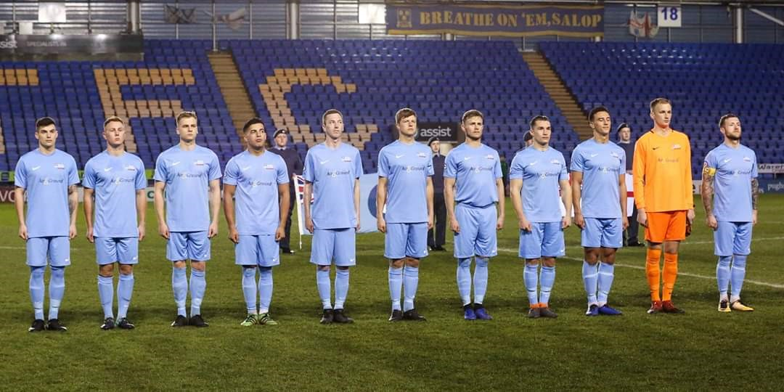

The RAF took on the NAVY in their final Inter-Services game, looking to finish on a high after the loss to the Army, Manager FS Kev Barry rung in the changes with Cpl Michael Atkinson back in from International Duty and Cpl Michael Campbell given the armband, after the formal greeting on the players play started steady with both teams trying to figure each other out until disaster stuck when the navy took the lead through AB Mike Smith strike nestling into the bottom left corner, this shocked the RAF and with some good work from SAC Gareth Barber down the left crossing in the ball that evaded everyone only for SAC Moxon to cross the ball back in finding Cpl David Webb at the to strike in the leveller after 7 minutes, the RAF started taking control of the game in the attacking half now and SAC’s Barber and Moxon causing trouble down both flanks with both SAC Cullen and Cpl Campbell making it hard for the Navy defence, the Navy still were causing the RAF Defence some issues after 18 minutes SLt Todd got the ball the right hand edge of the box only to be dragged wide

SAC Gareth Barber was making it hard for the Navy right back with some fancy foot work down the Left hand side crossed the ball in for Cpl Campbell only for the skipper to find the keeper, there was a sense of the second goal was coming and on the 23rd minute great play by SAC Moxon on the right hand side fired in a low cross across the face of the goal to give SAC Cullen a tap in to make it 2-1 to the RAF, the Navy knowing they have to attack a through ball saw a one and one only for SAC Dan Gorman recalled to the starting line up to make a one handed save, a chance from the following corner led the Navy to just narrowly miss the chances were coming, a later challenge from SAC Ben Greenwood find his way into book, the free kick

crossed in found its way to the Navy forward Smith only to see SAC Dan Gorman in his way again, the half time whistle blew with the RAF going in with a 2-1 lead looking like they could have had more but the Navy showing signs of getting back into it

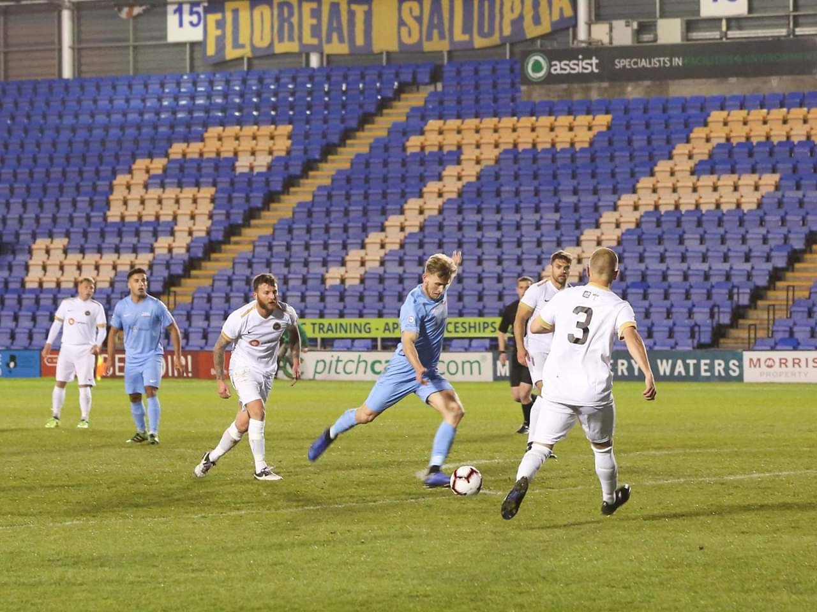

The second half started relatively quiet with the Navy not seeing much of the goal this was more due to the strong back defensive line up, most of the action was taking place in the middle of the park with both keepers feeling left out of the game, a strike from Cpl David Webb narrowly missing the head of SAC Cullen the RAF now starting to sign shows of that attacking prowess from the first half, the RAF bench looked calm with the Navy starting to ring in the changes the second half game to light on the 67th minute when the RAF were awarded a free kick just outside the area on the left hand side with the Navy keeper lining up his 4 man wall Cpl David Webb spotted the gap and curled it around the wall around hip height piercing the net sending the RAF Fans into delight 3-1. The navy couldn’t break past the RAF defence if they managed to there were faced with SAC Dan Gorman, a cross from the right hand side did cause a slight fumble only for Gorman to recover quickly though receiving a knock to the head, this lead to the warm up of SAC Chris Adams in what was virtually his last day in the service, Gorman recovered after some magic work from Physio WO Tony Dunn

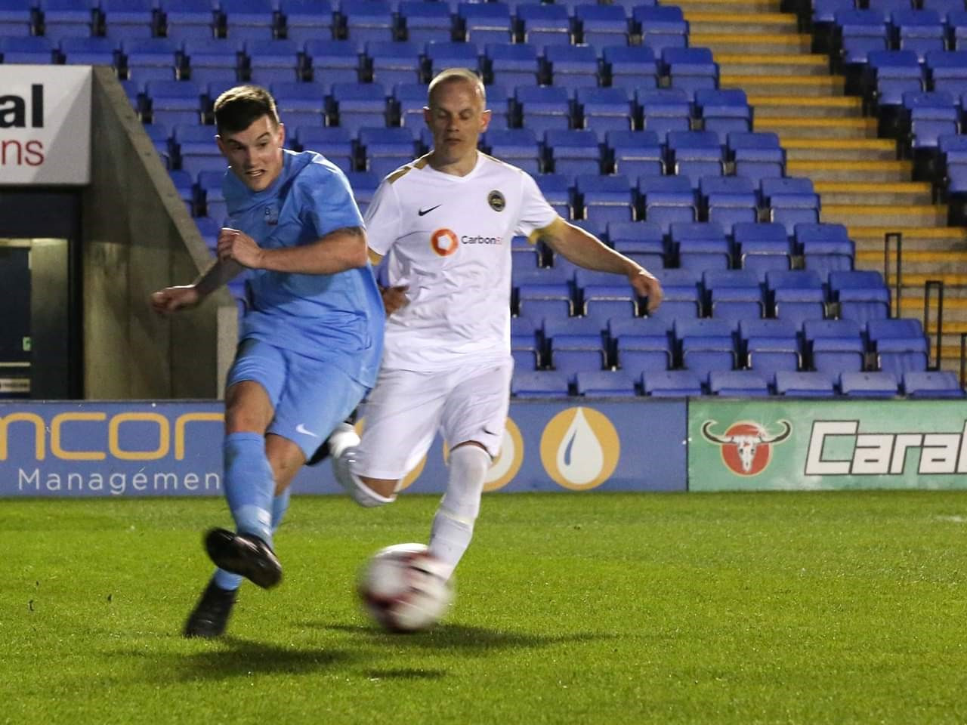
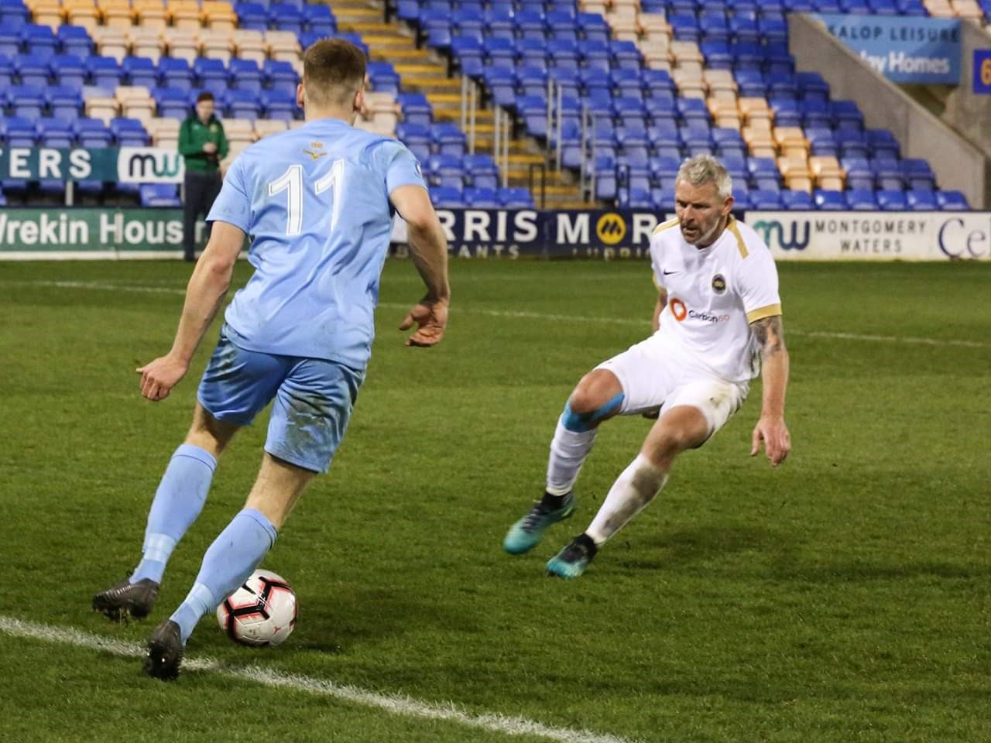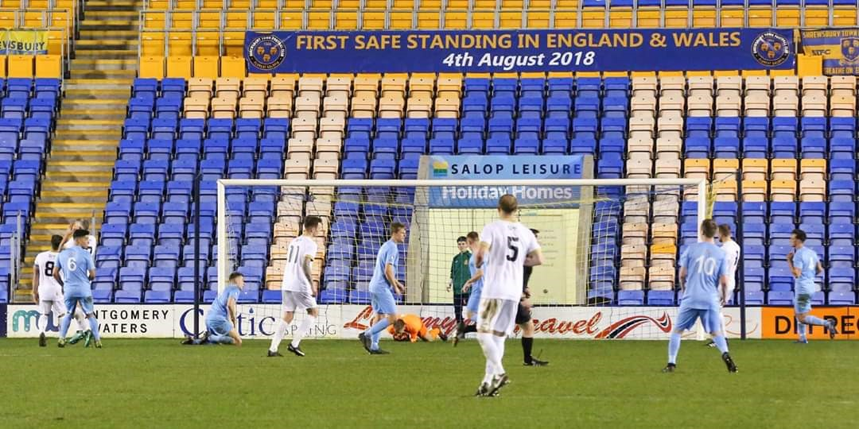

it was all RAF now with the wingers linking well with Campbell and Cullen, the RAF knew that 3-1 wouldn’t be enough and on the 88th minute some great work on the left from Cpl Campbell saw him find SAC Barber or outrageously lobbed the keeper from an acute angle sending the bench crazy 4-1 to the RAF, last moment of play saw Barber try something just as amazing only for it just to go over, the final whistle blew with the RAF coming out 4-1 winners and much deserved Cpl David Webb was all over the pitch and was at the heart of everything the RAF created, the RAF were presented with the Cassar Cup from AM Young and the celebrations on the field could begin

After the game joyful manager Kev Barry heaped praise on his team saying he told them to forget the tactic board and go out there and outwork the navy and we will get the rewards and we did that and was proud of them all and the young lads coming did brilliant worked there socks off

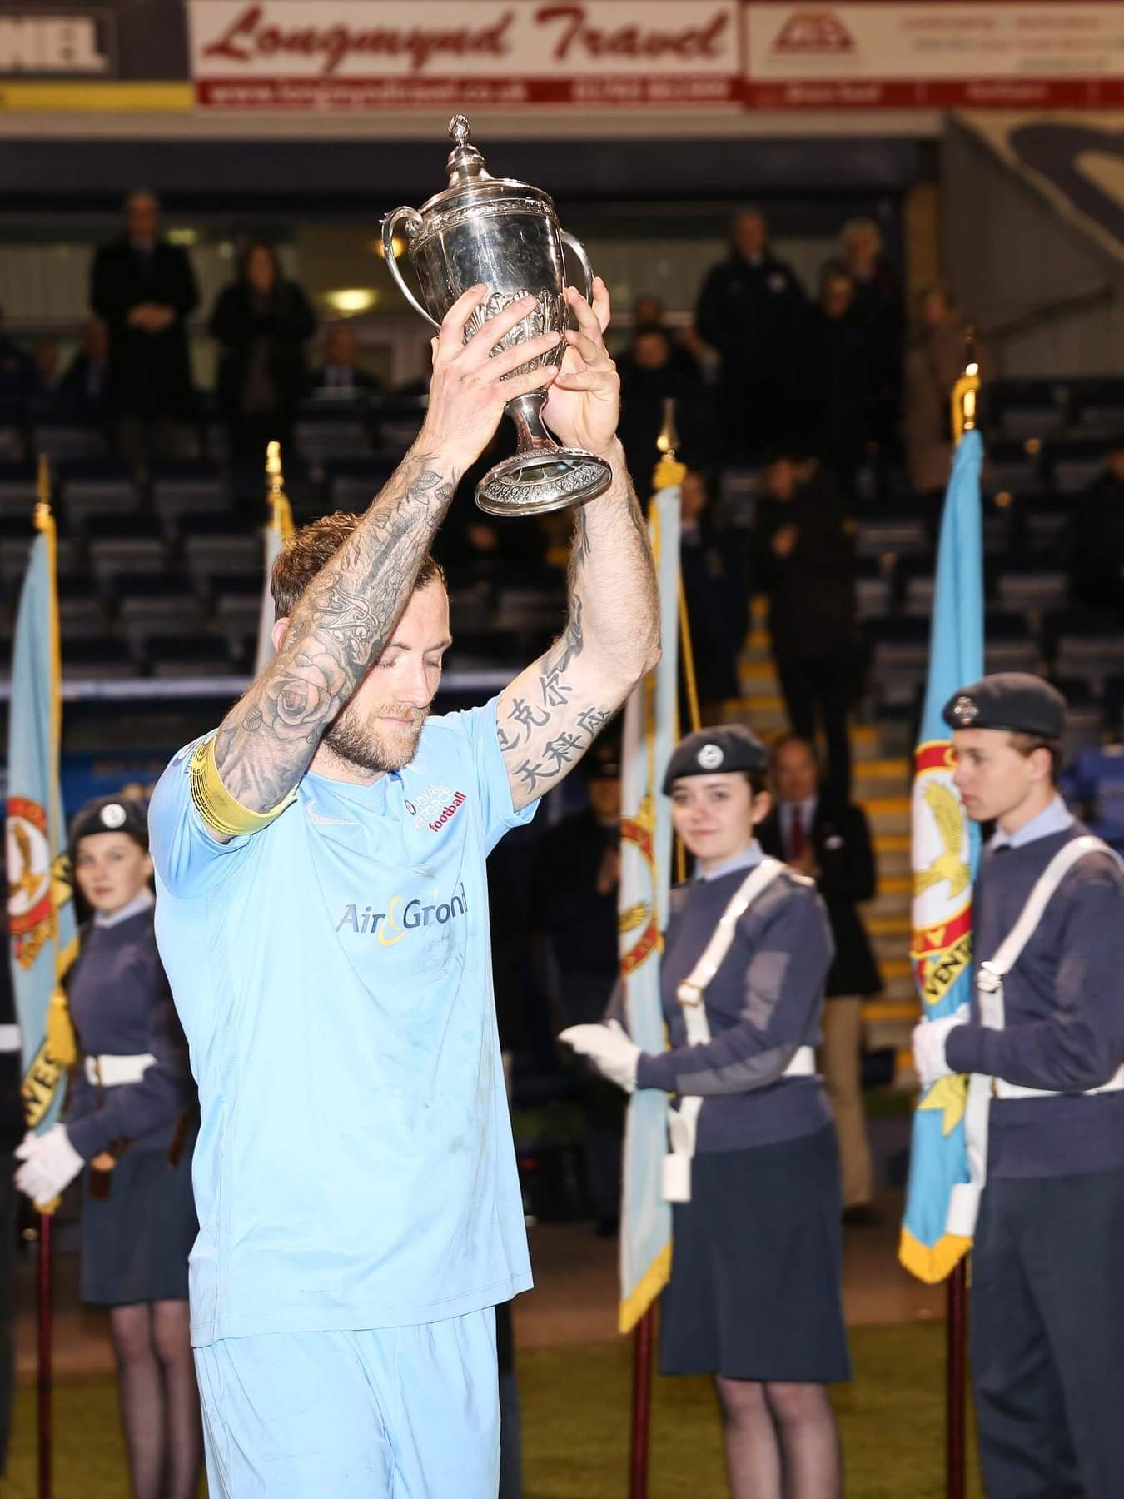
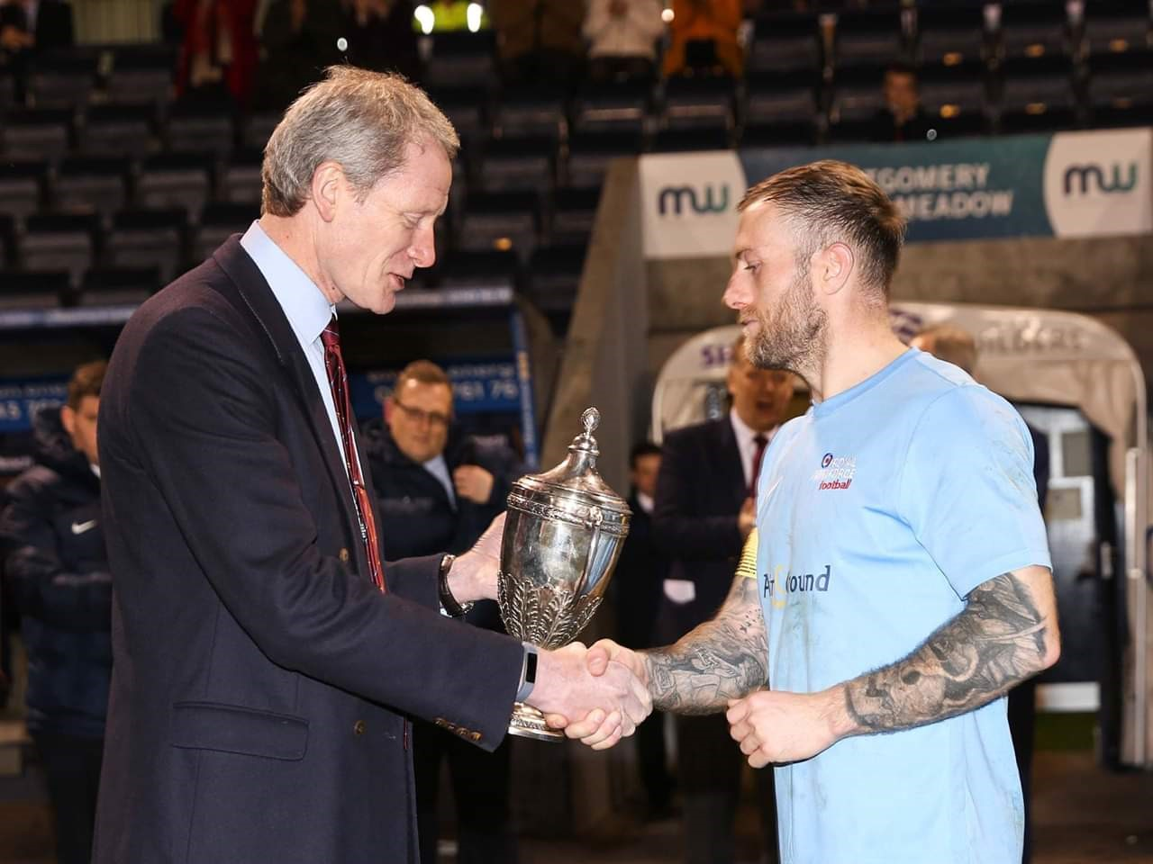

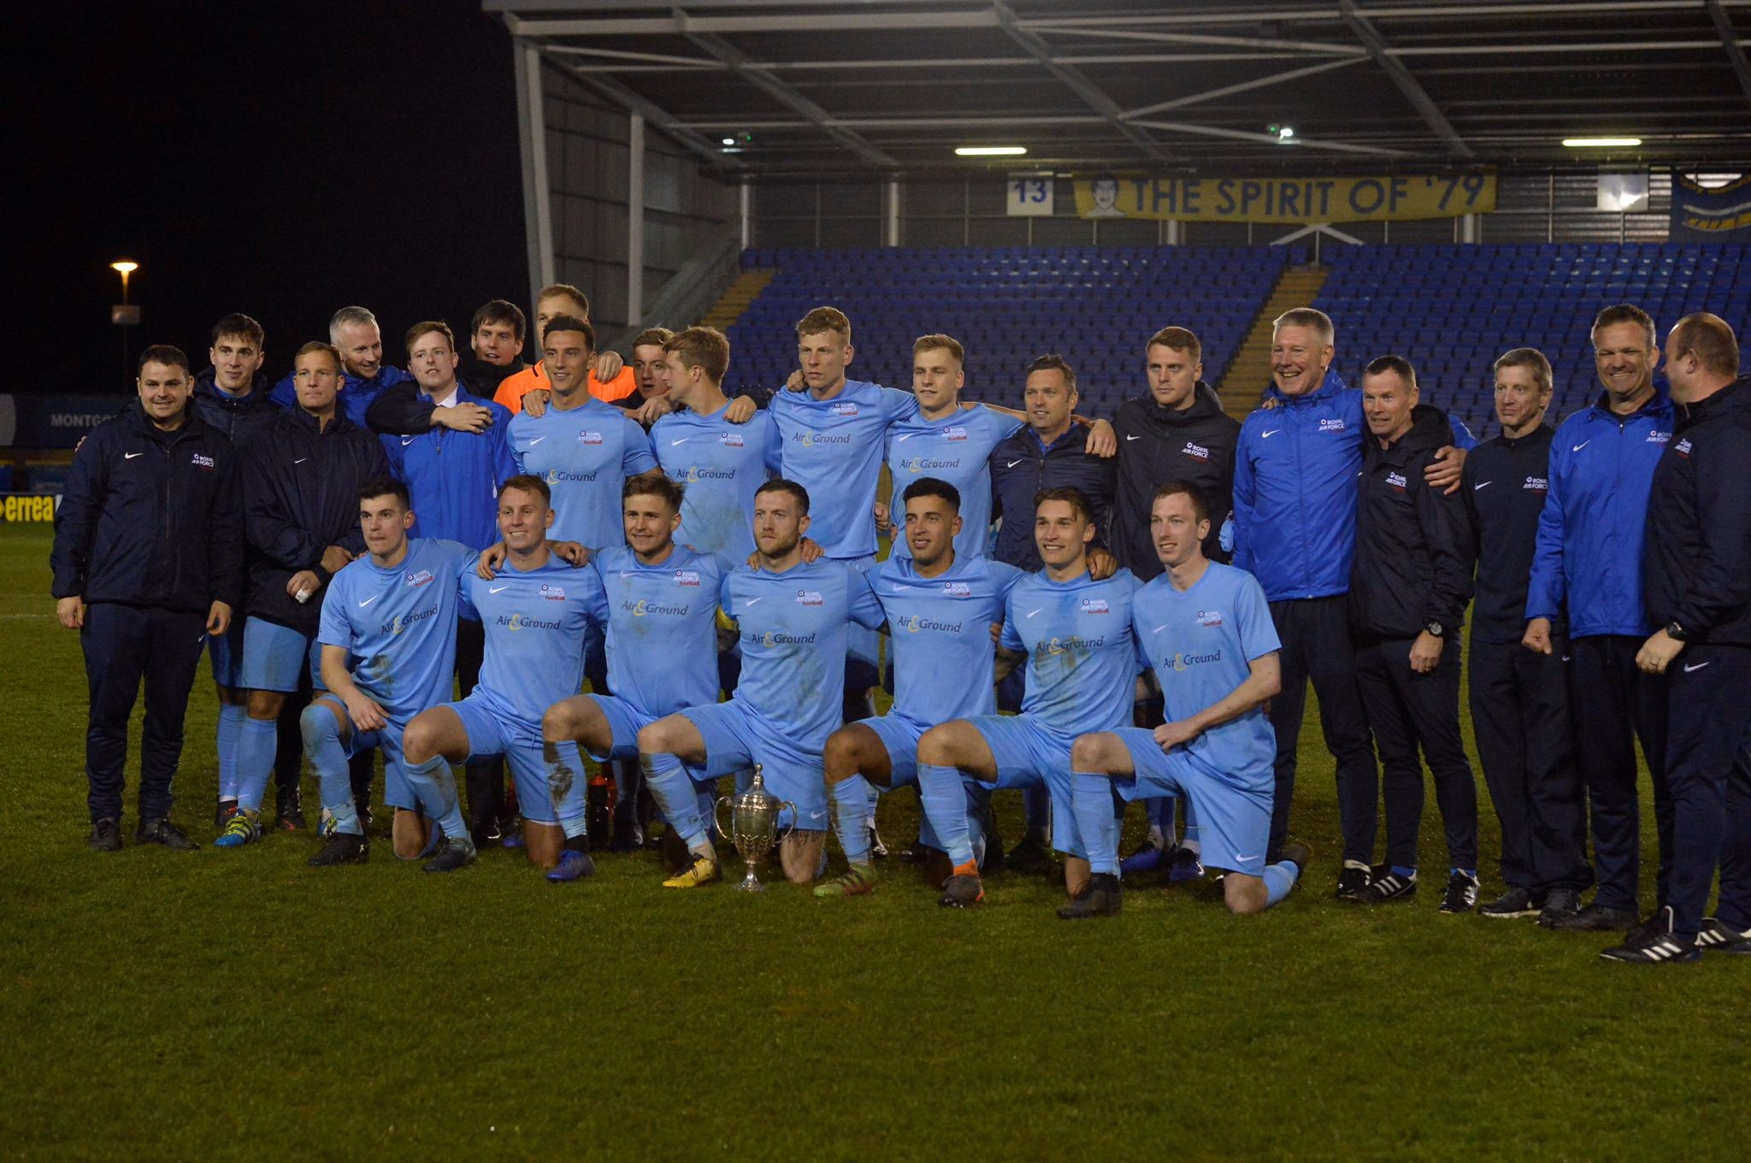

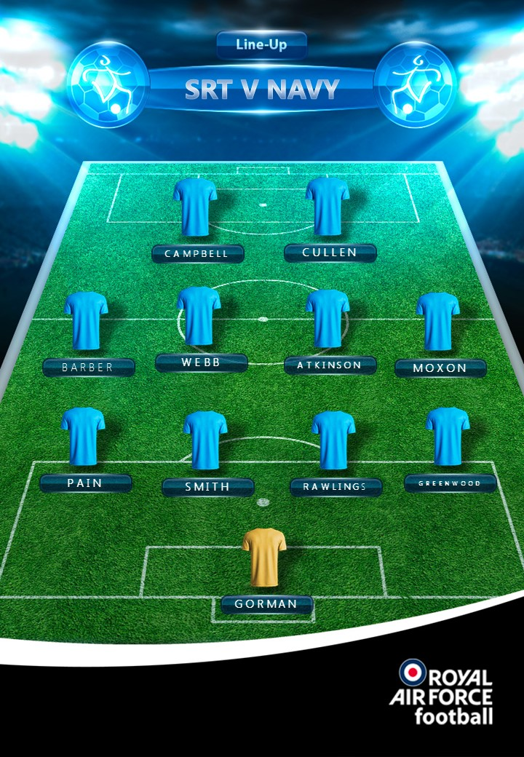

- SAC Dan Gorman
- SAC Ben Greenwood
- L/Cpl Hayden Pain
- SAC Elliot Smith
- SAC Sam Rawlings
- Cpl Mike Atkinson
- AC Terran Moxon
- Cpl David Webb
- Cpl Michael Campbell (Captain)
- SAC Ben Cullen
- SAC Gareth Barber

- SAC Ross Gilberry
- SAC Danny Dixon
- SAC Levi Freeman
- Sgt Carl Evans
- Cpl Tom Claisse
- SAC Chris Adams (GK)
- SAC James McGowan

Match Report – Sgt Kyle Atkinson SRT Comms Lead

Photos – SAC Alexa Thompson RAF Cosford

RAF FOOTBALL ASSOCIATION SPONSORS
