RAF Football Association - E-Bulletin
RAF Female Festival of Football – Shrewsbury Town FC – 8 Jun 22
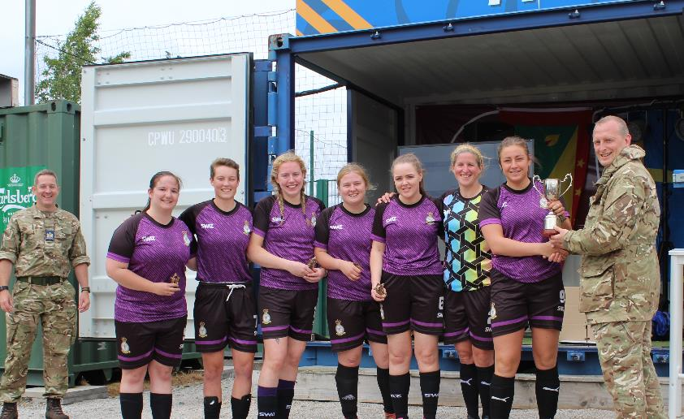
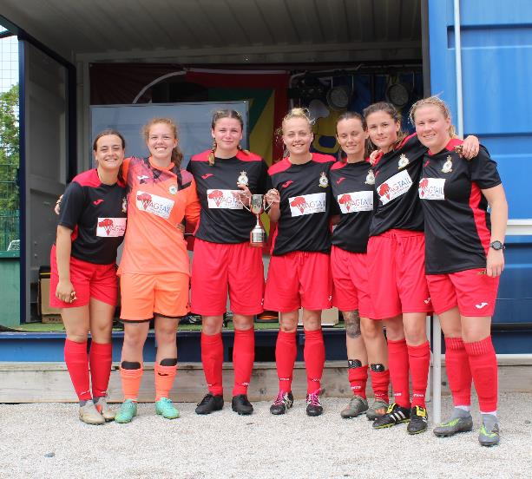

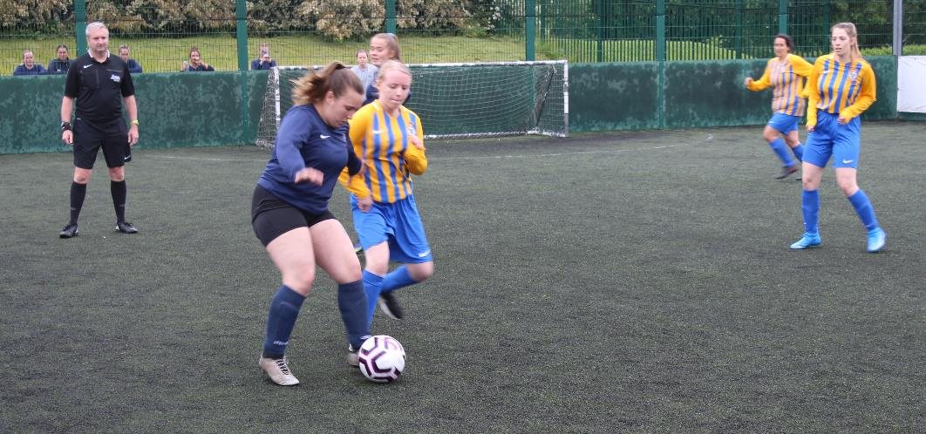
Shrewsbury Town FC Hub was the venue for the 2022 RAF FA Female Festival of Football. Building on the success of the 2021 tournament, it was great to see a fantastic turnout of 14 teams (12 teams participated in 2021) from different stations across the RAF, with some units represented for the first time. The tournament also included representation from the Army (3 Med Regt & 34 Med Field Hospital). What was clear from the off was that all teams were excited about playing and that they would give it their best and see where the day took them. With the rain not damping spirits the draw was made for the 3 groups and the opening fixtures advised. The small pitches at the Hub enabled teams to create chances quickly and as the first few games were played it was clear that there would be plenty of goals flying in. Despite the competitive nature of the games, all teams demonstrated a high level of control and this helped the matches flow without the need for the officials to get the cards out. Strong early performances from Cosford A, Logs/Movs Lionesses, RAFP A and Coningsby set them out as potential winners but the chasing pack were also making things interesting with some spirited performances. With the withdrawal of the Honington/Marham team, it made it slightly more complicated to determine who would automatically qualify for the Trophy semi-final, but it is worth acknowledging that two players from Honington/Marham still travelled and guest appeared for other teams, proving that irrespective of representing your unit playing football is what it is all about.
As the group stages came to a close, the tournament split into plate and trophy competitions with the top seven teams from the groups going through to the trophy and the bottom seven going into the plate.

With the tournament moving into knockout games there wasn’t any let up in the number of goals being scored with Coningsby and Logs/Movs Lionesses both scoring 4 in the quarter finals of the Trophy and
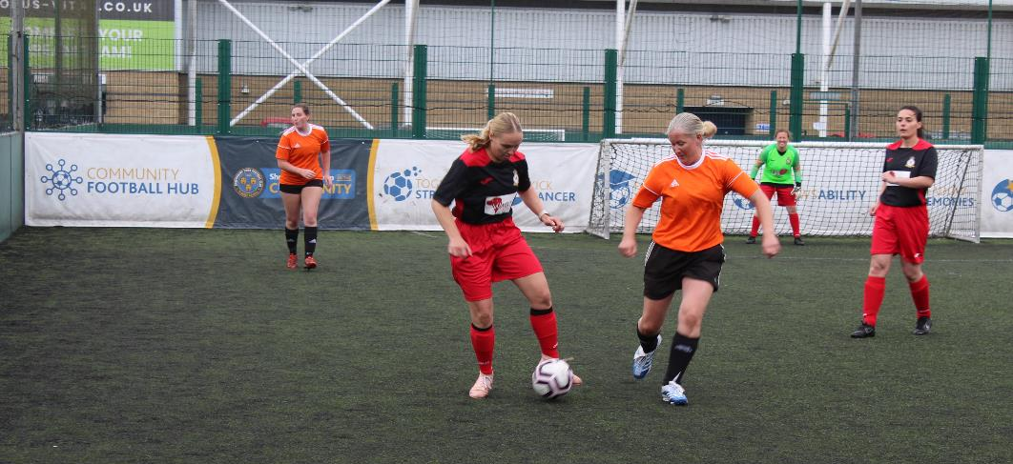
3 Med Reg smashing in 6 making Waddington/Digby’s 3 looking tame in the Plate. However, with the reintroduction of RAFP A in the Trophy after their bye and High Wycombe/Halton into the Plate, the semi finals would be a harder contest for the teams.

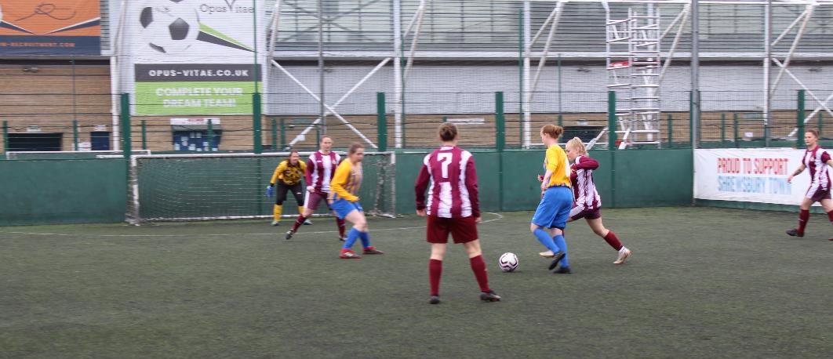
Over in the plate competition, High Wycombe/Halton put in an impressive performance to reach the
Final, beating RAFP B 9-1 with Waddington/Digby beating 3 Med Reg 4-2 in a far tighter game. In keeping with the spirit of the day, many of the teams who had been knocked out of the tournament stayed to watch the two finals, making for a fantastic atmosphere.

The Plate Final seen High Wycombe/Halton continue in free-scoring form to comprehensively secure the Plate victory putting 7 past Waddington/Digby to win 7-1.

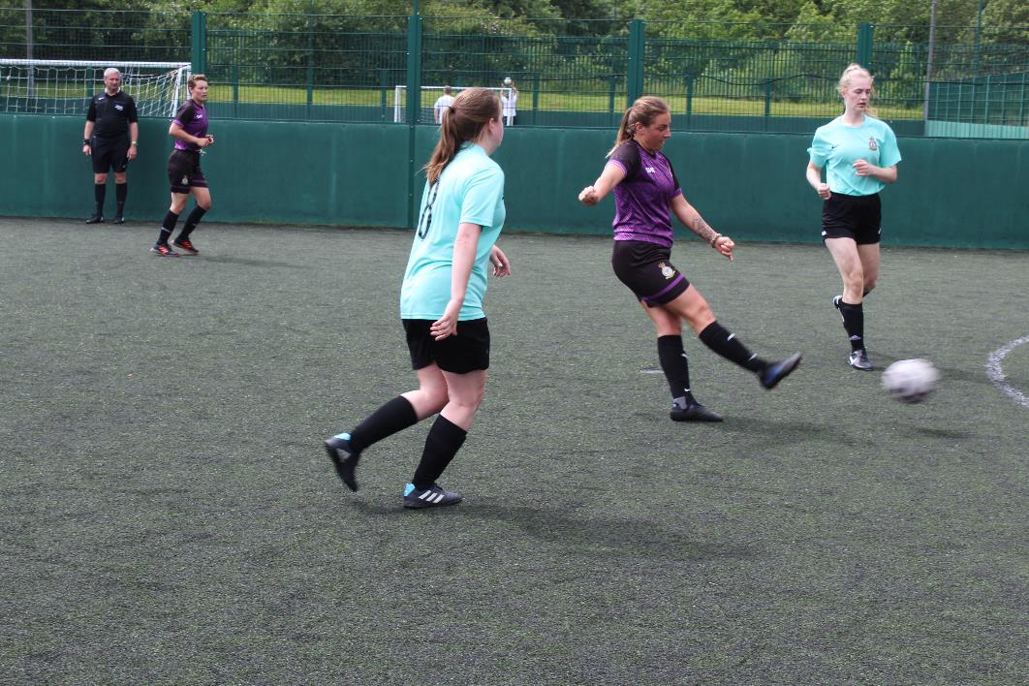

In the Trophy Semi-Finals Coningsby played a very capable and improving Cosford A Team but with a number of RAF Ladies Representative players (current and retired) Coningsby had the experience and quality to ensure they progressed to the Final. In the Final they would take on an unbeaten RAFP A Team.

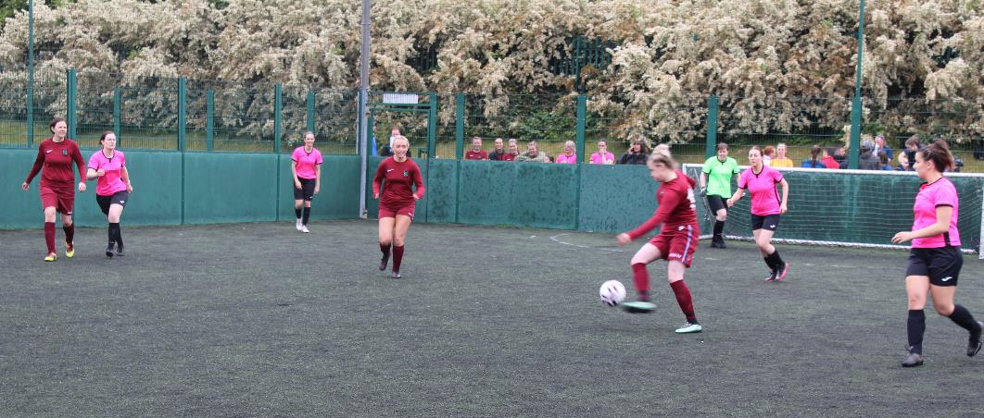
Although their semi-final victory came after penalties having thrown away a two-goal lead to nearly come unstuck against a spirited and skilful Logs/Movs Lioness team.
The Final was a tight game, with Coningsby struggling to get into a rhythm mainly due to the hard work of the RAFP team who were really fired up for the match. However, at fulltime the scores were level 2-2 and penalties were called for again.
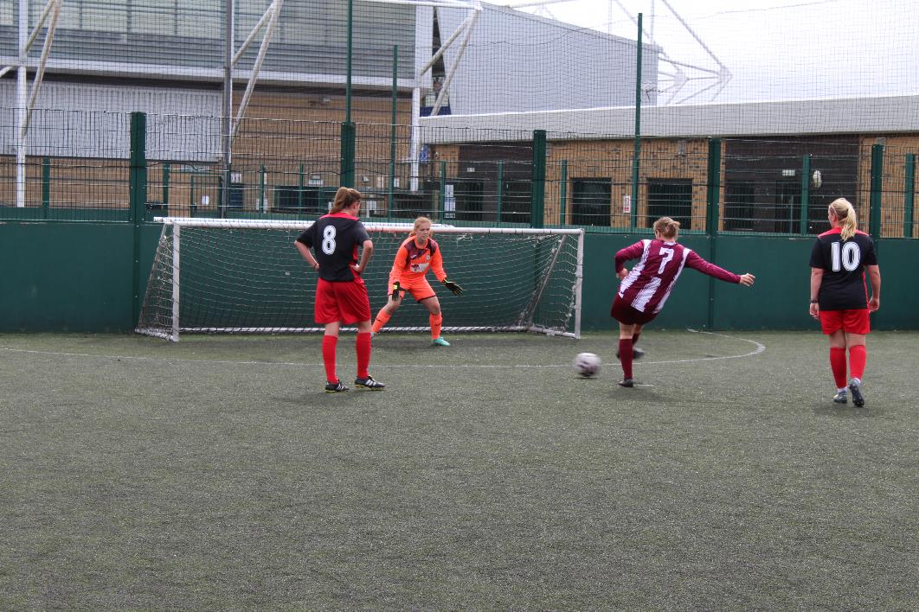
With a penalty missed by each team, sudden death penalties followed and unfortunately for Coningsby they were the first to miss with RAFP ensuring they sealed the win.

With the huge success of the day and another step in the right direction for the development of RAF Ladies football it is hoped that even more teams will enter next year with potential for post event functions to reward the participants for their contribution. Special thanks must go to WO Si Waldock and FS Phil Morris for their hard work in organising and running the tournament as without them the day could not have been possible.
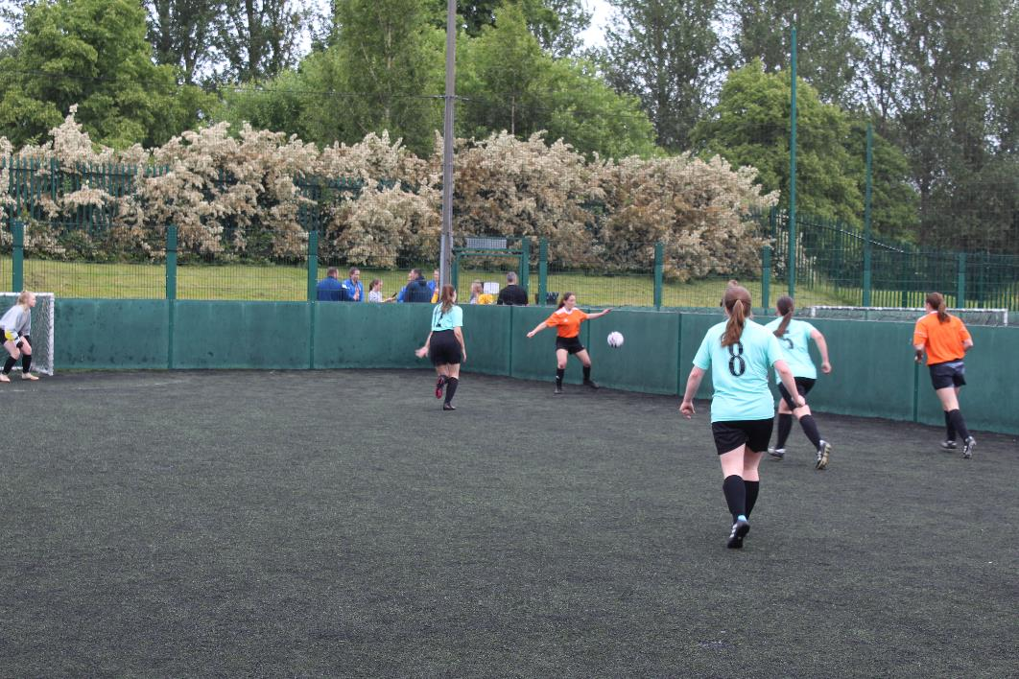
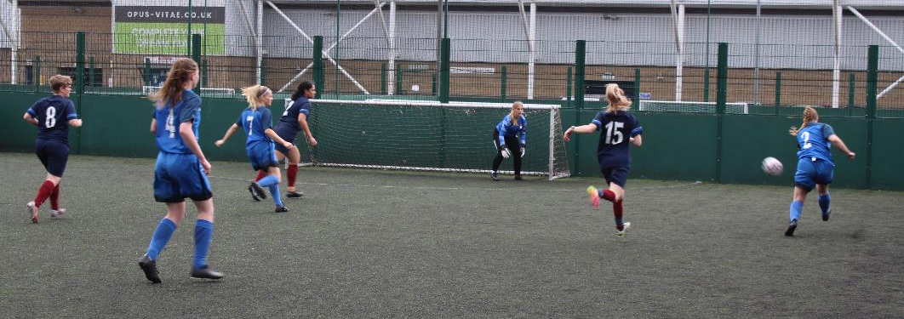

RAF FOOTBALL ASSOCIATION SPONSORS
