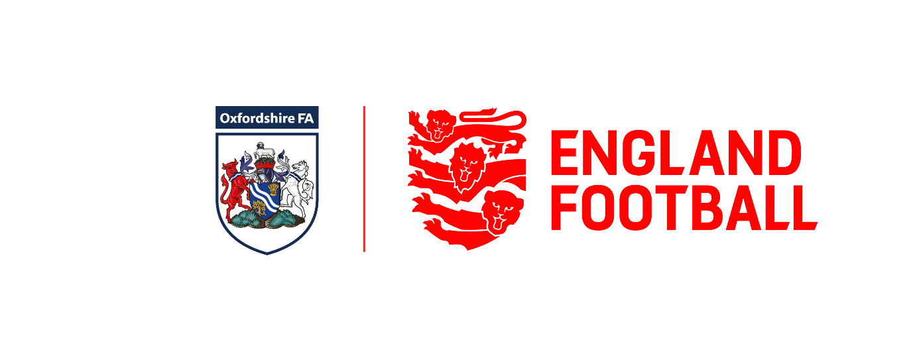

OXFORDSHIRE FA PARTICIPATION GROUPS
INFORMATION PACK

Contents
Oxfordshire FA About Us/Groups Explained/IAG |  | Pages 2-3
Where we recruit from/Groups Foreword |  | Page 4
Purpose/Roles/Responsibilities |  | Page 5
Terms of Reference/Meetings/Membership |  | Pages 6-7
Equality & Diversity Statement |  | Page 8
Expression of Interest Form |  | Page 9

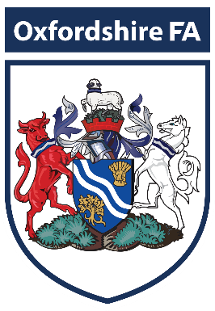
Established in 1884 Oxfordshire FA has been making a significant contribution to the community for over 138 years. Oxfordshire FA is the not-for-profit Governing Body of Football in the County.

Our role is to grow participation, promote diversity and regulate the game for everyone to enjoy.
Over 10,000 players, 200 clubs, 1,000 teams and thousands more volunteers of all ages help Oxfordshire FA keep the grassroots game going.
As the home of local football at the heart of our community, we’re proud to be developing the sport in Oxfordshire, providing opportunities For All, regardless of age, ability, faith, gender, sexuality or any other protected characteristic or background to get involved in the game - in whatever role they choose.

OUR MISSION STATEMENT

To lead change, driving the development of football in Oxfordshire and creating environments which encourage participation and enjoyment of football For All.
In doing so, we aim to govern, develop and innovate football within our county in a manner that is transparent, inclusive and supportive of our predominantly volunteer community.

#WeAreYourFA

Oxfordshire FA Participation Groups Explained

How We Operate
The Participation Group Structures highlighted below have been designed to ensure the County FA continue to serve and develop grassroots football within Oxfordshire. There are 7 OFA employees reporting through the Chief Executive into the OFA Board. The Participation Groups will help provide guidance and support how we develop the game across the County.

FOOTBALL DEVELOPMENT

YOUTH COUNCIL
OFA BOARD
FOOTBALL PARTICIPATION
GROUPS

INCLUSION ADVISORY
GROUP

Our aim is to be the most wholly inclusive County FA in the country. Our Inclusion Advisory Group acts as a critical friend to Oxfordshire FA to provide valuable advice and guidance around equality and inclusion in relation to our strategy and annual delivery plans and services. It also provides advice to assist in the development of a diverse and inclusive paid and volunteer workforce at all levels that reflects the community within Oxfordshire. The IAG plays an important role in influencing how we, as the CFA, make decisions, with the IAG Chair being a member of our Board of Directors.

Where we recruit representation from
OXFORDSHIRE FA GROUPS

Oxfordshire Referees Groups
Oxfordshire Youth Council
Inclusion Advisory Group
Leagues/Clubs
Adults/Youth
Women’s/Girls
Football Development
County Cups
Accreditation
Representatives from OFA Senior Clubs
Oxfordshire Referee’s
Disability Football
Facilities

PARTICIPATION GROUPS
The Oxfordshire Football Association is a Membership organisation, as such we work closely with our Member Clubs, Leagues and Strategic Partners to ensure the Oxfordshire Football Association is representative of the people in Oxfordshire that we serve. Leagues and Clubs will be the initial Participation Groups. Members of the Participation Groups will have a voice within the organisation. To enable this to happen we will recruit volunteers to our newly formed Participation Groups with the skills and experience best suited to support the decision-making process within the Association.

Purpose of Oxfordshire FA Participation Groups
- To debate issues and reflect the views of its members.
- To support all football in Oxfordshire regardless of gender, age, disability or any other protected characteristic or demographic background.
- To represent Oxfordshire FA and highlight the work being undertaken.
- To provide clear feedback on decisions made to those you represent.
- To increase and sustain participation within the County.

Participation Groups Members Roles and Responsibilities
- To attend and actively participate in Groups Meetings.
- All members of the Groups will have the experience and skills directly relevant to the work of the Groups.
- The Groups shall be chaired by a member of each Participation Group, and at least one member of the Board of Directors shall be a member together with any relevant members of Staff. The quorum necessary for the transaction of the business is 5.
- On the recommendation of the Board Members, suitable applicants will be approved by the Board of Directors.
- Any Board Member will be entitled to attend.
- The core qualities and experience required for Membership of the Groups will be determined by the Board of Directors and may be modified in particular cases, if the Board of Directors consider that appropriate.
- Membership will comprise representatives from the above Oxfordshire FA Groups.
- If a budget is required for the tasks, then the Board will determine if necessary.

MEMBERSHIP OF THE PARTICIPATION GROUPS

The Groups shall be Chaired by a member of the Participation Groups, and at least one member of the Board of Directors shall be a member together with the relevant members of staff. The quorum necessary for the transaction of business is 5.
All members of the Groups will have experience and skills directly relevant to the work of the Groups.
On the recommendation of the Board Members suitable applicants will be approved by the Board of Directors.
Any Board Member will be entitled to attend.
The core qualities and experience required for Membership of the Groups will be determined by the Board of Directors and may be modified in particular cases if the Board of Directors consider that appropriate.
Membership will compromise representatives from the following:
OFA Board Member with the relevant responsibilities.
Representatives from the affiliated OFA Leagues representing Male and Female, Adult and Youth
Representative from a Club at Step 4 and above.
If a budget is required for the tasks, then the Board will determine if necessary.

TERMS OF REFERENCE DEVELOPMENT GROUPS
- Assist in identifying and supporting, relevant actions contained within the County FA Game Strategy.
- Assist in the development of football for all regardless of gender, age or disability.
- Create opportunities for all to participate in the game through recreational football.
- Referee training and development.
- Support the County Cup Finals.

MEETINGS
The Participation Groups will meet on as many occasions as required to carry out the business of the Groups.
Decisions will normally be taken on the basis of consensus, and otherwise on the basis of a simple majority, of members present and voting at a duly convened meeting. The Chairperson may use their casting vote only if there is a tied vote.
Actions recorded will be produced within 7 days and approved by the Chair before being distributed to all other Participation Groups Members
All minutes will be referred through to the OFA Directors.
The Participation Groups shall review its Terms of Reference and processes on an annual basis. Any alterations will be referred to the OFA Directors for approval.
All Members of the Participation Groups must sign to say any necessary training has been taken and they will operate within the Terms of Reference.
Failure to sign or follow the TOR will mean the member(s) being required to stand down.

Name ……………………………………………………………………………
Position on Participation Groups ………………………………………………………………………………….….
Signature ……………………………………………………………………..
Date ……………………………………………………………………………..

EQUALITY AND DIVERSITY STATEMENT
Oxfordshire Football Association Ltd is committed to encouraging equality, diversity and inclusion among our Groups and workforce, and eliminating unlawful discrimination.

The aim is for our Board, Participation Groups and workforce to be truly representative of all sections of society and our customers, and for each member to feel respected and able to give their best.
Our policy’s purpose
1. Provide equality, fairness and respect for all in our members, whether employed or voluntary
2. Not unlawfully discriminate because of the Equality Act 2010 protected characteristics of:
- age
- disability
- gender reassignment
- marriage and civil partnership
- pregnancy and maternity
- race (including colour, nationality, and ethnic or national origin)
- religion or belief
- sex
- sexual orientation

Monitor the make-up of the Groups regarding information such as age, sex, ethnic background, sexual orientation, religion or belief, and disability in encouraging equality, diversity and inclusion, and in meeting the aims and commitments set out in the equality, diversity and inclusion policy.
Monitoring will also include assessing how the equality, diversity and inclusion policy, and any supporting action plan, are working in practice, reviewing them annually, and considering and taking action to address any issues.

EXPRESSION OF INTEREST FORM
A form is now available on our OFA Website and needs to be returned to the OFA Chairman no later than Friday 15th September 2023.
Please follow the link below to access the form:
https://bit.ly/3KHeWAk

