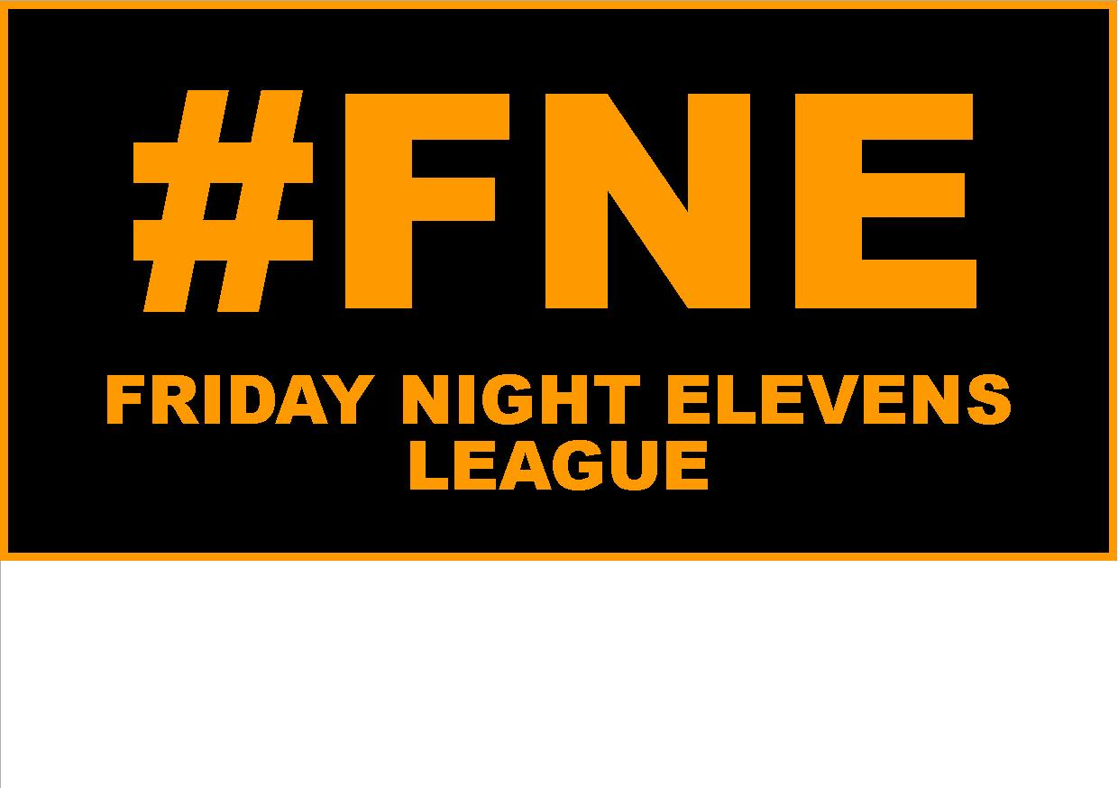

ENTRY FORM

TEAM NAME

PLEASE COMPLETE ALL PARTS OF THE FORM AND EMAIL TO [mark.woodhall@northumberlandfa.com](mailto:mark.woodhall@northumberlandfa.com)

OR POST TO NORTHUMBERLAND FA, WHITLEY PARK, WHITLEY ROAD, BENTON, NE12 9FA.

BY SUBMITTING THIS ENTRY FORM YOU ARE CONFIRMING YOUR TEAMS AVAILABILITY FOR THIS COMPETITION AND AGREEING TO THE COMPETITION RULES AND F.A CODES OF CONDUCT.

MAIN CONTACT DETAILS

FIRST NAME

POST CODE

MOBILE

EMAIL

ADDRESS

DATE OF BIRTH

SURNAME

*If available*

TEAM TWITTER

TEAM COLOURS