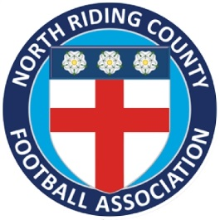
North Riding County Football Association
Referee Promotion Candidate
Service Level Agreement (SLA) 2020/21

I can confirm that I have fully read the “North Riding County FA Referee Promotion Scheme Guidance 2020/21 Booklet” and fully understand what is required of me as a promotion candidate as detailed within the guidance booklet.
As a promotion candidate, I also understand that I must ensure my closed dates are kept up to date at all times and that this is to be done via the Pitchside Referees online portal.
Lastly, I agree that it is my responsibility to ensure that I officiate in the required number of games needed for promotion and that it is my responsibility to submit these fixtures to the Observer Coordinator as and when requested. I also understand that it is my responsibility as the referee to ensure that I meet all aspects of the promotion criteria outlined within the guidance booklet in order for me to be successful in achieving promotion.
Professional conduct is also expected by all Promotion Candidates both on and off the field of play. Extreme caution should be taken when using Social Networking websites and messaging boards.
Therefore, I am fully aware that as a promotion candidate, should I bring either the game, or North Riding County Football Association into disrepute via my conduct either on or off the field of play, then this may result in my removal from the 2020/21 Promotion Scheme.

Name:
Signed:
Date:

