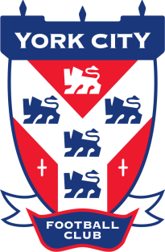
PART TIME YDP COACH (U14’S)

York City Academy are looking to appoint a part time YDP coach to support the development of our talented and committed U14 squad for the 2018/19 season.

Role

The academy will be playing in the Junior Premier League in the 2018/19 season where the majority of games will be on a Saturday. There will be two training sessions per week that you would need to plan, deliver and review against the club’s curriculum and frameworks. You will also be expected to write and deliver reviews with players three times per season in order to agree and reflect upon performance goals with players.

Qualities

You will play a key role in the delivery of the academy programme that commits to offering outstanding experiences to the young people within it. You will be able to design outstanding learning environments that are challenging, engaging and allow players to develop their skills and decision making in line with the academy curriculum. You will have the skills and commitment required to understand the needs and wants of the players you are working with, not just technically and tactically but physically, psychologically and socially as well.

You will ideally have experience working with older players in a talent development environment over a number of years. It is important to us that our coaches are reliable, honest and committed in order that they set the best possible example to our young players.

Qualifications (Essential)

As a minimum we expect candidates to hold their Uefa B coaching badge (Level 3) and FA Youth Award. Candidates must also have an in date First Aid/Emergency Aid and FA Safeguarding Children Certificate.

As part of the application process you will be subject to undertaking an enhanced DBS Check.

If you feel your skills and experience would add value to our academy coaching team please send a CV and short covering letter to:

academy@yorkcityfootballclub.co.uk

Applications close: 20th July 2018.

