Role Specification: INCLUSION ADVISORY BOARD MEMBER | 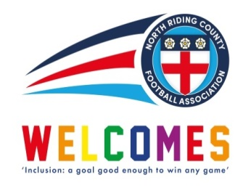  The Group will report to:  North Riding FA Board of Directors

Job Purpose:

To be part of an Inclusion Advisory Board whose role is to:
- Advance equality of opportunity for all groups, as well as having a focus on the protected characteristics
- Support the County FA in its Operational Planning
- Foster good relationships with the local community so that football can be used as a vehicle to create positive sporting opportunities and increase participation for all
- Eliminate unlawful discrimination, bullying, harassment and victimisation, and any form of abuse directed at specific groups

Key Skills And Experience Required: Essential  - To have knowledge of the key legislation aspects of inclusion and diversity and to be able to promote inclusion and diversity as part of the group  - To be able to identify key issues and trends that may help to promote the game through inclusion and diversity interventions  - Experience of working with diverse groups and individuals who have different ethnicity and cultural backgrounds  - To be able to identify key equality issues and to support the identification and delivery of solutions  - To be able to successfully network with key staff and contacts within the County FA and the area in which the County FA operates  - To be a positive team player within a group that will provide direction to Members, Directors and staff of the County FA | Key Skills And Experience Required: Desirable  - Possess a good understanding of grassroots football  - Consumer-facing on the basis that everyone is a customer and therefore a consumer  - To be able to undertake and utilise relevant research and analyse data, as required, to assist in making informed decisions  - A degree of experience of the sports/football industry  - Knowledge of how to utilise and use appropriate and relevant social media  - Basic and relevant presentation skills (if required)

Person Specification: Essential  - Ability to communicate effectively and confidently, both in written form and verbally  - Positive attitude towards the requirements of the role  - Capacity to handle confidential information sensitively  - Ability to work as part of a team group  - Ability to work in a professional manner as a representative of the County FA  - Ability to meet and work outside of normal working hours if required | Person Specification: Desirable  - To have existing positive contacts within the sports/football industry and the wider community  - To have a positive nature  - To have existing contacts within the local business community  - To have existing contacts within local community groups  - To have a knowledge of existing equality groups in the local area and who to contact

