How do you feel about not playing football during lockdown?
Click or tap here to enter text.
How do you keep fit during lockdown?
Click or tap here to enter text.
What are you looking forward to when you play football again?
Click or tap here to enter text.
What other interests do you have?
Click or tap here to enter text.
What would you like to be different when you play again?
Click or tap here to enter text.
Is there anything you would like help or advice on?
Click or tap here to enter text.
Click or tap here to enter text. |  | 
Club welfare officer name: | Click or tap here to enter text.
Email address | Click or tap here to enter text.
Telephone number | Click or tap here to enter text.
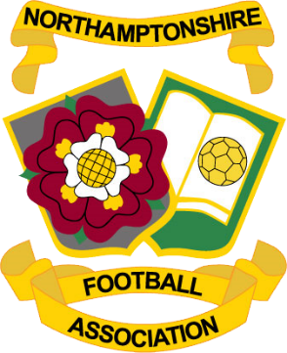

The Northants FA run all football in Northamptonshire. We work closely with
the leagues and clubs to ensure that football is safe, fun and fair for everyone involved.
We would love your help to make sure that football is as safe and as fun as possible for all of our players!

Who are we?

