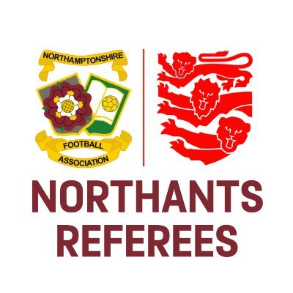
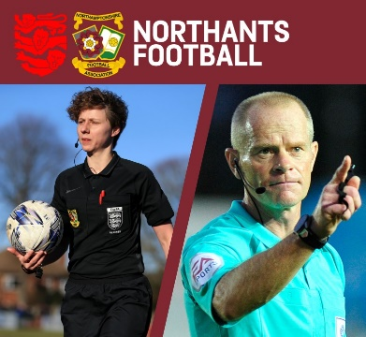
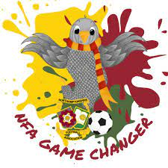

Under-18 referees – have fun and keep safe

Dear Referee,

Northamptonshire County FA wants to ensure that you are aware of the support you can access should you have any concerns over your safety and welfare while carrying out your refereeing duties. Please read the information below in full and keep the information and contact details safe in case you need them.
Northamptonshire Football Association Limited
Registered Office: 9 Duncan Close, Red House Square, Moulton Park, Northampton, NN3 6WL
Tel: 01604 670741 Fax: 01604 670 742 Email: info@NorthamptonshireFA.com

www.NorthamptonshireFA.com

It is important to remember that the vast majority of football is played in safe and friendly environments where everyone can enjoy taking part. However, we appreciate that there may be occasions when you would like additional help and support.

Concerned about something you’ve seen or heard?

Tell an adult you trust if you are concerned about something you have seen or heard, if something doesn’t feel right or if you are worried about comments someone has made to - or about - you via text or social media.

It’s very important that, if you are concerned about you own safety or the safety of another child or young person, that you let the Designated Safeguarding Officer know as soon as possible to ensure we can support you.

If you or someone else is in immediate risk of harm, then this should be reported to the police on 999.

You can also contact Childline for advice and support on 0800 11 11 or go online to www.childline.org.uk/get-support/

Disciplinary Matters

It’s also very important that all match day disciplinary matters are reported to Northamptonshire FA as soon as possible. In most cases this is a simple and speedy process that can be completed online. However, should you need assistance in compiling a report contact Olly Mackey, Northamptonshire County FA Referee Development Officer.

In the unlikely event of a very serious disciplinary matter, you may wish to speak to somebody about it. Our Referee Development Officer or Designated Safeguarding Officer can be contacted for advice and support.

Feel threatened?

In the unlikely event you feel threatened whilst refereeing; your own safety must be your priority. Find a supportive adult and ensure you can leave the venue safely. Avoid doing or saying anything that might make things worse. At the first opportunity please report these events to our Disciplinary and Designated Safeguarding Officer department. Our Referee Development Officer will contact you when he/she has been informed about the incident.

Attending a disciplinary hearing

During the course of your refereeing career you may need to attend a disciplinary hearing to give evidence. Don’t worry about this as you will be offered guidance and support by a member of the Discipline team. If you are under 18 we take your age into account and ensure the environment is relaxed and not threatening in any way. Referees under 16 can be accompanied by a parent/carer or colleague. If they prefer, our Referee Development Officer or Designated Safeguarding Officer can be on hand to offer this assistance.

Inclusion

If you have an impairment or believe there are restrictions in place preventing you from fully accessing and enjoying refereeing then you need to inform us. Football is inclusive and that applies to refereeing too. If you would like to chat about this please contact the County FA Referee Development officer or Designated Safeguarding Officer and we can help to remove the barriers to your full participation.

Name | Title | Contact Details
Olly Mackey | Referee Development Officer | Olly.Mackey@NorthamptonshireFA.com
Rosie Brown | Designated Safeguarding Officer | Rosie.Brown@NorthamptonshireFA.com
Luke Scott | Head of Operations | Luke.Scott@NorthamptonshireFA.com

Kind Regards,

Olly Mackey
Northamptonshire Football Association Limited
Registered Office: 9 Duncan Close, Red House Square, Moulton Park, Northampton, NN3 6WL
Tel: 01604 670741 Fax: 01604 670 742 Email: info@NorthamptonshireFA.com

www.NorthamptonshireFA.com

Referee Development Officer

