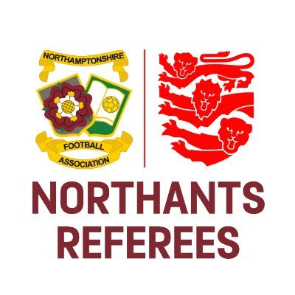
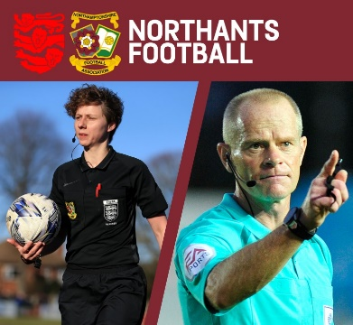
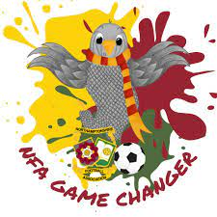
Social Media Guidance

There are 4.74 billion active social media users in the world. 84% of the UK population are on social media, which equates to over 57 million people.

There are an increasing number of referees taking to Social Media to voice their opinions on a wide variety of topics. As a result of this, we are having an increasing number of referees reported to us for their conduct on social media.

Northamptonshire FA would like to take this opportunity to remind you of your responsibilities as a match official. Match officials, Matchday Observers/Coaches, Mentors and Referee Developers need to act responsibly both on and off the field of play, which includes the use of electronic communications such as social media. Under The FA Rules and Regulations, The FA Discipline Department are beginning to charge more and more participants in football with breaches of regulation on social media for the reasons outlined above.

As you can see from the figures above, many people are using social media now any comments made on these sites are in the public domain. As such, it may reflect badly on The FA, Northamptonshire FA, all match officials and more importantly: yourself.

As an absolute minimum, when on social media, please refrain from commenting about:
- Colleagues (this includes all referees - just because a referee has given a penalty against your team in the Premier League, this doesn’t make it okay for you to publicly question their integrity/ability)
- Clubs
- Players
- The FA/County FA
- Observers

There have been - and will continue to be - examples where participants in football are charged for comments not relating to football. In particular, discriminatory and offensive comments will not be tolerated, so please be careful what you post, like, share & retweet.

This guidance is here to help you to continue enjoy using social media, but to hopefully avoid getting yourself in any unnecessary trouble with The FA/County FA.

Please remember the following:
- Don’t let your colleagues down
- Don’t let The FA/County FA down
- Don’t let YOURSELVES down
- Don’t let your guard down

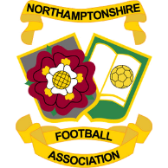
If you wouldn’t say it in a press conference, don’t write it on social media!
Northamptonshire Football Association Limited
Registered Office: 9 Duncan Close, Red House Square, Moulton Park, Northampton, NN3 6WL
Tel: 01604 670741 Fax: 01604 670 742 Email: info@NorthamptonshireFA.com

www.NorthamptonshireFA.com

