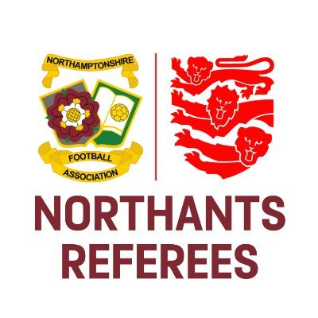
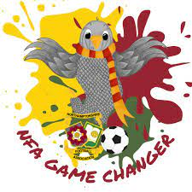

Fourth Official Guidance

A ‘Fourth Official’ will be appointed to certain rounds of FA and County FA Competitions and all matches in the English Premier League, English Football League and National League. The FA may also appoint a Fourth Official to a National League North / South, Contributory or Supply League match.

The Fourth Official actively officiates if any of the three match officials are unable to start or continue officiating. Therefore, it is important that the Fourth Official is dressed appropriately should they need to replace another official.

Before The Match, the Fourth Official should ensure that:

- Information on the teamsheets has been recorded and is correct as per LOTG / Competition Rules i.e. number of substitutes is complied with
- The match ball and any replacement balls have been checked for pressure and quality

During The Match, the Fourth Official should ensure that:

Their priorities are in the following order:
- Fouls & Misconduct
- Administration
- Management of the Technical Area and responding to any questions etc

- They alert the referee to any misconduct that has taken place (via communications kit if one has been provided)
- They maintain frequent eye-contact with the referee and other match officials
- Substitutions are managed carefully and calmly, with the ‘board’ raised to indicate the players leaving/entering the field of play
- They keep a full match record i.e. misconduct, substitutions, goals, time lost etc
- The ‘board’ is raised on exactly 45 and 90 minutes showing the number of minutes that has been added
- The entry of physiotherapists / doctors is managed effectively
- The Technical Area occupants are dealt with in a preventative rather than confrontational manner
- They are aware of the current LOTG relating to Technical Area occupants and make the referee aware of any relevant misconduct, should it occur, throughout the match

After The Match, the Fourth Official should ensure that:

- They clarify and cross-check the misconduct, substitutes, goals scored and all other relevant administration with the Referee and that this is suitably recorded
Northamptonshire Football Association Limited
Registered Office: 9 Duncan Close, Red House Square, Moulton Park, Northampton, NN3 6WL
Tel: 01604 670741 Fax: 01604 670 742 Email: info@NorthamptonshireFA.com

www.NorthamptonshireFA.com

