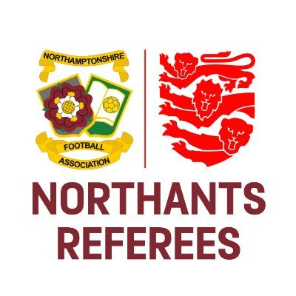
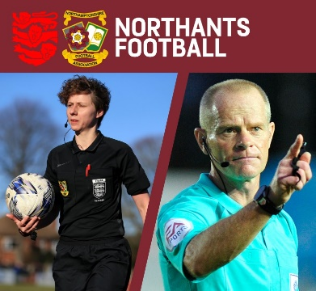
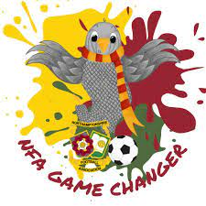

Treatment of Injuries Guidance

The Laws of the Game stipulate that the Referee should “allow play to continue until the ball is out of play if a player is only slightly injured” and “stops play [immediately] if a player is seriously injured”. If you’re in any doubt whether the injury is ‘slight’ or ‘serious’, our advice would be to air on the side of caution and stop the game.

Once a ‘medical representative’ has entered the field of play - following the Referee’s signal - and assessed the injured player, the injured player must leave the field of play until they are ready to return. The returning player must only re-enter the field of play following the Referee’s signal and must only return from the touchline (unless the ball has since gone out of play, in which case the injured player can re-enter from any boundary line).

There is no requirement for the injured player to leave the field of play following assessment by a ‘medical representative’ in the following circumstances only:

- A goalkeeper is injured
- A goalkeeper and outfield player have collided and require attention
- Two or more players from the same team have collided and require attention
- A severe injury has occurred
- A player is injured as a result of an offence for which the offending player is cautioned or sent off and the treatment is completed quickly**
- A penalty kick is awarded and the injured player is the kicker

** If the assessment / treatment of a player takes longer than it takes for you to issue the yellow or red card to the offending player, the injured player should still be directed to leave the field of play, as their assessment / treatment has not been completed ‘quickly’.

In relation to the management of injuries, the Referee should also:

- Ensure that any bleeding player, or a player with blood on their playing equipment, should leave the field of play. The player should only return after a signal from the Referee and when they have stopped bleeding and have no blood on their equipment.
- Ensure that the injured player leaves the field of play following assessment / treatment

As always if you have any questions regarding any of the above, please don’t hesitate to contact us. Good luck in your upcoming games!

Olly Mackey
Referee Development Officer
Northamptonshire Football Association Limited
Registered Office: 9 Duncan Close, Red House Square, Moulton Park, Northampton, NN3 6WL
Tel: 01604 670741 Fax: 01604 670 742 Email: info@NorthamptonshireFA.com

www.NorthamptonshireFA.com

