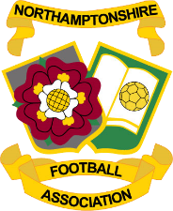
Northamptonshire Football Association Vacant Council Positions Nomination 2021.

Northamptonshire FA has two Council positions which are currently vacant.
Please send any nominations for the positions below to maria.murphy@northantsfa.com by 5pm on 6th July 2021.

Position Vacant | Name of Proposed person for the position | Nominated by: | Seconded by:
Clubs without a League representative

Disability Football

There will be a ballot should there be more than one nomination for these positions. Details of the election will be forwarded should a ballot be required.

