
Women’s Community Football Officer





Who we are
Middlesex Football Association are a charitable organisation providing everyone with the opportunity to participate in football across our Boroughs which are the most densely populated and diverse in the country.
We aim to ignite positive change through the power of football. The purpose of everything we do is to unite communities, tackle inequalities, and promote health across our county. Our values are integral to everything we do. We are committed to making the grassroots game better. Through continuous connection with our local community, we will work creatively and collaboratively to enhance their experience.
We nurture the grassroots game, fostering a love for the sport that extends far beyond the pitch. By building strong relationships with our community, we will understand their needs and will develop solutions together, to ensure everyone has the chance to participate.
With unwavering dedication and a spirit of innovation, we are building a Middlesex where football flourishes, inspiring a brighter future for all.
Our Strategy
‘Realising Our Potential’ is our current four-year strategy which is made up of four strategies which include Commercial, Middlesex Community Football Centres, Equality, Diversity and Inclusion, and a Grassroots Strategy.
Our Purpose
Inspiring positive change through football by uniting communities, tackling inequalities and improving the health of the Middlesex Football community.
Our Values
We are Committed – We are committed to governing the game in a way that is fair and treats everyone the same regardless of age, disability, gender reassignment, race, religion or belief, sex, sexual orientation, marriage and civil partnership, pregnancy and maternity.​
We are Creative – We are creative, always finding new ways to stay ahead and serve our football community. We learn from our experiences and focus on the future.
We are Collaborative – We will collaborate with our clubs, leagues, referees, players, coaches and volunteers to ensure we are listening to feedback and meeting their needs. We will collaborate as a team to share knowledge, provide feedback and work as a team to meet our common goal. ​
We are Connected – We are connected with our community, operating with a customer-focused approach that puts our participants at the heart of what we do.

For further information on Middlesex FA please visit our website and please review our Annual Report and our four-year strategy ‘Realising Our Potential’.
Season Review link https://www.middlesexfa.com/news/2024/aug/08/annual-review-2024
Strategy link https://www.middlesexfa.com/about/strategy-2024-28
ROLE DESCRIPTION
Women’s Community Football Officer

What is the role?
The Women’s Community Football Officer will play a key role in developing and growing women’s and teenage girls’ football across Middlesex, with a particular focus on increasing participation and creating opportunities within targeted communities.

The role will lead on the development of community-based football opportunities, supporting both sessional and team-based activity across formats including walking football, small-sided football, flexi leagues and Just Play. A key element of the role will be understanding the needs of local communities and working with partners to develop accessible, inclusive and sustainable football opportunities that respond to those needs.

Women’s and girls’ football is a key priority within Middlesex FA’s 2024–2028 strategy, and this role provides an exciting opportunity to make a tangible difference to the growth and development of the game. The postholder will work collaboratively with clubs, leagues, community organisations, local authorities, schools, education providers and other strategic partners to identify barriers to participation, engage historically underrepresented groups and develop new pathways into football.

We are looking for a conscientious and self-motivated individual, who is passionate about supporting and growing our membership to provide and develop football opportunities for all sectors of the Middlesex community.

What will you do?

- Lead the development and growth of women’s and teenage girls’ community football across targeted areas of Middlesex, supporting the creation and delivery of accessible sessional and team-based opportunities, including Just Play, walking football, small-sided football and flexi leagues.
- Develop and maintain strong partnerships with clubs, leagues, local authorities, community organisations, schools, education providers, Active Partnerships and other local and national stakeholders to identify opportunities, address barriers to participation and support the delivery of place-based football plans.
- Champion inclusion and participation, working with partners and underrepresented groups to understand local needs and develop relevant, sustainable football opportunities that enable more women and girls to participate and remain involved in the game.
- Monitor, evaluate and communicate the impact of the work, using data, insight and feedback to measure progress, identify good practice and inform future delivery, while ensuring compliance with FA strategies, policies, safeguarding requirements and relevant reporting arrangements.

If you need any more information or have any questions about this role, please contact Andrew.Perren@middlesexfa.com.

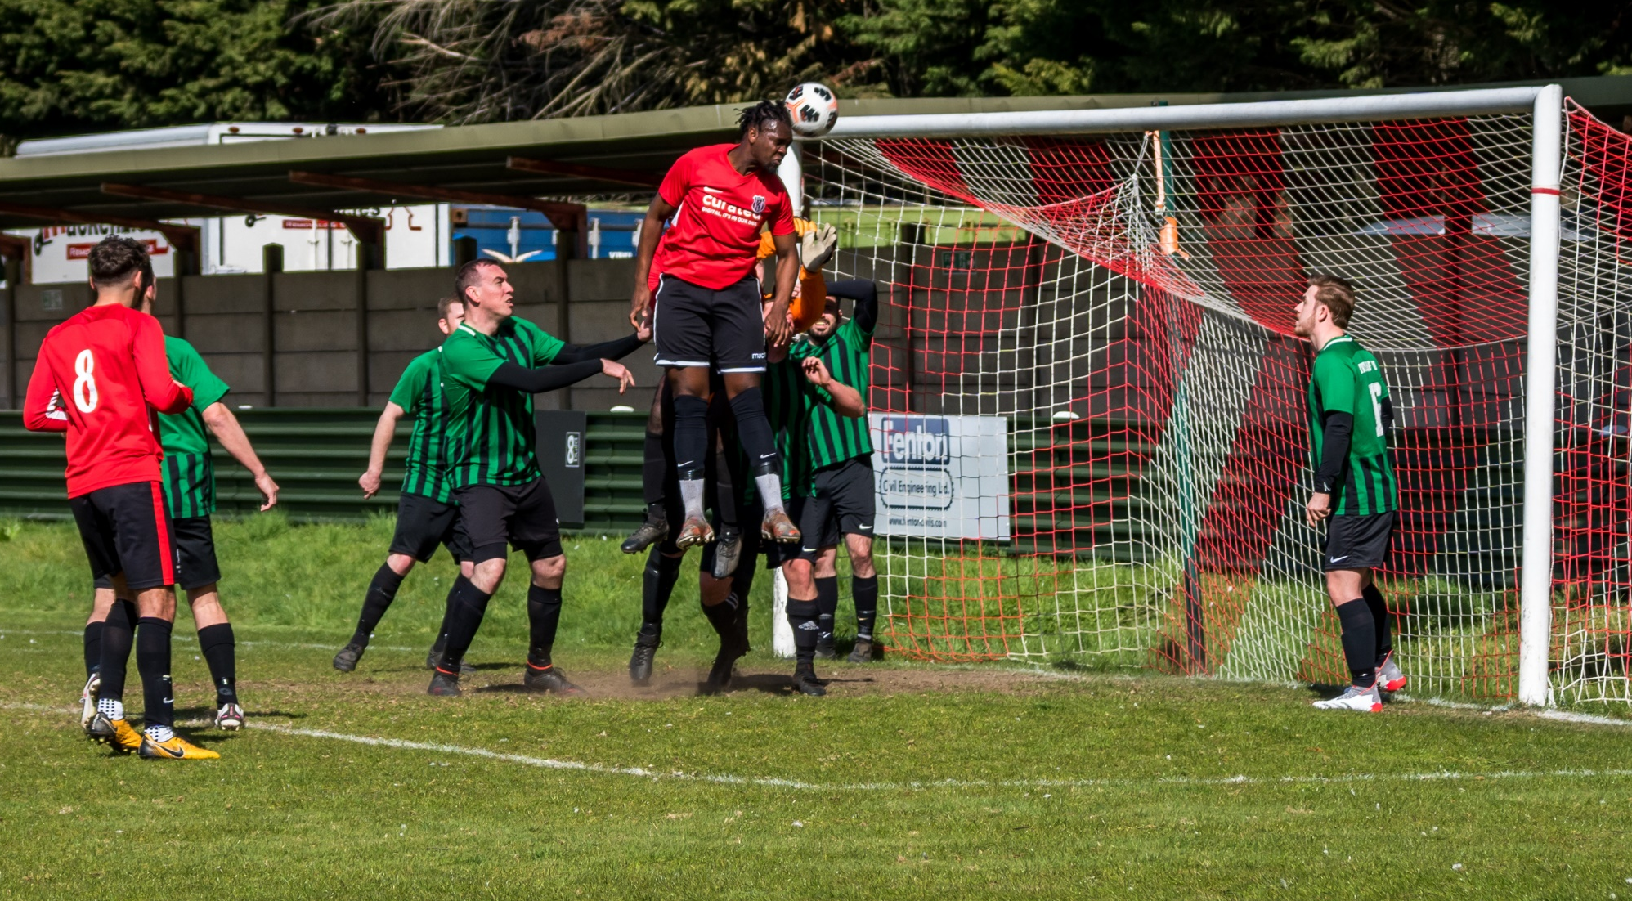

APPLICATION PROCESS

To apply, please complete the below Application Form and send it (no CVs) to management@middlesexfa.com.

Please make sure to review the recruitment pack in full before completing your application. If for any reason you are unable to access or complete the application, please contact management@middlesexfa.com who can arrange for any reasonable adjustment to be made for your application.

If shortlisted, you will be invited to attend an interview for this role. The interview will be arranged at your convenience; Middlesex FA will happily work around your current commitments and responsibilities.

Middlesex FA is committed to equality, diversity and inclusion. Striving to be fully representative of the community it serves by ensuring that all job applicants, third-party partners, and members of staff are treated equally, without discrimination because of gender, sexual orientation, marital or civil partner status, gender reassignment, race, colour, nationality, ethnic or national origin, religion or belief, disability, or age.

KEY DATES

APPLICATION CLOSING DATE: Sunday 22nd November 2026

INTERVIEWS: Monday 30th November 2026
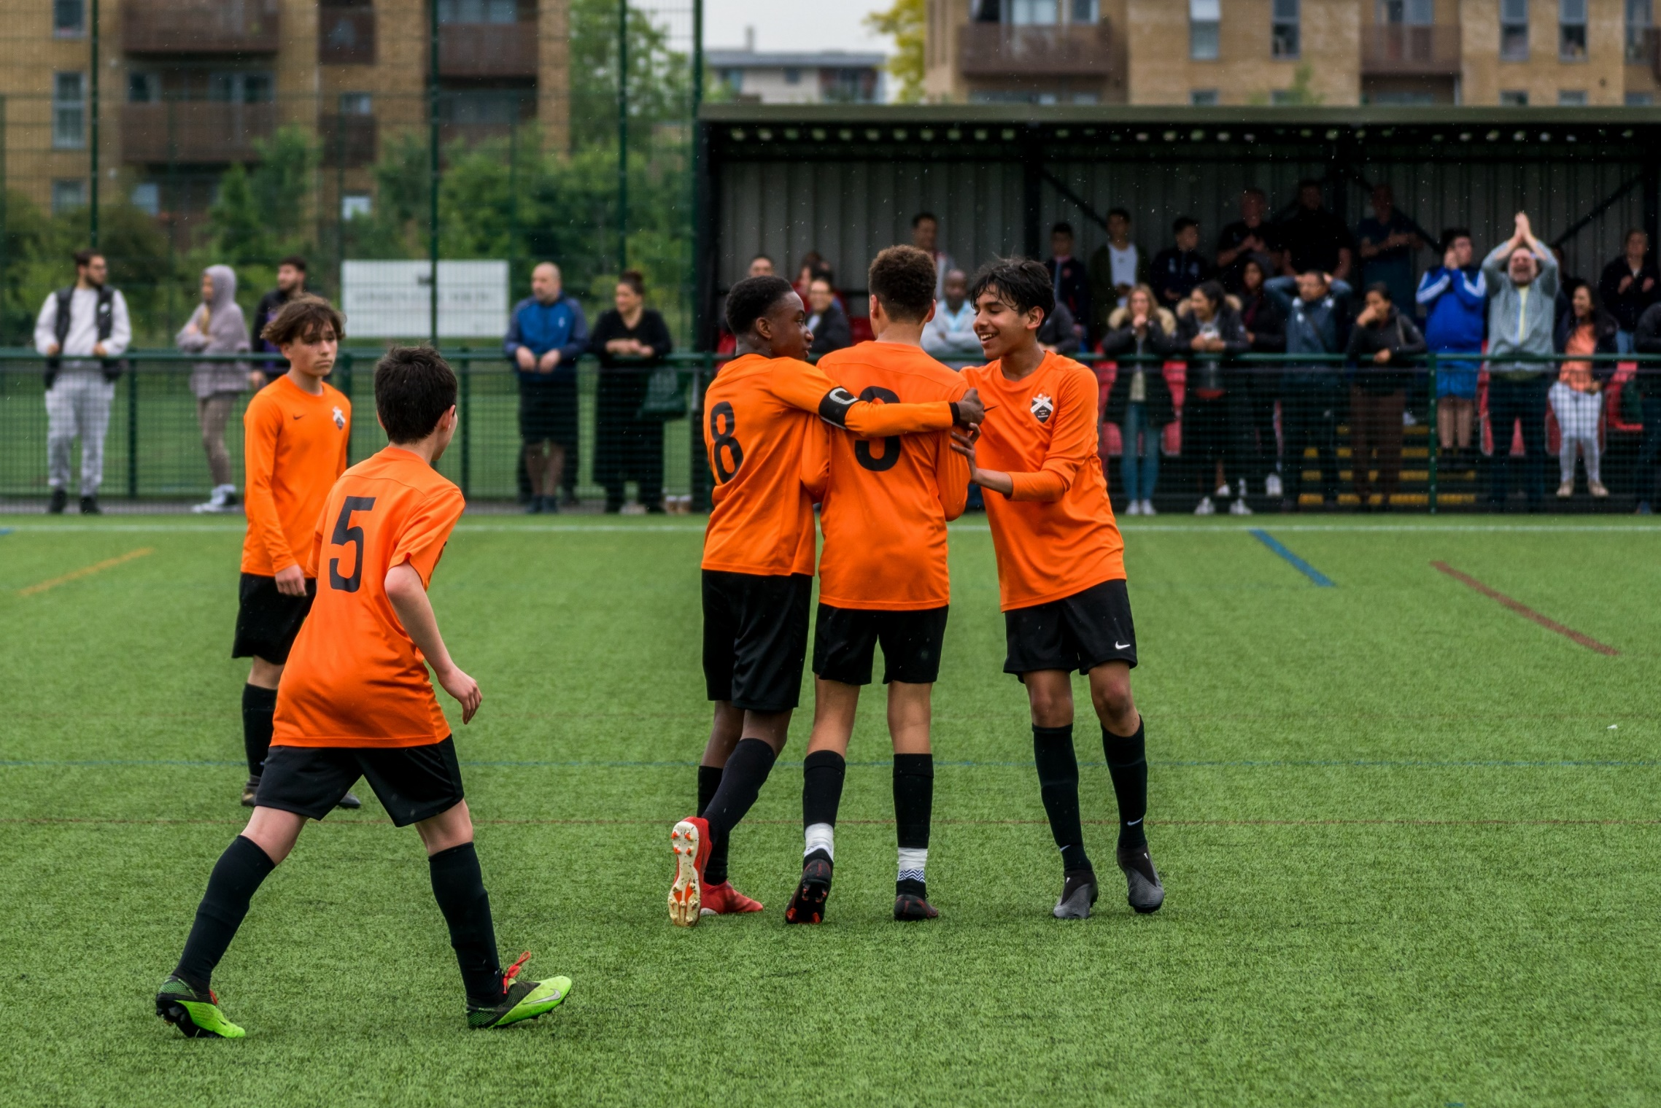

INDIVIDUAL ROLE PROFILE
Women’s Community Football Officer
Reports to: Development & Workforce Lead
Direct Reports: N/A
Role Purpose: To support delivery of The FA National Game Strategy and the County FA’s Business Strategy.
To lead on the development of women’s and teenage girls’ community football in priority places (Brent & Harrow). This is inclusive of sessional football and team-based opportunities across walking football, small-sided football and flexi-leagues.
To contribute to the effective implementation of The FA’s Safeguarding Operating Standard for County FAs.
To support the adoption of FA technology systems across grassroots football.
To comply with FA rules, regulations, policies, procedures and guidance that are in place from time to time.

Salary Band: circa £26,000
Working Hours: 35 hours per week. Flexible working hours between 8:00am – 6:00pm with a minimum requirement of two days in the office per week. Evening and weekend work will be required.
Contract Type: Fixed term until 30th June 2028
Location: Office based (Middlesex FA HQ, UB5 5FA) with regular travel across Middlesex.

Responsibilities
Participation
- Understand what the current adult women's and teenage football landscape looks like in the area to help identify potential development opportunities.
- Collaborate with stakeholders to support the development and implementation of a female football plan for targeted geographical locations (place based approach).
- Grow adult women’s community football, inclusive of sessional football via Just Play, alongside team based football across walking football, small sided football, and flexi leagues.
- Identify and engage historically underrepresented groups by working with local relevant partners and community organisations, developing fit for purpose football offers.
- Identify good practice and share learnings, contributing to the understanding and development of an effective place based approach for football.
- Provide The FA with quarterly monitoring and evaluation reports.

Workforce
- Ensure that the projects and the volunteers recruited are inclusive, diverse and reflective of local communities.
- Grow and diversify volunteers, maximising and aligning relevant FA opportunities and resources such as courses, workshops, and learning materials.

Networks & Partnerships
- Ensure connectivity with the local Active Partnership and Sport England's place expansion work in targeted communities. Connect with the local ‘Active Through Football’ Development Officer where relevant.
- Utilise key local and national partners to support the plans, including Barclays Girls Football School Partnerships, AoC Sport and BUCS, Sported, Street Games, and Power League.
- Work closely with the County FA Women's Football Development Officer and County FA Club Development Leads to ensure connectivity of this work from the youth game (including schools), and into the women’s football pyramid (beyond recreational competition).
- Work with County FA and FA colleagues to develop and sustain a localised project/steering group to support the development, evolution and evaluation of local delivery plans.

Health & Wellbeing
- Support the development of relationships between Greater Game Flagship Clubs and local health, education, youth and community organisations to create connected networks that enhance the health, wellbeing and football experiences of teenage female players.
- Work with County FA Club Development Leads to promote The Greater Game and Equal Game principles within Club’s wider health and wellbeing initiatives, providing guidance, resources, and practical support to help create positive environments that promote the physical, mental, social, and emotional wellbeing of female players.
- Provide bespoke support, mentoring, and resources to sessional football providers to help them effectively integrate The Greater Game principles into delivery, ensuring programmes meet the needs of teenage girls and support sustained engagement in football and wellbeing-focused activity.

Person specification
Qualifications
Essential  - Degree level qualification or equivalent experience  - Relevant sports coaching qualification | Desirable  - Two years’ sports development experience  - Relevant FA coaching qualification
Skills
Essential  - Ability to work strategically with partner organisations across different sectors to plan and deliver football programmes.  - Project management skills and experience – to plan, set and achieve objectives to deadlines.  - Excellent IT skills, including the use of Microsoft Office applications.  - Ability to work independently and as part of a team  - Excellent time management and prioritisation skills.  - Excellent creative problem-solving and decision- making skills.  - Outstanding communication and presentation skills.  - Exceptional customer service.  - Budget management skills  - Report-writing skills.  - Ability to use data to monitor and evaluate programmes.  - Influencing skills to champion change. | Desirable  - Practised at developing networks and relationships with a variety of stakeholders in order to support the delivery of strategic priorities.  - Skilled in creating, delivering and maintaining pathways which support the growth, transition and retention of players.  - Capability to create multiple reports, budgets and plans.
Knowledge and experience
Essential  - Passionate about working in women’s and girls’ football.  - Knowledge and understanding of the barriers to participation faced by females, and underrepresented female groups in sport/football  - Knowledge of The FA’s strategy for women’s and girls’ football.  - Knowledge and understanding of the infrastructure and networks that exist that can support the development of women’s and girls’ football.  - Knowledge of the structure and partner organisations within football both nationally and within the locality.  - Practical experience of sports / football development including coaching and leading sports activity  - Demonstrate a working knowledge of inclusion, equality, anti–discrimination and safeguarding. | Desirable  - Knowledge of The FA’s National Game Strategy.  - Experience of project management.  - Experience of utilising mapping programmes to support strategic and logistical planning.  - Knowledge and understanding of working with volunteers.  - Knowledge of The FA coaching qualification framework.  - Experience coaching and leading sports activity / football for underrepresented groups.
Enhanced DBS Check required? | YES
Clean, full driving licence? | YES
To apply, please complete the below Application Form and send it (no CVs) to management@middlesexfa.com.

Please make sure to review the recruitment pack in full before completing your application. If for any reason you are unable to access or complete the application, please contact management@middlesexfa.com who can arrange for any reasonable adjustment to be made for your application.


WHY WORK FOR MIDDLESEX FA?

CYCLESCHEME
Staff can purchase commuter bikes and cycling accessories which is taken before tax as a salary sacrifice and paid back to MFA over a 12-month period.

BIRTHDAY
We give you your birthday off! If it falls on a Saturday or Sunday, you will be given the Friday or Monday.

ADDITIONAL DAYS
We choose to close the office and give you time off at Christmas but reviewed yearly. We give you two volunteering days a year (to take place in Middlesex).

STAFF SOCIALS
Our team training days always contain social activity.
TRAINING
We offer financial and professional support for education and training (linked to your role) but supportive of your own personal development.

ACCESS TO FA TICKETS
Staff Members have the opportunity to purchase tickets, allocated to County FAs, for England internationals and the FA Cup Final.

FLEXIBLE AND AGILE WORKING
We offer flexible working, giving you the opportunity to work from home, remotely and to manage your own time around your personal life and family.

STAFF DISCOUNT
Staff can purchase goods from Rectory Park at a discount.

STANDARD BENEFITS FOR MIDDLESEX FA?
Workplace pension scheme
Free Nike Staff Uniform every year
Employee Assistance Programme
Opportunity to be part of the Health and Wellbeing Group (This group supports all staff on a range of topics such as fundraising for our Charity Partner, Health and Fitness, Wellbeing Workshops, Staff Socials and much more)
Annual Leave entitlement

Middlesex Football Association
Job Application Pack

Position Applied for:
Job Reference: | N/A
How you learnt about this position | Please provide an answer as it helps us refine future recruitment processes
THE INFORMATION YOU SUPPLY ON THIS FORM WILL BE TREATED IN CONFIDENCE

Section 1: Personal Details

Surname |  |  | Forename
Address |  |  | Home No
 |  |  | Mobile No
Postcode |  |  | National Insurance No.
Email Address |  |  | National Insurance No.
Can we contact you at work? | Choose an item.
If yes, Work Telephone Number:
Are you free to remain and take up employment in the UK  with no current immigration restrictions | Choose an item.
If you are successful you will be required to provide relevant evidence of the above details
Section 2: Present Employment (if not currently employed please give details of last employer)

Name of Employer: |  |  |  |  | Job Title:
Address: |  |  |  |  | Date of Appointment:
Postcode: |  |  |  |  | Department/Location:
Salary:
Brief Description of duties:

Continue on a separate sheet if necessary.
Period of Notice: |  |  |  | Last day of service:  If no longer employed
Reason for Leaving (if no longer employed):

Section 3: Previous Employment (most recent employer first)

Name of Employer:
Address:
Postcode:
Position Held:
Start Date: |  | End Date:
Summary of Duties:

Reason for Leaving:

Name of Employer:
Address:
Postcode:
Position Held:
Start Date: |  | End Date:
Summary of Duties:

Reason for Leaving:

Name of Employer:
Address:
Postcode:
Position Held:
Start Date: |  | End Date:
Summary of Duties:

Reason for Leaving:

Section 4: Education

Qualifications obtained from Schools, Colleges and Universities (please list the highest qualification first)

College or University | Start (mm/yy) | Completed (mm/yy) | Course | Qualifications and Grade obtained

School | Start (mm/yy) | Completed (mm/yy) | Subjects | Qualifications

Professional / Coaching Qualifications

Professional / Coaching Qualifications | Course Details (Level/Pass Date)
Section 5: Training and Development (please give details of any training and development courses or non-qualifications courses which support your application. Include any on the job training as well as a formal course)

Title of Training Programme or Course | Duration of Course

Section 6: Personal Statement
Skills, knowledge and experience.
Please use this section to explain in detail how you meet the requirements of the Job Description. If you are or have been involved in voluntary/unpaid activities, please feel free to include this information.
Attach and label any additional sheets used (we recommend no more than one additional A4 sheet).

Section 7: Rehabilitation of Offenders Act (1974)

Do you have any convictions that are unspent under the Rehabilitation of Offenders Act (1974) | Choose an item.
If yes, please give details / dates of offence(s) and sentence:

Section 8: Protecting Children and Vulnerable Adults (this information may be required if the post you are applying for requires a Disclosure and Barring Service (DBS) police check)

Are you aware of any police enquires undertaken following allegations made against you, which may have bearing on your suitability for this post | Choose an item.

Section 9: References
Please give the names and addresses of your two most recent employers (if applicable). If you are unable to do this, please clearly outline who your referees are.

Reference 1 |  |  | Reference 2
Name: |  |  | Name:
Position: |  |  | Position:
Work Relationship: |  |  | Work Relationship:
Organisation: |  |  | Organisation:
Address: |  |  | Address:
Postcode: |  |  | Postcode:
Telephone No: |  |  | Telephone No:
Email: |  |  | Email:

Are you willing for this referee to be approached prior to the interview? | Choose an item. |  | Are you willing for this referee to be approached prior to the interview? | Choose an item.

Section 10: Declaration
Signed: |  |  | Date:



