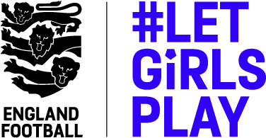

Application form: Equal Game Ambassador – Women & Girls Football

To be returned via email with a copy of your CV and Cover Letter to development@middlesexfa.com for the attention of Andrew Perren,

Surname
First name
Address
Post Code
Contact Telephone Number
Mobile Telephone Number
Email Address
Do you consider yourself to have a disability? Please tell us if there are any ‘reasonable adjustments’ we can make to assist you in your application or with our recruitment process
Do you need a work permit to work in the UK?
Please give the names and address of two referees who can be contacted (only in the event of your being offered the position). Please state in what capacity they are known to you (i.e. Personal or employer, etc)
Reference One

Reference Two

Do you hold a current Football Association issued Criminal Records Bureau certificate?

I certify that the above are correct details and that any offer of employment would be subject to satisfactory references. I also consent to the MFA making verification checks as appropriate.
To assist us in monitoring that the wider community is being made aware of our vacancies, you are invited to complete the following form. It is not mandatory and non-completion will not affect your application.

Ethnic background. Please choose one category from A to E and then please mark X in the appropriate box to indicate your ethnic background

A White |  | B Mixed |  | C Asian or Asian British
English |  | White & black Caribbean |  | Indian
Irish |  | White & black African |  | Pakistani
Scottish |  | White & Asian |  | Bangladeshi
Welsh |  | Other |  | Other
Other

D Black or Black British |  | E Chinese or Other Ethnic group
Caribbean |  | Chinese
African |  | Other
Other

Do not wish to disclose Yes No

Disability
Do you consider yourself to be a disabled person? Yes No

If you have indicated yes please mark X in all the boxes that apply to you:

Hearing impairment |  | Physical impairment
Learning difficulty / disability |  | Visual impairment
Mental health issues |  | Do not wish to disclose Yes No
Religion

Buddhist |  | Muslim
Christian |  | Sikh
Hindu |  | No active faith
Catholic
Jewish |  | Any other religion (please write in)
Do not wish to disclose Yes No
Sexual orientation

Heterosexual |  | Lesbian
Gay |  | Bisexual
Do not wish to disclose |  | Other (please write in your preferred description)

