Middlesex Football Association
Referee Registration Guidelines 2019-20 Season
Dear Referee,
The 2019-20 Referee re-registration process will go ‘live’ on the 1st June 2019 to all referees who live/register in Middlesex.
PLEASE read the following information before you contact The FA or The Middlesex FA because most queries on how to complete the registration process should be answered in these guidance notes.
WGS is an FA system and their helpline is it.support@thefa.com
The following guidance notes explain step by step how to complete the process online through The FA Whole Game System and whilst registering you can amend your personal details such as address, email and phone numbers, plus your availability and any known closed dates.
(After registering, if you need to change your contact details throughout the year, you can simply log-in to your account on WGS and amend).
You will not be able to re-register if any of the following are relevant:
- Referees (aged 16+) who intend to officiate in any Youth Football are required to have a valid FA DBS certificate. They expire after three years but can be renewed online and then verified.
Details of how to complete this requirement can be found using the following link:
http://www.middlesexfa.com/about/rules-and-regulations/safeguarding-and-welfare/local-initiatives

- Haven’t selected the Referee Administration tab once logged into the system?
Please remember that referees who do not meet the necessary criteria will not be able to register online and as a result will not see a registration tab. All officials are encouraged to complete any missing requirements before attempting to re-register again.

- Haven’t completed the necessary FA Safeguarding criteria or it has expired?
The FA have previously stated that it is only Best Practice for referees to have an in-date FA Safeguarding certificate, but from the 2019-20 season it will be mandatory for all referees in all formats of the game to have a valid FA Safeguarding certificate, you can renew now using this link:
http://www.middlesexfa.com/about/rules-and-regulations/safeguarding-and-welfare

- Referees who have not registered for more than a couple of seasons will be required to re-sit and pass the latest Laws of the Game exam before manually being registered by The County FA. Contact daniel.may@middlesexfa.com for more information.

- If the referee is suspended, as a player or other reason, you will not be able to re-register.

Please register sooner rather than later so you are registered during the summer for Tournaments and pre-season games. If you need an FA CRC check, complete it now in time for the new season.
How to use The Whole Game System to Re-register?
- To start with, please click on the following link: https://wholegame.thefa.com

- This will take you to the following home page (if you are using Internet Explorer 8 or older, the Home page will be there but you will need to scroll down the page to see it.
I found Google Chrome to work better.
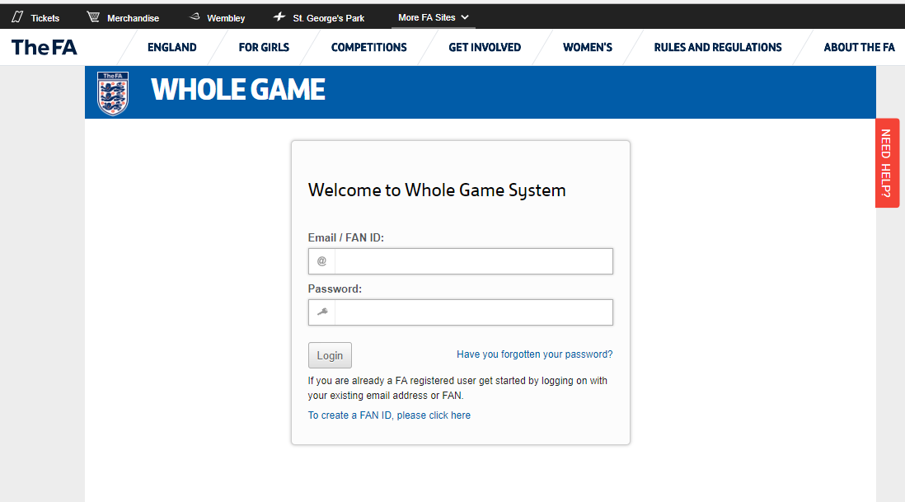

You will need your FAN number and password to enter the site.
I would suggest FAN number rather than email, just in case your email address has changed but not been updated on your FA records.
If you have forgotten your password or have never had one before, click on ‘Have you Forgotten your password?
It will take you to a new page asking you for your FAN number and date of birth?
You will receive an email immediately asking you for your New Password ? and Confirm New Password ? and it will be sent to the email address The Middlesex FA have for you on their records.
If you have changed your email address since last registering, you will need to do this before you can gain access to the WGS re-registration site.
If you have changed your email address since last registering, email your FAN number and name plus new email address to daniel.may@middlesexfa.com who will look into this for you.

- Once into your records, Click onto the Referee Administration tab (below)
Either click on the Registration – available (Green Circle in illustration below) or re-register for 2019-20 season.
If it does not say ‘Available’ as illustrated, this could be because of one of the reasons listed in red on page one of these guidence notes and you’ll need to rectify this and then re-enter the site again to start the registration process.
(3a) Read the pop up box about Youth Football and click Accept (Red Box in illustration below)
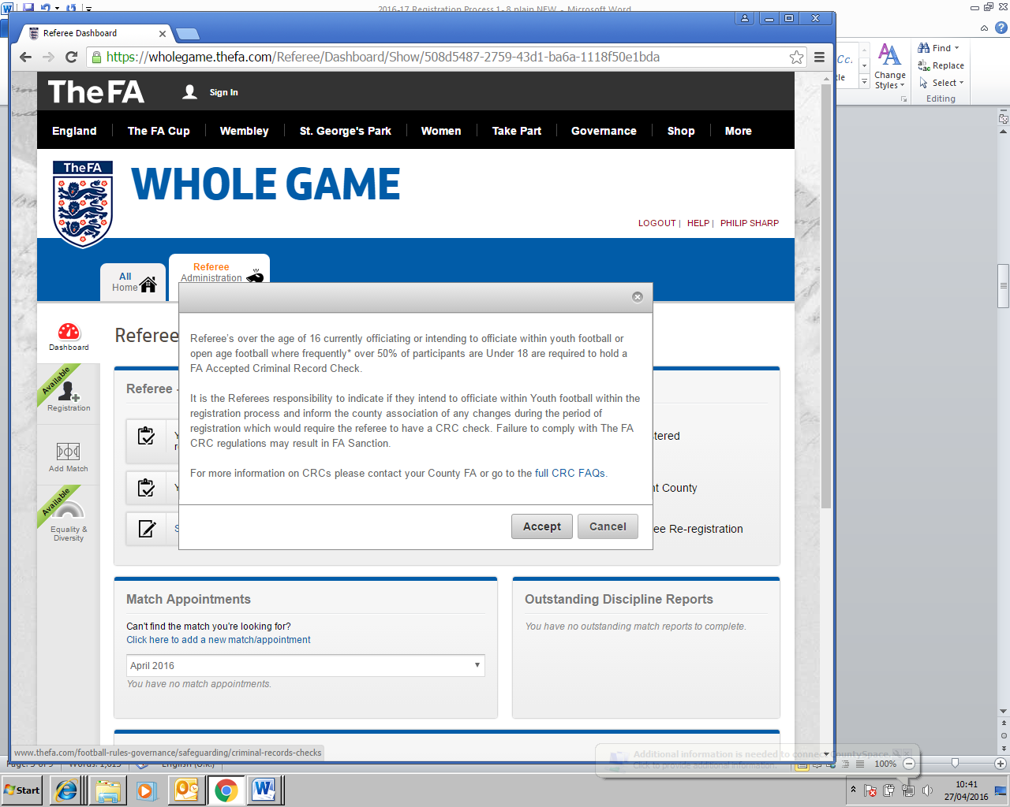
(4) Each season all referees are required to complete the Equality and Diversity page, which consists of 5 questions. You do have the option of ‘Prefer not to say’ once you have clicked on Take me to the form, but The FA have included this page to research who the workforce are in each County. I would really appreciate you completing this has it will help us to research which demopraphic of official the County FA is attracting/retaining as referees.

(5) Equality and Diversity – complete the answers and press Save Details
This will take you to the first of six stages to complete the re-registration process
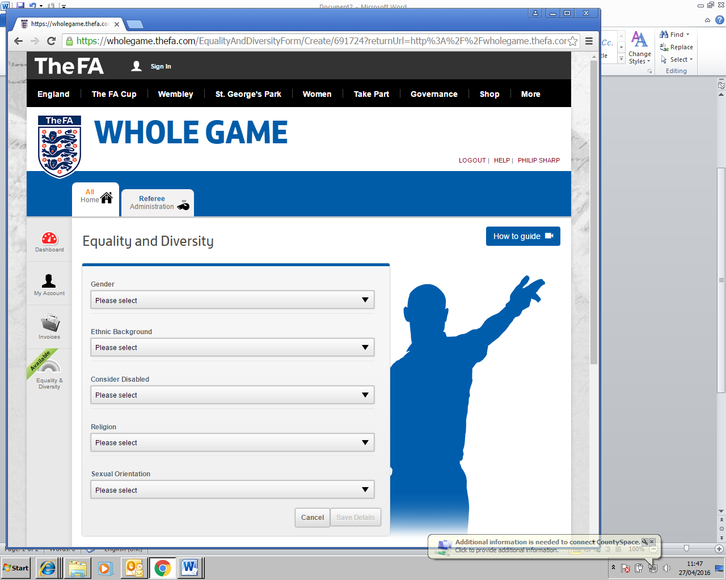
(6) Step 1 – My Registration is your personal details – either Update or if all correct, just click on Save and Continue to go to the next page.
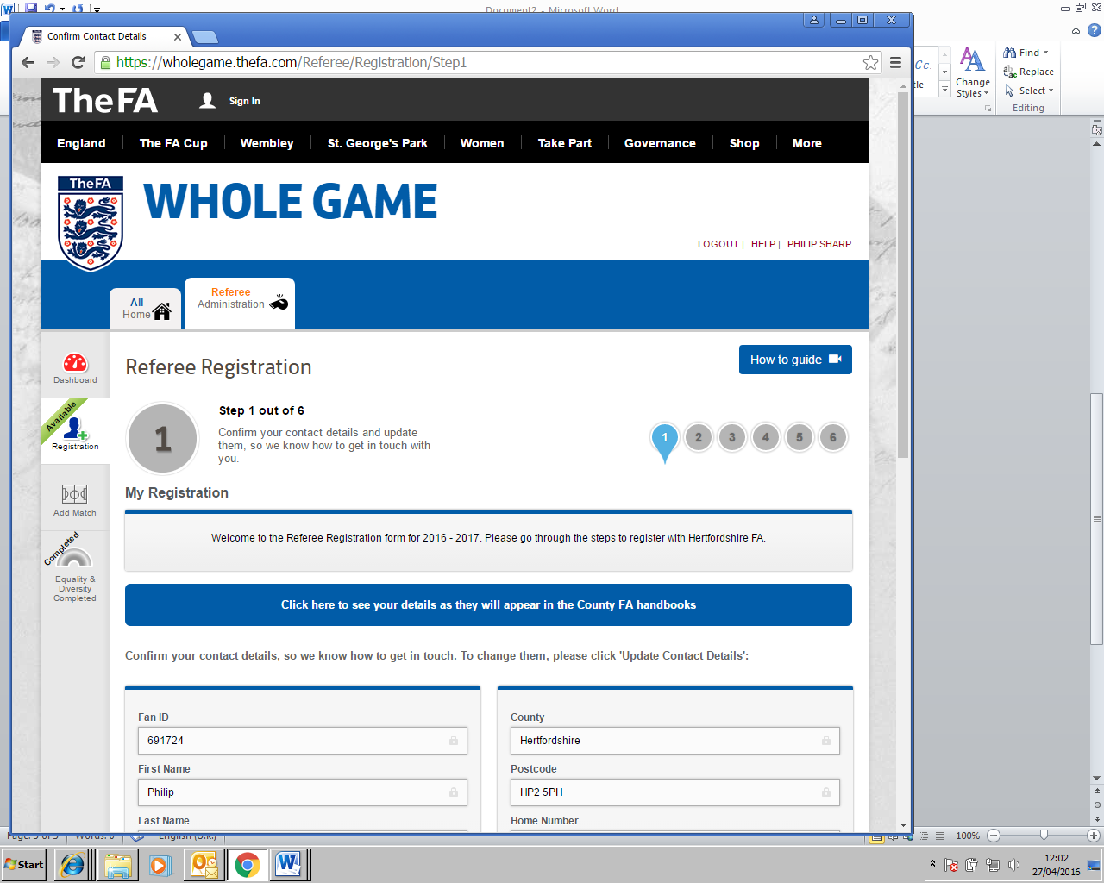

(7) Step 2 – Specialisms and Qualifications details, what type of football you officiate and if you have qualified in any other forms of the game?
If you only officiate in small-sided or have done a Futsal conversion course and it’s not listed, contact daniel.may@middlesexfa.com and inform him of the details and he’ll amend your FA records for you.
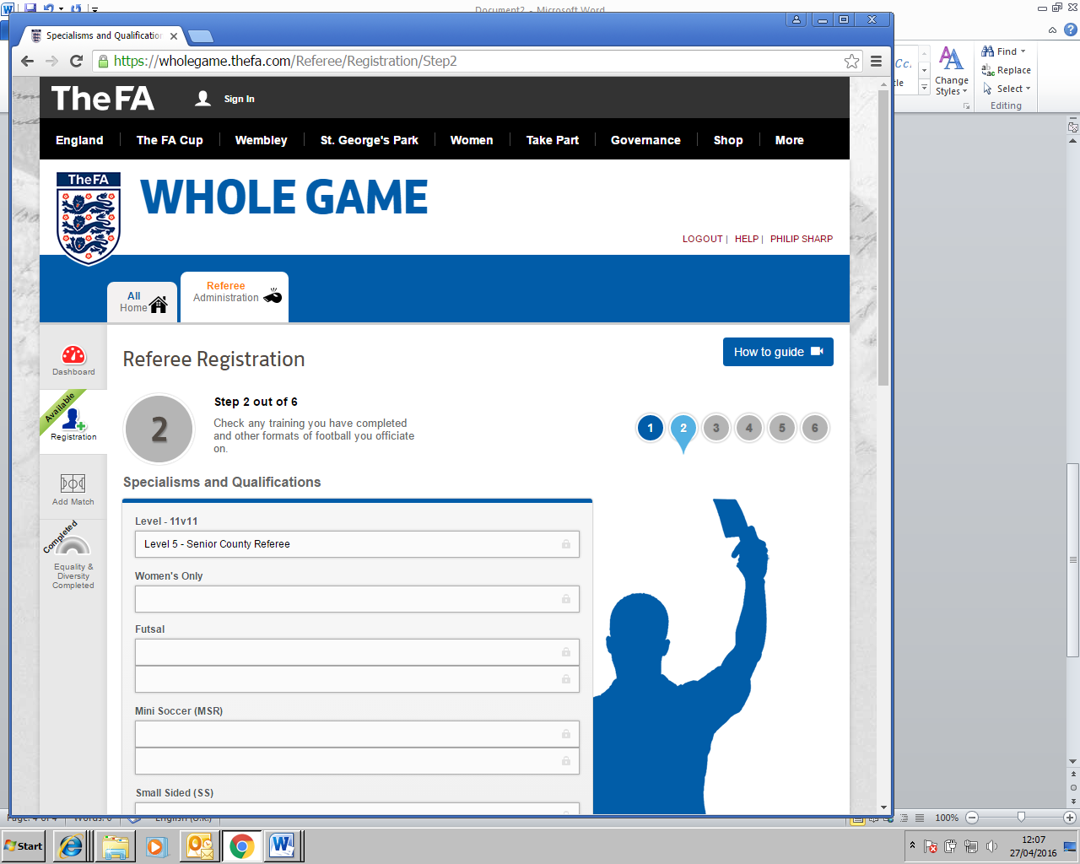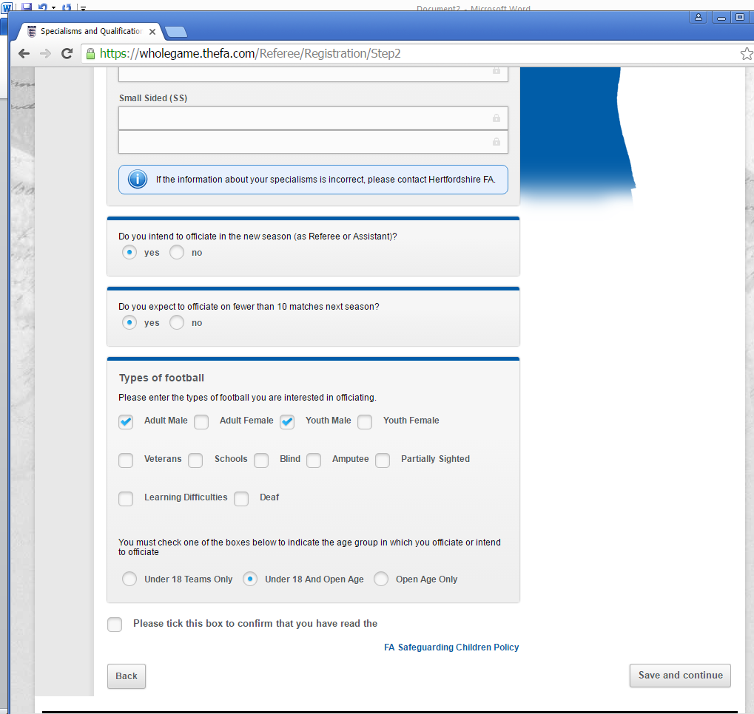
At the bottom of this page it asks you to detail the Types of Football you referee?
You MUST have a valid FA DBS certificate in place if you tick Under 18 or under 18/open age and then any of the following: Youth Male, Youth Female or Schools football.
The system won’t allow you to register if you don’t have a valid FA CRC certificate in place for any Youth Football.
You don’t need a valid FA DBS certificate if you only tick Open Age (Adult) football and then any of the following: Adult Male, Adult Female or Veterans football.
Click on Save and Continue to go to the next page
(8) Step 3 – Associate Membership, leave blank and click Save and continue unless you have an affiliation with another County FA and you wish to request with that County FA Associate membership. Please don’t click on Middlesex FA as you are already registering with us.
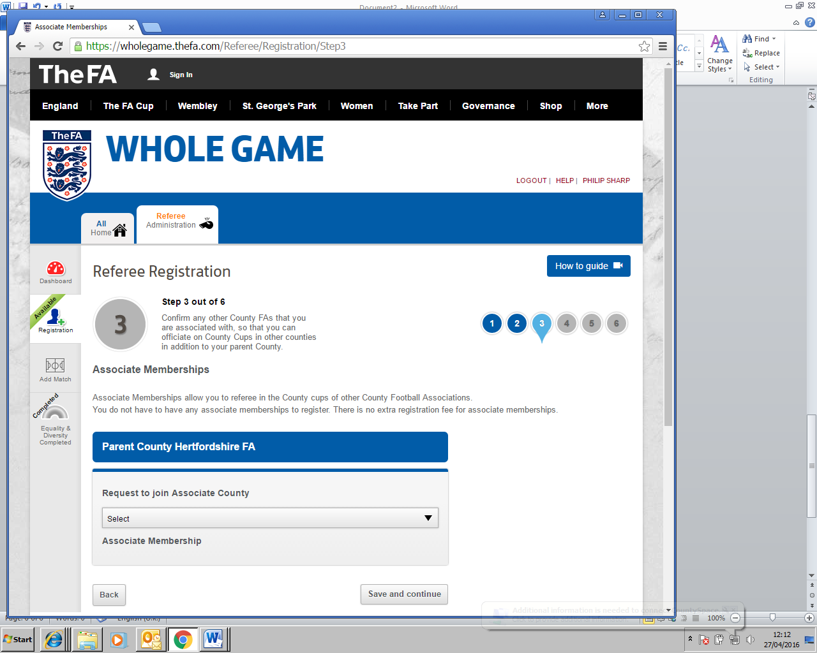
Parent County Middlesex FA
(9) Step 4 – Availability
This stage is to let us know when you are generally available to officiate.
Click on the boxes you are available on a regular basis?
New for this season are the following two requests:
Wish to be considered for ESFA Competitions (This is Schools Football)
Wish to be considered for FA Competitions (This is for referees who can officiate in The FA Cup, FA Trophy, FA Vase and FA Youth Cup Competitions – not Trainee or newly qualified referees)
Closed Dates
If you know any dates that you are not available, for example: Holidays / Injured/ Away from Home, complete the Closed Dates section, if not – leave it blank.
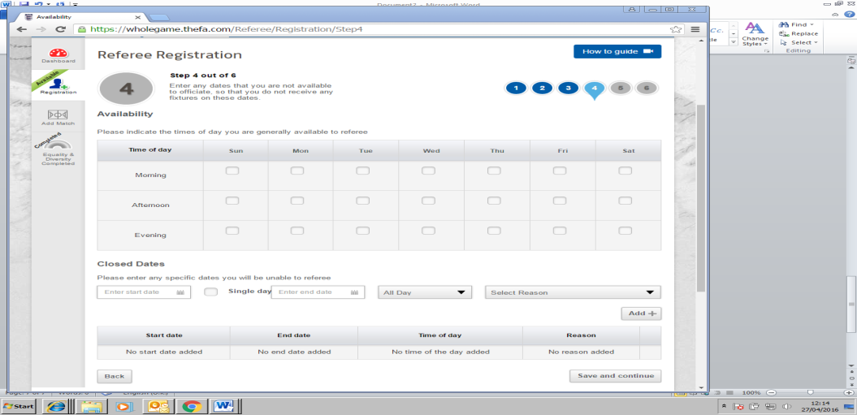

Click on the Save and Continue tab

10) Step 5 – Leagues this section requires you to list all the Leagues that you officiate on or are intending to officiate on next season?
Type in the first 4 letters of the League name i.e. Harr
and wait a few moments whilst the system processes this information.
It will then show all the Leagues with this detail like: Harrow Youth League
Click on the League you officiate on.
If you are officiating on more than one League, do the same for each League.
If you are a new referee/trainee and not joined a League yet leave this blank
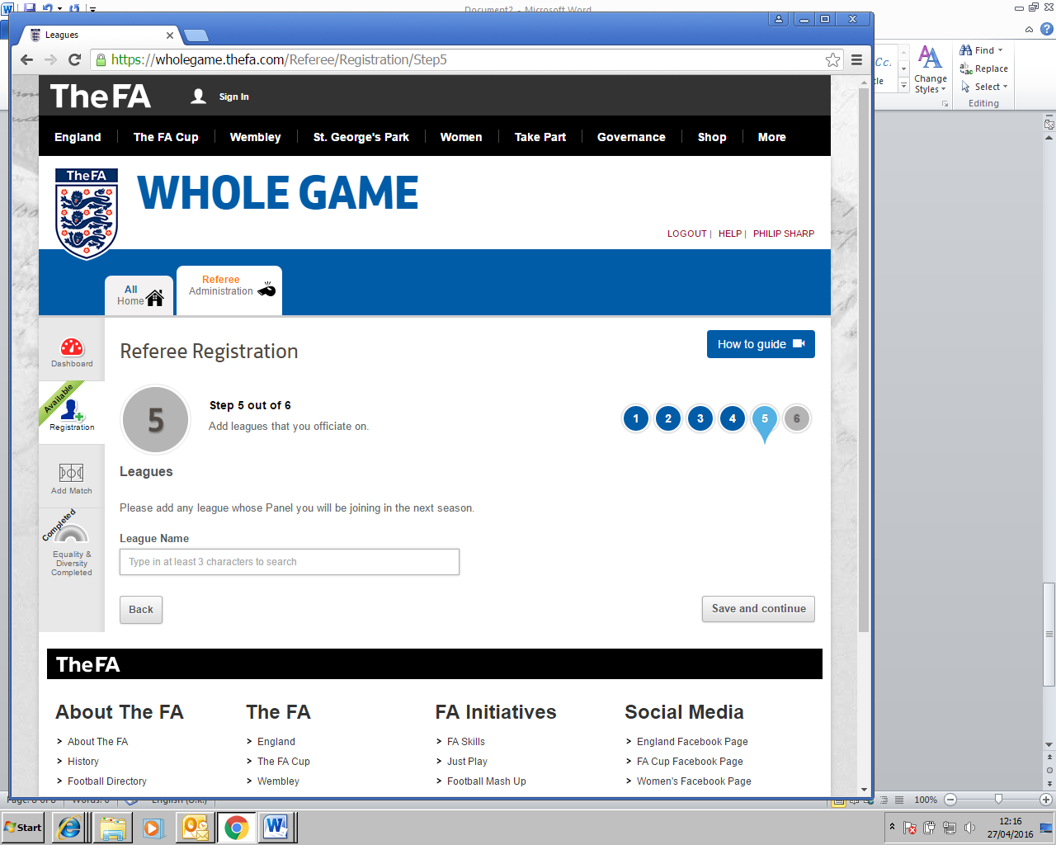

(11) Step 6 – Purchase Products This final stage of the process completes your registration.
If you have been registered previously the referee registration fee will be shown (£20.00) for the 2019-20 season plus any additional items that you may wish to purchase from the list provided.
Just click on the quantity to add it to your total.

Referees who have another role in refereeing such as Observers, Coaches and League Referee Secretaries must still register on WGS but their registration fee will be set at £0.00 because they offer a valuable service to referees in this other role and will not have to pay a fee.
What is your new 2019-20 season registration number?
To source your NEW registration number, go back to the Referee Dashboard where it will state your new number.
You will need this number when you join a League for next season.

PLEASE read the above information before you contact The FA or The Middlesex FA because most of your queries on how to complete the registration process should be answered in these guidance notes.

