Coaches Wanted
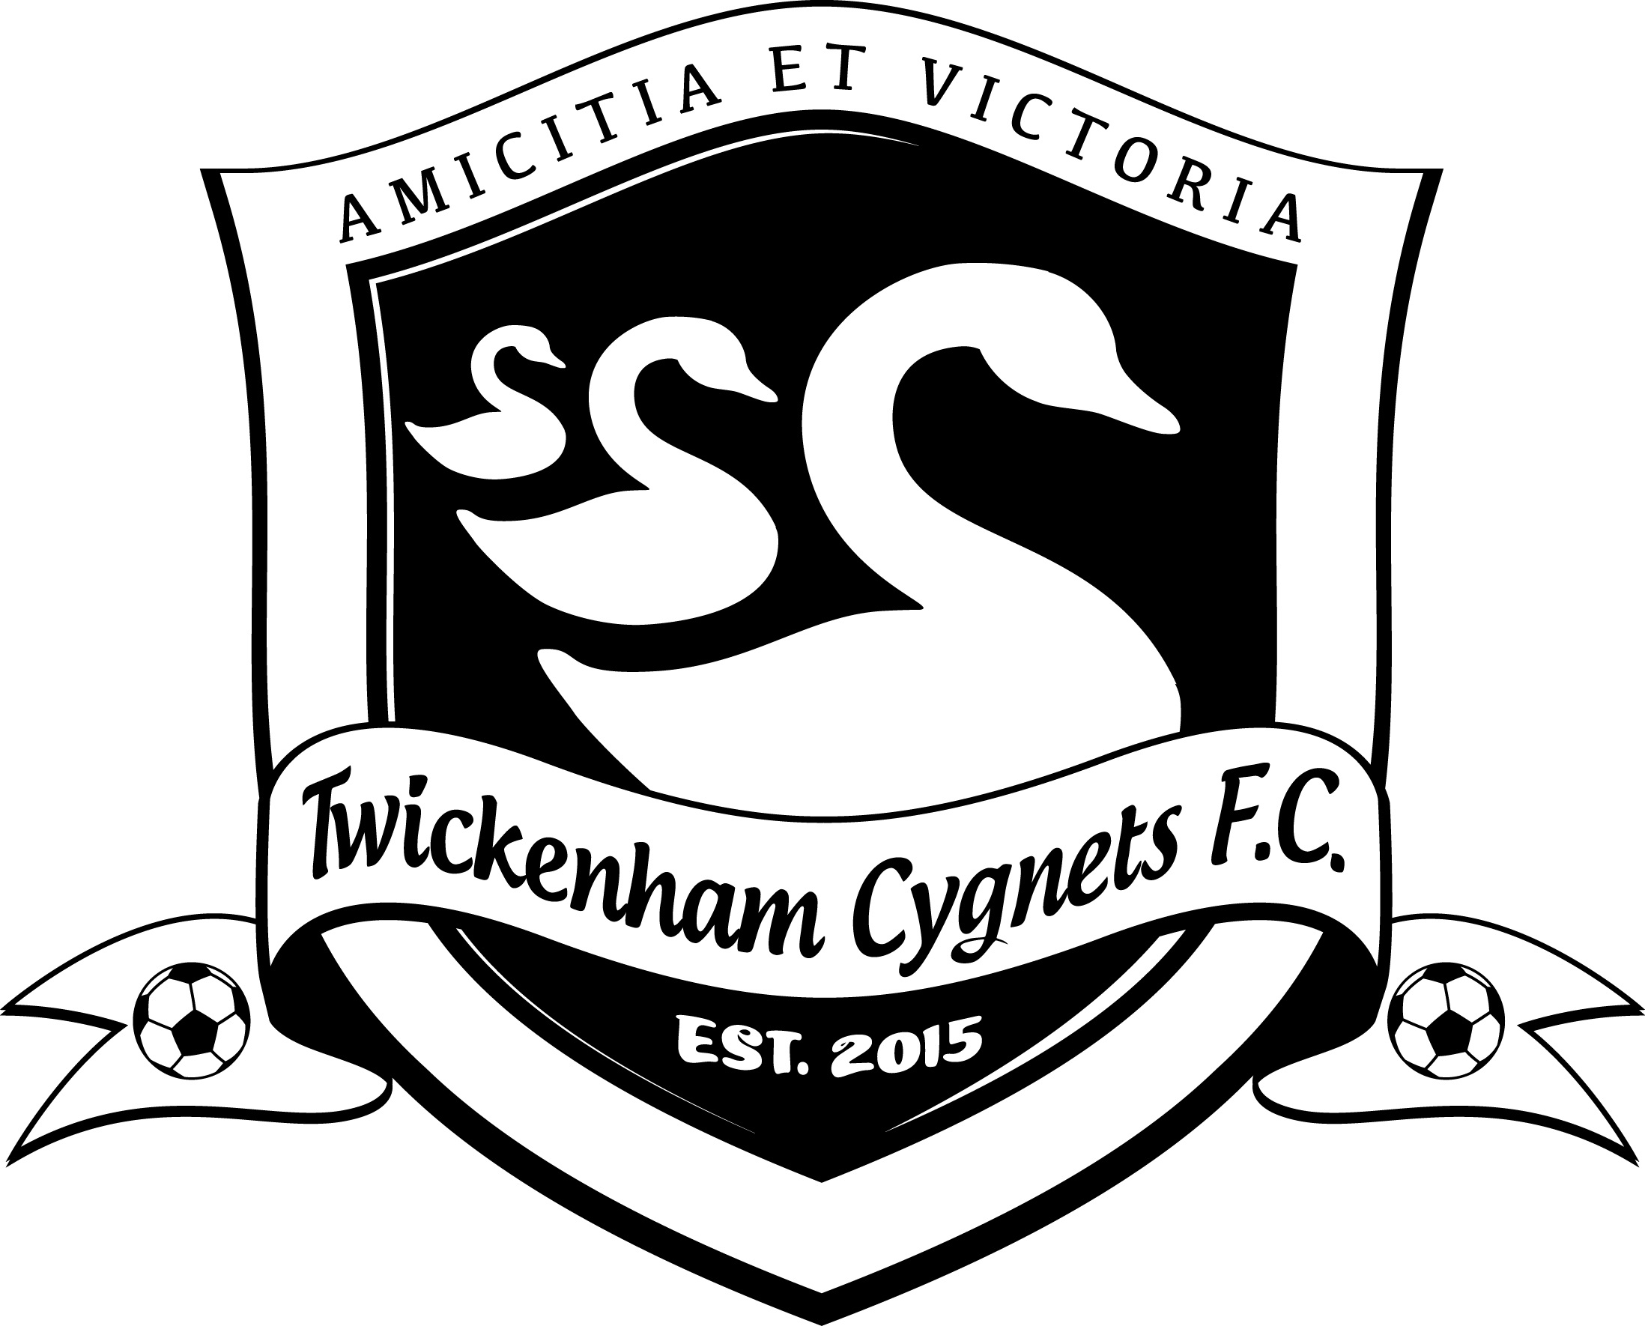
Twickenham Cygnets FC
2020/21 Season
FA Charter Standard Club, Twickenham Cygnets FC are looking for coach / assistant coach positions for the 2020/21 Season. The club play in the Surrey County Women & Girls League and have teams playing at U16, U11, U10 U9 and U8 age groups during the 2020/21 Season. The club was formed in 2015 and now has 150 girls regularly playing football. Passionate about promoting girls’ football, the club adopts a welcoming philosophy where every girl wishing to learn, play and enjoy football can do so in a supportive environment.
Due to this rapid growth, the club is now looking for voluntary coaching support across all age groups but particularly U9 and U8. Being a development focused club, the club is particularly interested in coaches who may have recently completed their FA Level 1 coaching qualification.
The role will suit individuals passionate about girls’ football, working with young people, and being part of an expanding community club. Candidates will need to demonstrate a good understanding of coaching and how to create a positive, enjoyable, leaning environment across the different age groups.
Training sessions for next season are as follows:
U16s – 7.30pm-8.30pm on Monday evenings @ Orleans Park School, Twickenham. TW1 3BB
U11s – 1pm-2pm on Saturday afternoons @ Orleans Park School, Twickenham. TW1 3BB
U10s – 2.30pm-3.30pm on Saturday afternoons @ Orleans Park School, Twickenham. TW1 3BB
U9s – 11.30am-12.30pm on Saturday mornings @ Orleans Park School, Twickenham. TW1 3BB
U8s – 10.30am-11.30am on Sunday mornings @ Orleans Park School, Twickenham. TW1 3BB
In addition, all age groups will play matches or tournaments on Sunday mornings.

Training sessions for next season are as follows:
U16s – 7.30pm-8.30pm on Monday evenings @ Orleans Park School, Twickenham. TW1 3BB
U11s – 1pm-2pm on Saturday afternoons @ Orleans Park School, Twickenham. TW1 3BB
Although the role is voluntary, reasonable expenses will be paid and the club will help support the continued professional development of successful candidate(s).
Please contact Eamonn Newell (Chairman) on 07973 844693 or email twickenhamcygnets@gmail.com for more information.
Visit: www.twickenhamcygnetsfc.com
Follow Twickenham Cygnets FC on Twitter and Instagram @thecygnetsFC

