Instructions for completing a DBS Application

Before you start this process please make sure that you have the following information in front of you if possible:
- Your Passport, a bank or credit card statement, and your driving licence (includes provisional).

- Should you not have all three of these, please click on the link before to find accepted documentation for the DBS Application https://www.gov.uk/guidance/documents-the-applicant-must-provide

Step 1: Please click here.

Step 2: Click on the grey register button top right side of the page
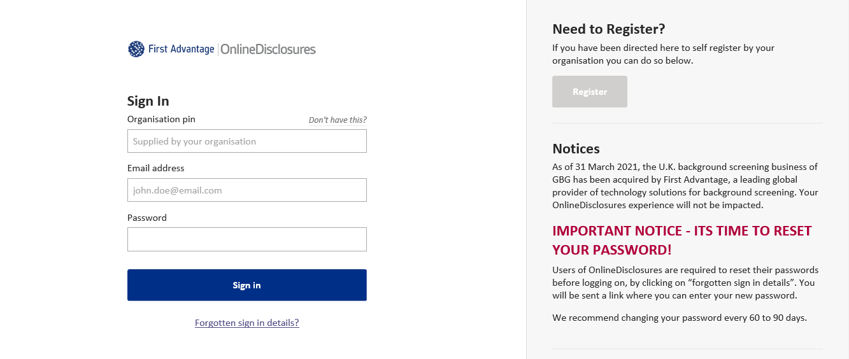

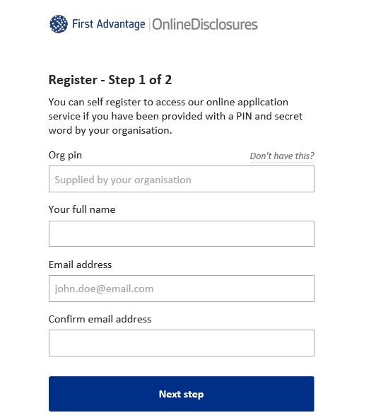
Step 3: Register online. To do this, please input the organisation pin number 102223 (or your clubs organisation pin) in the appropriate box, followed by your email address.

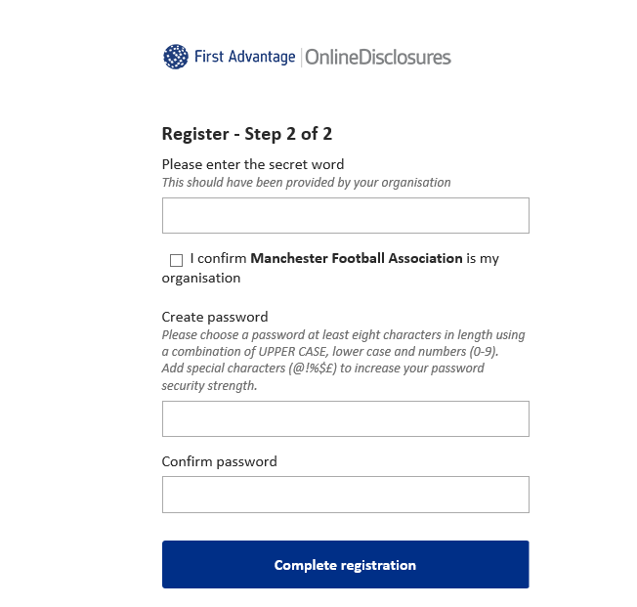

Step 4: Please enter the secret word/code Z4LQX (or your clubs secret word) in the appropriate box and create a memorable password of your choice. Your password must include a capital letter, lowercase letter and a number.

Step 5: Once you have completed the registration, you will return to the login page again. Please now sign in using the organisation pin 102223 (or your clubs organisation pin), your email address and your newly created password. When prompted, please enter the secret word which is Z4LQX (or your clubs secret word).

Step 6: Complete the application.
Step 7: You will now need to contact a member of the Manchester FA team to arrange a time which is convenient for you to have your selected documents verified.

Step 8: Once the documents have been verified, you will now be required to pay £10 for the DBS. To pay please log back into the system, using the organisation pin, your email address and password.

A green pay sign will appear, you can either pay using PayPal or click to make a one off payment on your credit/debit card.
That’s it…. your DBS is in progress.
The average time taken for you to receive your disclosure is 21 days. Once received, please check that all the information is correct.
*If you have content on your disclosure you will receive a letter from FA Disclosures requesting your DBS (disclosure) is sent to them. There will be an address label within the letter. It is recommended that you send the original by recorded delivery. We must inform you that failure to send your FA DBS to the FA under these circumstances within 21 days will result in a suspension from all football until the matter is resolved.

