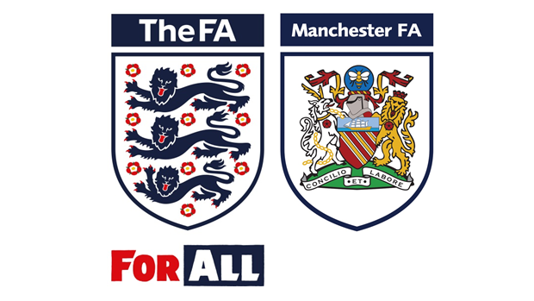
Manchester Football Association

Independent Competitions Working Group Member

Manchester FA
Independent Competitions Working Group Member
Voluntary / Expenses
We are looking for dynamic, self-motivated representative individuals with a passion for football to join an already diverse Competitions Working Group t tasked with shaping Manchester FA County Competitions for the future.
The role will work alongside the Independent Chair of the Competitions Working Group to ensure that, all competition related matters are dealt with in a timely and fair manner. The role holder will be one of just a few that are responsible for ensuring that Manchester FA’s current and future competition offers are competitive and representative of the teams across Greater Manchester.
The successful applicants will need to be able to demonstrate their ability to deliver within our County FA’s three core values; ‘Passionate, Inspiring and Professional’.
The successful applicant must also be able to demonstrate excellent communication and questioning skills.
Title: Independent Member of the Competitions Working Group
Hours: Flexible – as much time as you wish to put into the role but an expectation to attend quarterly meetings and be contactable throughout the day.
Working Location: Flexible
Specific Duties:
- To deal with Competition Queries, Protests and Appeals in line with the Competition Rules.
- To assist in the annual review process of all county Competition Rules.
- To offer the group thoughts and opinions from your chosen area of the game and its impact on county competitions.
- To attend all Competitions Working Group meetings as and when scheduled.
- To champion core projects and tasks as prescribed by the Independent Chair of Competitions.
- To be able to respond via email in a timely manner to all queries by the Business Operations Manager and Independent Chair of Competitions.
What can we offer?
- An exciting opportunity to be part of a forward thinking, progressive business.
- To work with key stakeholders within the grassroots and the professional game.
- A commitment to empowered and supportive personal development.

How to apply:
Applications will be accepted upon the completion of the application form contained in this recruitment pack. It is essential that applicants clearly demonstrate their ability to meet the requirements of the role, explaining how their experience and technical skills will assist them.
Recruitment for the voluntary role will be based on both the technical ability to fulfil the role and also the following key behavioural competencies:
- Collaborative Teamwork
- Creating Solutions
- Customer Excellence & Quality
- Influential Communication
- Inspiring Others To Succeed

Criminal Records Check - As this role may involve direct access to young persons under the age of eighteen, within the context of the job or any subsequently related activities or responsibilities, the successful candidate will undergo a thorough screening process, which will include a Criminal Records Check, to ensure their suitability for the role.

Manchester FA is committed to equality of opportunity and welcomes applications from all sections of the community. Manchester County FA’s Equality Statement is available on request.

Independent Competitions Working Group Member
Name:
Address:
Contact Number (Daytime):
Contact Number (Home):
Contact Email:
Are you currently employed?  Please delete accordingly | Yes / No / Retired
Do you have access to a PC/Tablet with microphone and speaker?  Please delete accordingly | Yes / No

Please return this form together with your CV by no later than
28TH June 2019
All applications submitted will be treated confidentially.
Please send them marked ‘Private and Confidential’ to:
Independent Competition Working Group Members, Manchester FA, Manchester Tennis & Football Centre, 9 Sportcity Way, Etihad Campus, M11 3DU or by email to: Paul.Roots@ManchesterFA.com

Personal Characteristics
Please tell us how about your personal experience with Manchester FA or County FA Cup Competitions
Please tell us your reasons/motives for applying for this role
Please tell us about your background in football

Independent Competitions Working Group Members
Please list any Clubs that you are involved with for the 2019/20 season

Please list any Leagues that you are involved with for the 2019/20 season

Please list any Clubs or Leagues you have been involved in over the past 10 years

